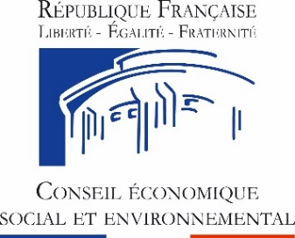
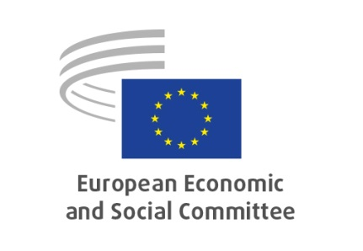

EN

Annual meeting of presidents and secretaries-general of the Economic and Social Councils
of the EU and the European Economic and Social Committee
Videoconference, 9 September 2020

The challenges of contemporary participatory democracy in a Europe that is rebuilding itself: an initial contribution from the economic and social councils and similar institutions to the Conference on the Future of Europe

CONCLUSIONS

The presidents and secretaries-general of the national Economic and Social Councils of the EU and the European Economic and Social Committee (EESC) met in a videoconference on 9 September 2020. They present the following conclusions, which convey a clear message of support for the European recovery and reconstruction project in the wake of the crisis caused by the pandemic.

This year's annual meeting comes at an extremely crucial time, when the EU is suffering the consequences of the most severe health crisis in its history and on the eve of the adoption and implementation of the recovery and reconstruction package and the launch of the Conference on the Future of Europe (CoFoE).

Following an in-depth debate with delegations at the annual meeting, the presidents and secretaries-general of the national ESCs and the EESC consider that:

- The pandemic crisis is severely threatening the resilience of societies, economies and health systems, and poses major challenges for the European institutions as it has also revealed weaknesses and limits of the current state of the European project, in particular. The need to promptly address this global emergency is imperative for the protection of public health, economic wellbeing and social systems, as well as for the very quality of democracy.

- Recovery from the effects of the coronavirus crisis will only be successful if it is accompanied by the restructuring of our society as well as by strengthening the European project. We cannot simply restore what existed in the past: we need to restructure and improve it. For the ESCs, restructuring and improvement will have to be based on the principles underpinning all our work: protecting human and social rights, democratic values and the rule of law, good governance and democratic accountability, unlocking the full potential of the Single Market, achieving the Sustainable Development Goals (SDGs) and creating a circular economy. It is crucial that all investments lead to a structural transformation of the European economy while protecting social cohesion, moving towards food sovereignty, zero pollution, restored diversity and climate neutrality in the EU by 2050 at the latest.

- The European Semester is of paramount importance. From this year onwards, the Semester will focus on a sustainable growth strategy and will be crucial for the implementation of national recovery plans. Civil society at both European and national level is willing and well equipped to be fully involved in the Semester process. The EU ESCs, which are already closely involved in the National Reform Programme (NRP) in the context of the European Semester each year, should also be involved in drawing up their countries' recovery plans.

- It is also imperative to understand why certain social groups became more vulnerable during the crisis, both in terms of insufficient protection against contagion and loss of livelihood, and to work to limit such vulnerability in the future: no one must be left behind.

- However good and extensive the measures to be taken are, they can only be effective and count on support if they operate locally and reach the people for whom they are intended. It is therefore vital to ensure effectiveness, transparency and fairness of implementation.

- Most importantly, one of the main lessons of the coronavirus crisis is that health systems in almost every European country need to be strengthened through the creation of an "EU Health Union", as proposed by the European Commission with its "EU4Health"programme.

- Employers' organisations, trade unions and other civil society organisations played a key role in drawing up appropriate measures and making often very difficult measures tolerable for business and individuals. They have carried out a great number of measures and provided many valid responses in recent months. A few examples may illustrate these recent experiences: in a number of member states unions and employers have been very active in developing and implementing measures as regards labour and industrial relations, e.g. ‘return to work protocols’; new collective agreements have been signed, extending access to unemployment schemes to workers; the social partners have proposed support instruments for self-employed people and sole traders, they have concluded agreements on health and safety, as well as employment measures for workers; other civil society organisations have disseminated information concerning emergency measures taken by the government to protect consumers, introduced distance-learning schemes to help teachers and learners, supported healthcare professionals, communities and vulnerable groups affected by the pandemic and many other measures that have demonstrated a wholehearted commitment to continuing to provide vital support to vulnerable people and those in need.

- Intergenerational solidarity will be a key factor in overcoming the crisis. This solidarity and commitment are particularly significant when it comes to integrating young people into society in terms of work, training and learning, and for people with disabilities, those experiencing a loss of independence, and older people, in order to ensure that they are cared for at home or in specialised establishments. Finally, civil society is determined to support efforts to combat intra-family violence against women and children.

- Although there are exceptions in some countries, it is nevertheless true that for the great majority of national ESCs, their role has been generally strengthened.

- The social partners, other civil society organisations and the ESCs will have to play a key role in this process of recovery and reconstruction, as they are rooted in the reality of our societies and economies. The EESC, together with the network of national ESCs, is indeed the right place to share best practice, exchange views and share the best solutions for recovery and reconstruction.

- At the same time, we are facing a structural crisis of representation. The current model is impacted today by major changes that upset the traditional representative organisations and have a negative impact on intermediary bodies. The evolution of good governance in the 21st century will not be able to ignore the growing demand for public participation in the political process at the national, as well as the European level. The ESCs face the challenge of addressing this growing demand in their activities, while respecting the culture and form of social dialogue in the different Member States. Some ESCs are at the forefront of these developments and they were able to design and implement instruments of participation with great success. Civil society platforms, citizens' panels or structured online consultation are some of the examples that have shown remarkably successful outcomes.

- On the eve of the Conference on the Future of Europe, the European ESCs reiterate their willingness to cooperate fully with governments and parliaments and participate in designing, formulating and implementing processes at all levels and all stages, and on all specific matters in order to protect the public's health, safety and well-being. According to ESCs, the envisaged measures should emerge through social dialogue and consensus building and the participation and agreement of the social partners and organised civil society. In this new recovery and reconstruction process, the ESCs hope that the forthcoming Conference on the Future of Europe will provide an opportunity to strengthen and deepen the EU's institutional structure and for a real renewal of the EU project, capable of facing the challenges of the coming decades and meeting the aspirations of European nations for more Europe.

_____________

