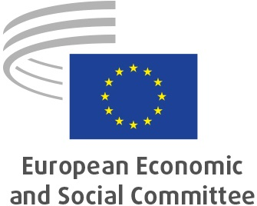
EN
Krzysztof PATER
Vice-president
of the European Economic and Social Committee (EESC)
in charge of budget
Inaugural speech
Brussels, 26 April 2023

Dear colleagues,
First of all, I would like to thank you for your trust in assigning me the role of vice-president of the European Economic and Social Committee with responsibility for the budget.
I have been dealing with financial and budgetary matters in our Committee for many years, so I am fully aware of the challenges that lay ahead and of my responsibility. I am convinced that I will meet this task and will not fail your trust.
The EESC is an institution which for years has shown particular care for the financial resources allocated to us under the European Union budget. We have never asked for more than we really need. It is our Committee that in the last ten years has recorded the highest staff reductions among all the European institutions. In recent years our budget has been planned primarily on the basis of real needs, leading, for example, to a freezing of planned expenditure on certain budget lines that was unique among the European institutions. The buildings strategy implemented in the past few years is another example of how the Committee's expenditure is optimised.
A period of challenges lies ahead. After several years of experience, it will be necessary to further optimise the structure of expenditure related to the changes in the organisation of the Committee's work made in recent years.
Since Russia's invasion of Ukraine, there has been not only a dramatic change in the economic landscape, which is a source of great uncertainty in the planning of much of the Committee's expenditure, but also in the global geopolitical situation. This makes it more important than ever to invest to make existing democratic systems more capable of protecting fundamental rights and of reinforcing their own stability. In this process, the EESC wants to and should play a key role in taking initiatives adapted to current needs.
When granting the 2020 discharge to the EESC, the European Parliament rightly pointed to "the Committee's key role in representing the social partners and civil society organisations from the Member States in the EU decision-making process". European civil society proves its role in strengthening democratic processes on a day-to-day basis, developing a wide variety of forms of civic participation in partnership with the institutions of the Member States, especially in crisis situations. Voluntary activity saved the lives of thousands of European Union citizens during the COVID-19 pandemic and ensured that hundreds of thousands of refugees from Ukraine were able to get the help they needed. I very much hope that the European Commission will also acknowledge their efforts by making 2025 the European Year of Volunteers, as requested by our Committee in its opinion.
As one of the three representative EU institutions, we are an important link in democratic decision-making. I will do my utmost to ensure the optimal structuring of financial and staff resources to carry out our Committee's tasks.
_____________

