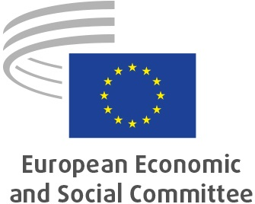
EN
Krzysztof PATER: Vice-President in charge of Budget
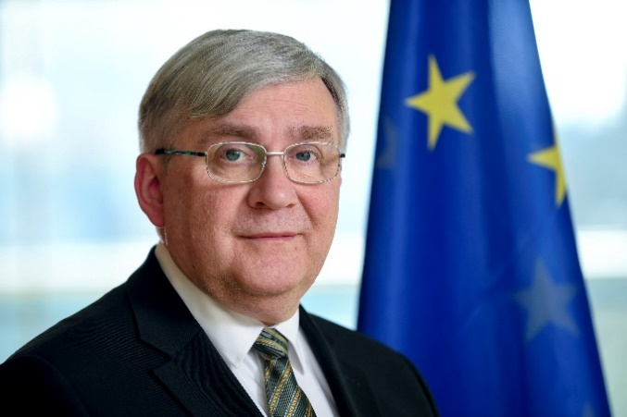
Krzysztof Pater has been a member of the European Economic and Social Committee (EESC) since 2006. He was president of the Section for Economic and Monetary Union and Economic and Social Cohesion (ECO) between 2008 and 2010, and president of the Labour Market Observatory (LMO) from 2010-2013 and 2018-2020.
In his native Poland, Krzysztof Pater played a prominent role in the reform of the Polish pension system in the late 1990s, and helped shape the concept of the funded pillars in the new system. He also worked in the newly created pension sector and afterwards both as an independent advisor to public, scientific and private institutions and as an academic.
In November 2001, Mr Pater was appointed Undersecretary of State for Labour and Social Policy and in May 2004 he became Minister for Social Policy in the Polish government. He has also been a permanent advisor to the Polish Parliamentary Social Policy Commission (January 2006 to November 2015) as well as to the Polish Parliamentary Petitions Commission (since January 2016).
Mr Pater has been an active member of the Polish Scouting Association (ZHP) for more than 45 years and last year became its president. In 2005, he was awarded the Golden Cross of Merit by the President of Poland for his merits in educational work with children and young people.
Mr Pater holds a degree from the SGH Warsaw School of Economics.
_____________

