- Renewable Energy in the Caribbean  Worldwide, the Caribbean is among the regions most affected by climate change. Preserving ecosystems and their biodiversity is critical for long-term development in the Caribbean island and coastal states. Failure to do so would adversely affect tourism, fishing and agriculture in particular.  The EU supports various projects and programmes on the green transformation in Latin America and the Caribbean region through its regional flagship programme EUROCLIMA+, as well as the Caribbean Investment Facility, which mobilised EUR 149 million for various sustainable development projects since its launch in 2012.  In 2016, the Technical Assistance Programme for Sustainable Energy in the Caribbean (TAPSEC) came into effect. TAPSEC intends to support the region in achieving a transition towards sustainable energy and a low-carbon economic growth path.  Implemented together with the CARICOM secretariat, the Caribbean Centre for Renewable Energy and Energy Efficiency (CCREEE), and the Ministry of Energy and Mines in the Dominican Republic, TAPSEC’s mission is geared towards ensuring that all CARIFORUM citizens have access to modern, clean and reliable energy supplies at affordable and stable prices.  TAPSEC is funded by the European Union to the sum of EUR 9.0 million with the additional financial support of EUR 1.5 million from the German Federal Ministry of Economic Cooperation and Development. | EU-Caribbean relations  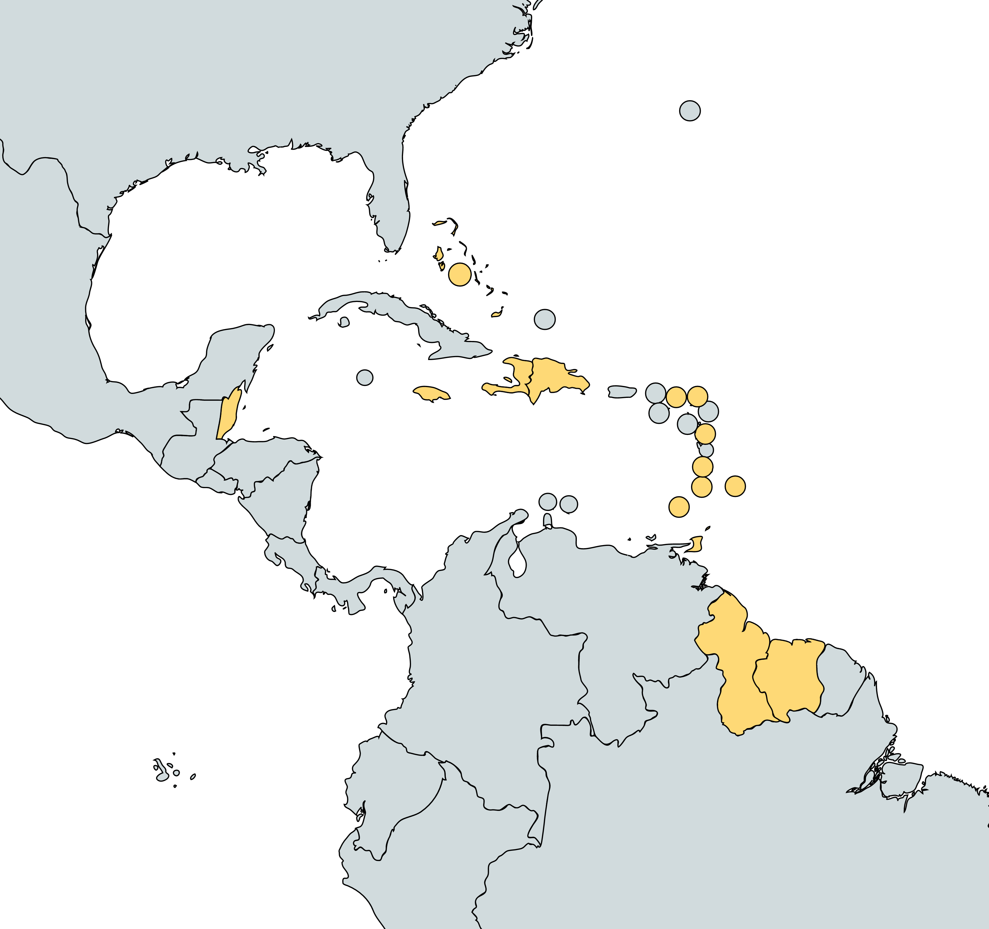  The framework for EU-Caribbean relations is provided by the Cotonou Agreement (2000), as well as the CARIFORUM-EU Economic Partnership Agreement (EPA) (2008), and the joint Caribbean-EU partnership strategy (2012). The joint Caribbean-EU strategy sets out five priority areas: regional cooperation and integration, reconstruction of Haiti, climate change and natural disasters, crime and security, and joint action in bi-regional and multilateral forums and on global issues.  In addition to dedicated regional meetings and the broader ACP-EU Joint Interparliamentary Assembly, the 2008 EPA established a CARIFORUM-EU Joint Parliamentary Committee to monitor the implementation of the agreement.  EU cooperation with the Caribbean is tailored to the needs of individual states, and carried out through combining bilateral cooperation with regional cooperation via the Organisation of Eastern Caribbean States (OECS), Caribbean Community (CARICOM), and CARIFORUM. The organized civil society from the EU and the Caribbean collaborate through the CARIFORUM-EU Consultative Committee.  OACPS-Caribbean states: Antigua and Barbuda, Bahamas, Barbados, Belize, Dominica, Dominican Republic, Grenada, Guyana, Haiti, Jamaica, St. Lucia, St Vincent, St Kitts and Nevis, Surinam, Trinidad and Tobago.  Within the Caribbean Regional Indicative Programme (CRIP) under the 11th European Development Fund (EDF), EUR346 million was allocated to the region in the 2014-2020 period. The programme put focus on regional economic cooperation and integration, climate change, environment, disaster management and sustainable energy, and crime and security.  The 11th European Development Fund (EDF) supports trade through different programmes:  - Caribbean Export - a region-wide agency supporting Caribbean exporters  - CDE - an agency helping businesses become more competitive  Caribbean Association of Investment Promotion Agencies - includes links to all 15 CARIFORUM States' investment promotion agencies  - Aid for Trade  Recent Events:  - The European Commission announced in March 2021 EUR 17 million in humanitarian aid to address the needs of the most vulnerable in Haiti and the Caribbean, which have been worsened by the COVID-19 pandemic, in addition to EUR 8 million contributed in 2020.  - In June 2021, the EU and the Caribbean Meteorological Organization (CMO) have partnered to support the countries in the Caribbean in their efforts in building resilience and adapting to the impacts of climate change. With a budget of EUR 9 million, it aims to improve access to and uptake of climate information.  - CARIBSAN (June 2021-December 2022, EUR 1.7 million), a Caribbean cooperation project that aims to deploy an innovative, environmentally friendly technology for wastewater treatment using local plants was inaugurated virtually on 27-28 September 2021. The project is financed by the European INTERREG Caribbean programme, AFD, and the Water Offices (ODE) of Martinique and Guadelupe.

