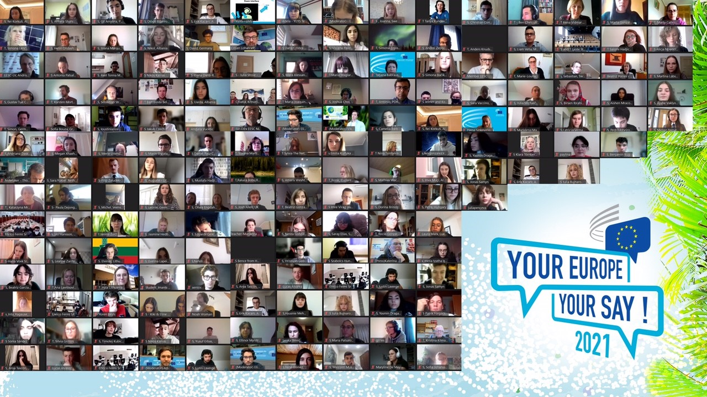

Your Europe, Your Say! 2021

European students from 29 countries took part in a virtual youth summit on climate and presented their recommendations live to European Commission Executive Vice-President Frans Timmermans.

This year's Your Europe, Your Say! (YEYS) event, entitled 'Our Climate, Our Future!' took the form of a COP climate negotiation, empowering students to engage with climate solutions, and brought together online 234 teenage students and 56 teachers from 29 European countries.

Over the course of two days, the students engaged in a roleplaying game, simulating a real climate negotiation at the United Nations headquarters in New York.

After three rounds of multilateral discussions, the students were able to propose a set of policies that limited global warming to 1.4 degrees Celsius by the end of the century. An impressive result, given that students represented groups with opposing priorities, which shows the importance of joining forces and collective thinking.

The conclusions the students came to were presented to Frans Timmermans, European Commission Executive Vice-President at the closing session, chaired by EESC Vice-President Cillian Lohan, making this a valuable contribution to the EU Climate Pact currently being prepared by the European Commission.

The students' proposals were as follows:

- Investing in carbon removal in urban spaces by planting city trees and installing vertical gardens, a solution already being implemented in some places in Europe.
- Investing in new technologies that will make it possible to remove carbon now and quickly
- Supporting afforestation as one of the most efficient long- term solutions for carbon removal
- Investing in more education for the general public
- Focusing not only on quick remedies but also on long-term solutions for carbon removal that can encourage people to adopt new habits
- Implementing tailor-made policies that respond to each country's specific circumstances
- Introducing hydrogen and biogas while phasing out fossil fuels
- Investing heavily in existing carbon-removal technology
- Capping pollution amounts, rather than taxing them, as those still end up being paid for by the consumers
- Investing more in the efficiency of renewable sources and making this the top priority on the EU’s agenda
- Making new buildings greener with solar panels, so that buildings can rely on a renewable energy supply
- We must find the middle course between old, quick short-term solutions and new, long-term solutions
- EU plans to reduce the number of new certificates issued in the cap-and-trade system by 48 million each year until 2030, but that way, the zero net goal will not be reached until 2057. If certificates are decreased by 66 million per year instead, the last certificates will be issued in 2040. That would work more in line with the Green Deal. It would be beneficial if Australia and other countries were also included in this agreement.
- The EU needs to start an “Ecological Manhattan-Project” and invest vast amounts in new technologies and, in so doing, help rapidly developing nations to tackle their problems by sharing new technologies, for example, with patent-free solutions
- It is important to close the gap as far as possible between developed and developing nations
- We should think of providing more workplaces for citizens from developing countries in eco-friendlier sectors, such as bioenergy, renewable energy etc., so that people are not so dependent on agriculture
- Increasing the general interest of investors and investment in renewable energy, which can be as much as three times cheaper than conventional power plant development
- Conventional suppliers do outperform clean ones in times of peak demand, but this problem can be addressed though the development of higher-capacity electricity storage units.

_____________________________________________________________________________

The speakers involved were:

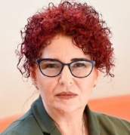
Christa SCHWENG, EESC President
"We need a green transition to a green economy that leaves no one behind. This means boosting green investments, promoting new lifestyles and forms of consumption. To achieve this, we need active citizens. This starts with involving young people!"

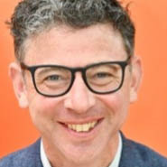
Cillian Lohan, EESC Vice-President
"The youth movement has shown that change can come from the streets. Today we help those demands for more action to resonate in the corridors of power."

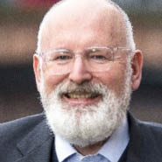
Frans TIMMERMANS, European Commission Executive Vice-President
"You have to help me and my generation and your parents' generation to change in order to give you a future. With your help, I'm sure we will convince the entire population."

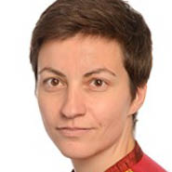
Ska Keller, Co-President, Greens/EFA in the European Parliament
"Without public pressure we wouldn't have got as far as we are now!"

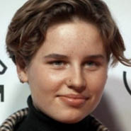
Anuna de Wever, Climate activist
"Dare to think outside the box and be brave enough to imagine a different world! We need young people to lead this change!"

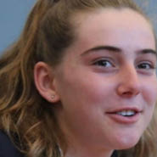
Adelaide Charlier, Climate activist
"We have to start communicating to citizens on the real crisis that we are facing! We expect more ambition from the European Union and must make sure that we stay coherent in our policies!"

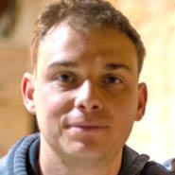
Samuel Masse, President of the European Council of Young Farmers
"European young farmers are committed to playing a role in tackling climate change and building a more sustainable Europe”

The students:
"Humanity has been pumping greenhouse gases into the atmosphere for decades and they’ll stay there if we don’t do something about it. We have to make right what the past generations have done wrong."

"By working together, we have proven that we can achieve greatness and efficiency. The results from this amazing project, including phenomenal people, show it."

"Listen to the youth! Listen to FFF (Fridays For Future)! Listen to the scientists! We need to start taking action now!"

