EN
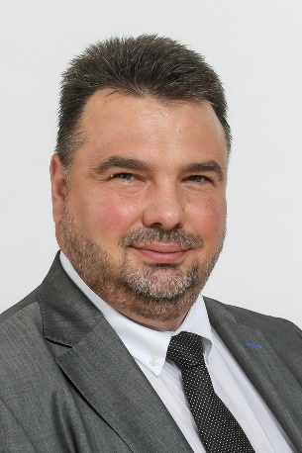 | Personal Information  Name: Plosceanu  First name: Aurel Laurenţiu  Nationality: Romanian  Work address: 99 Rue Belliard/Belliardstraat,  1000 Bruxelles/Brussel  E-mail: plosceanu@yahoo.com  Laurentiu.Plosceanu@eesc.europa.eu

Current employment

Member of the European Economic and Social Committee (EESC)
- Member of Group I Employers' Group
- President of the Section for Employment, Social Affairs and Citizenship

President of ARACO
Vice-president of UGIR

Education

1987–1992 Bucharest Construction Institute
1995-1998 Executive MBA at National Institute for Economical Development
(ASE Bucharest – CNAM Paris)
2001-2006 Law Faculty at "Nicolae Titulescu" University Bucharest
2006 Post-university course at National Defence College

Professional background

1992-2000 Human Resources Manager and member of the board at Energoconstructia SA (7 000 employees)
2000-2007 CEO at ABC Asigurari Reasigurari SA (150 employees)
1999-2016 President of the Social House of Building Workers (paritarian sectoral NGO)
2005-2016 Member of the board at House of training for the construction workers
2007-2011 Member of the board at the Bucharest Construction Technical University
2007-2011 Member of the Romanian ESC
2002-2006 Vice-president of ARACO (Romanian Association of Building Contractors)
2005-2007 President of ARMMA (Romanian Association of SME in Insurance)
Since 2007 President of ARACO (FIEC member – European Federation of Construction Industries)
2007-2013 Co-president of ACPR (Romanian Alliance of Employers Confederations)
Since 2016 Vice-president of UGIR (Romanian Industrialists General Union)
Since 2007 Member of the EESC

EESC main activities

Involved in the activities of all the EESC sections (ECO, SOC, NAT, INT, TEN, CCMI)

2015-2017 President of the Audit Committee
2013-2017 Member of the Group I Bureau
2017-2020 Member of the EESC Bureau
Since 2020 President elect for EU-Serbia JCC

Involved in other topics such as construction sector, CEF, TEN-T developments, European Defence, Smart cities, EU-China and EU-Ukraine Round Tables, Border Adjustment Measures, freeing EU from asbestos, support administrative issues for Group I.

Social projects

2005-2008 Founder of the Romanian construction training social committee under a PHARE programme
2005-2006 SNOW Leonardo project with Italian partners
2006 ILO training courses for construction sector
2006-2008 Belgian Govt. Project Adaptation of the Romanian Construction sector to the EU requirements with Flemish Construction Confederation and Bucharest Technical Construction University
2010 Strategic European Social Fund projects (CALE, ACCED, PICAS) for sectoral Romanian social partners
2018-2020 European construction social partners project TANSIRC for the promotion of industrial relations in Central and Eastern Europe
2019-2020 European construction social partners project TUWIC for tackling undeclared work in the construction sector
Negotiated and concluded several labour construction collective contracts at national level
2015-2017 Negotiated and signed the first Social Accord for Romanian Construction Sector

Private life

Born in 1968 in Bucharest, Romania. Divorced, with two children - boys of 25 and 9 years.

Languages

Romanian
English
French

_____________

