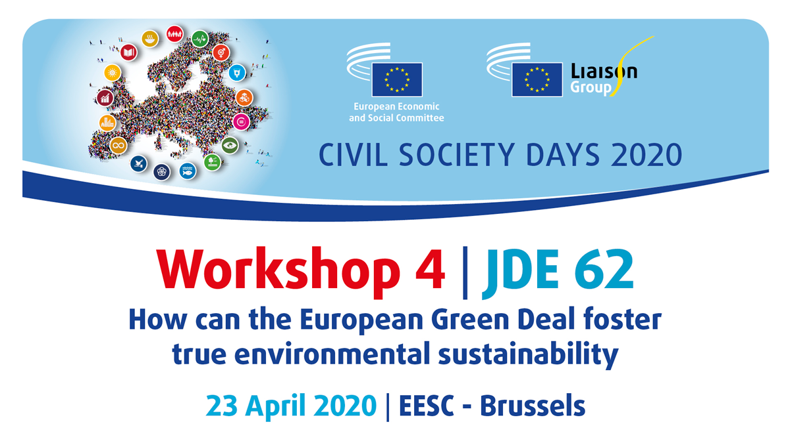
Time: 09:30-12:30, room JDE 62

Organised by:
European Environmental Bureau (EEB) and EESC Sustainable Development Observatory (SDO)

Background
We are at a critical moment in time. It is clear that the world is not on track to achieve the objectives of the Paris Agreement on climate change and SDG targets. Renewed political commitment, leadership and guidance are therefore essential. Stopping runaway climate change and environmental degradation must be a shared goal on a global scale. Efforts are needed from all countries and all players to achieve climate neutrality. Europe must be the frontrunner, the global leader in tackling climate change and presenting solutions to environmental degradation. With the presentation by Ursula von der Leyen of the Communication on the European Green Deal and its strong commitment to deliver climate neutrality by 2050, the EU showed leadership, seeking to promote ambitious climate and environment policies domestically and across the world. The European Green Deal must therefore also be a driver for the transition of our economy to an economy that serves the wellbeing of people and the planet while reducing our environmental impact. 2020 must be the year when political leaders finally listen to science and to the people, who are demanding decisive EU action to counter the devastating climate change and environmental degradation which are threatening our economy and our society.

Concept of the workshop

The workshop should focus on the key elements of the European Green Deal (EGD) in terms of environmental sustainability – biodiversity, climate, non-toxic environment (air, industrial emissions, chemicals) – and what civil society argues the EGD and its elements need to deliver. It will include close links to SDG implementation and examine how the SDGs can be achieved in the European context through the actions proposed by the EGD. It will look specifically at civil society's contribution to the design of the EGD and how it can support its implementation and monitor the various strategies announced.

Participants
The workshop will bring together participants from the EU institutions, with particular focus on services and cabinets responsible for delivering on the main elements of the EGD, along with civil society representatives and experts, who will provide their perspectives on how the EU strategy should be developed.

Format

The workshop will be structured to combine different methods, including short contributions from inspiring speakers and dynamic discussion on the topic. The format will be interactive, engaging and make sure that the topic is accessible to people who are not yet familiar with it.

