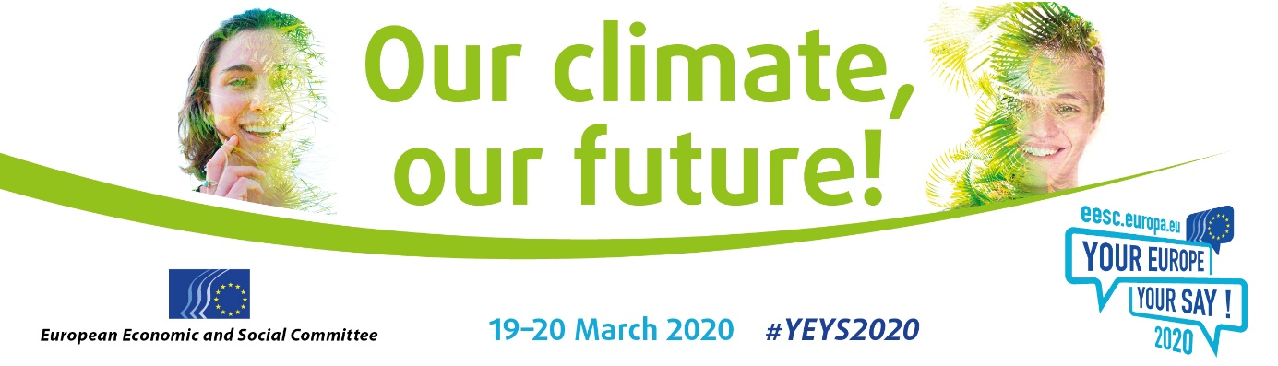

**EN**

Dear Sir/Madam,

The European Economic and Social Committee (EESC) is launching its 11th **"Your Europe, Your Say"** event, which will take place **in Brussels on 19-20 March 2020**.

As part of the ["Your Europe, Your Say"](https://www.eesc.europa.eu/yeys2020) (YEYS) event, 33 schools (from the 28 EU Member States and the five EU candidate countries) are invited to Brussels to participate in a debate on a topical issue that concerns young people.

TOPIC

The title of the upcoming event is **"Our climate, our future!" and will voice young people's concerns on climate change**.

This year's YEYs will take the form of a mock United Nations climate conference: students will be asked to represent a country and negotiate with each other, in order to come up with recommendations to stop climate change.

These recommendations will be submitted to international environment policymakers and discussed during conferences around Europe throughout the year.

During YEYS the students will also be put in contact with international youth organisations who will help them translate these recommendations into practical measures and make their voice heard.

If your institution is a secondary-level school, of any type, in one of the 28 Member States or one of the five candidate countries, we strongly encourage you to **send in** [**an application**](http://cdweb.eesc.europa.eu/eesceuropaeu-ae77k/pages/iixeqjteembfgbqvqbd6g.html) **to participate in the 2020 YEYS event**.

Schools will be chosen by drawing lots and the winners will spend **two days** in Brussels.

WHO

If your school is selected, you may send **three pupils** who are in their penultimate year to attend, accompanied by a teacher. The EESC will cover the costs of travel, accommodation and meals served during the event.

They will meet pupils from the other countries, with whom they will be able to exchange views and draw up resolutions on themes related to the European Union. This is a unique opportunity for them to gain a better understanding of how the EU works and to take part in an assembly-style debate in a multicultural environment.

LANGUAGE

All the proceedings will be conducted in English.

PREPARATION

EESC members will visit each selected school well in advance to prepare the students for the debates in Brussels.

Documentation and teaching materials will be sent to schools ahead of these visits.

MORE INFO

On [our website](https://www.eesc.europa.eu/en/agenda/our-events/events/your-europe-your-say-2020) you will find a detailed description of the event, a video of the 2019 YEYS event, the online registration form, rules and all practical information.

DEADLINE

[**The deadline for applications is 18 November 2019.**](http://cdweb.eesc.europa.eu/eesceuropaeu-ae77k/pages/iixeqjteembfgbqvqbd6g.html)

We look forward to welcoming you to Brussels!

Yours faithfully,

Isabel Caño Aguilar

EESC Vice-President for Communication

[](http://instagram.com/youreurope/) **[](https://www.facebook.com/pages/Your-Europe-Your-Say/255682697155?ref=hl)**