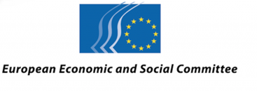  EN | 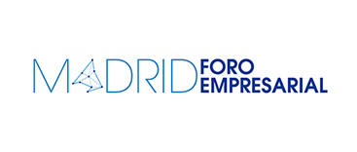

The role of European and regional institutional funding in the development of SMEs in Madrid

Date: 6 June 2018
Venue: Spanish Economic and Social Council, C/Huertas, 73. Madrid
PROVISIONAL PROGRAMME
9-9.30 a.m. Arrival of participants
9.30-10 a.m. Welcome and presentation of the programme

- Marcos Peña, President of the Economic and Social Council
- Lucie Studničná, President of the EESC Consultative Commission for Industrial Change (CCMI)
- Miguel Ángel García Martín, Deputy Minister for Employment and Finance of the Community of Madrid

Presenter: Hilario Alfaro, President of the Madrid Business Forum

10-10.30 a.m. Introduction to the EESC's project and its vision for SME funding policy

- Adrian Zelaia, CCMI delegate; Technical supervisor of the EESC project on European Industry and Monetary Policy
- Carlos Trias Pintó, member of the European Economic and Social Committee (EESC); President of the EESC project
10.30-11 a.m. Coffee break

11 a.m.-12 p.m. Round table on SME funding in Madrid

- Representative of the AVALMADRID Mutual Guarantee Company
- Spanish Representative of the European Investment Bank (EIB)
- Representative of the Spanish Official Credit Institute (ICO)

Moderator: Javier Fernández de Gorostiza, Finance and Development Desk, Madrid Business Forum

12-1.15 p.m. Round table on the role of financial institutions in the development of SMEs in Madrid

- Pedro Muñoz Abrines, spokesperson, Economic Affairs Committee, Popular Parliamentary Group
- María Reyes Maroto Illera, spokesperson, Economic Affairs Committee, Socialist Parliamentary Group
- Eduardo Gutiérrez Benito, spokesperson, Economic Affairs Committee, Podemos Parliamentary Group
- Susana Solís Pérez, spokesperson, Economic Affairs Committee, Citizens Parliamentary Group

Moderator: Miguel Ángel Robles, CEO, La Neurona
1.15 p.m. Closing statement
- Begoña Cristeto, General Secretary for Industry and Small and Medium Enterprises

Interpreting: Spanish, English

Media Partner:

