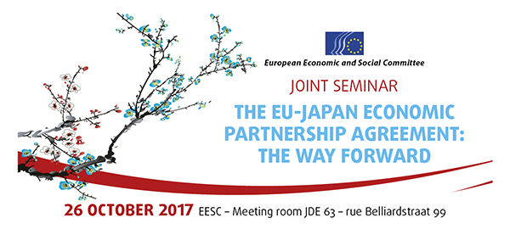

EN
DRAFT PROGRAMME

8.45–9.00 | Registration and welcoming of participants
9.00–9.30 | Opening Session  Chair: Ms Benedicte Federspiel, President of the International Trade Follow-up Committee, EESC  - H.E. Ambassador Kazuo Kodama, Ambassador of Japan to the European Union  - Mr Mauro Raffaele Petriccione, Deputy Director-General, DG TRADE, European Commission
9.30–10.30 | Session 1 --- The significance of the agreement in principle and the way forward  Chair: Ms Dilyana Slavova, President of the External relations section, EESC  An FTA/EPA "agreement in principle" was reached in July 2017. Details of the agreement need still to be fleshed out, this may take another year. Since negotiations started in 2013, the global trading context has changed significantly and consequently, the rationale for reaching this agreement has changed, too. Which factors played a role in bringing this agreement in principle about? Is there a roadmap towards provisional implementation? And where do the provisions establishing a civil society monitoring mechanism sit in this overall context?  Speakers:  - Ms Luisa Santos, Director for International Relations, BusinessEurope  - Mr Daniele Basso, Advisor, European Trade Union Confederation (ETUC)  - Ms Cécile Toubeau, Director Better Trade and Regulation, Transport & Environment  - Mr Hosuk-Lee-Makiyama, Director, European Centre for International Political Economy (ECIPE)  Discussion
10.30-10.45 | Coffee break

10.45–12.45 | Session 2 --- Opportunities and challenges
10.45–11.45 | Part 1  Taking a closer look at what is agreed  Chair: Mr Georgi Stoev, Member of the EU-Japan Follow-up Committee, EESC  Which chapters have been agreed and published and which have not? What results have been achieved looking at offensive and defensive interests for both sides? Where lie the benefits, and how will these translate into growth and jobs?  Speakers:  - Mr Arnaud Petit, Director Commodities and Trade, COPA-COGECA  - Mr Philippe Citroën, Director General, Union des Industries Ferroviaires Européennes (Unife)  - Mr Dirk Vantyghem, Director of Operations, of Eurochambres (tbc)  Discussion

11.45–12.45 | Part 2  What is not included? What will be decided at a later stage?  Which areas included in the EU's negotiation mandate have not been included in the political agreement (yet), and which aspects are subject to further negotiation? What is the timeline and what is at stake? What is left to gain for the EU and for Japan?
Chair: Ms Tanja Buzek, Member of the International Trade Follow-up Committee , EESC

Speakers:
- Mr Antoine Larpin, Government Affairs Manager, Panasonic Europe Ltd.
- Mr Andrea Carta, Legal strategist, Greenpeace EU
- Ms Monique Goyens, Director General, The European Consumer Organisation (BEUC)
- Mr Pablo Sanchez, Advisor, European Public Services Union (EPSU) (tbc)

Discussion

12.45– 13.00 | Conclusions and closing remarks  By Mr Krzysztof Pater, President of the EU-Japan Follow-up Committee, EESC

Interpretation requested from / into: EN/FR/JA
@EESC_Trade @EESC_REX
_____________

