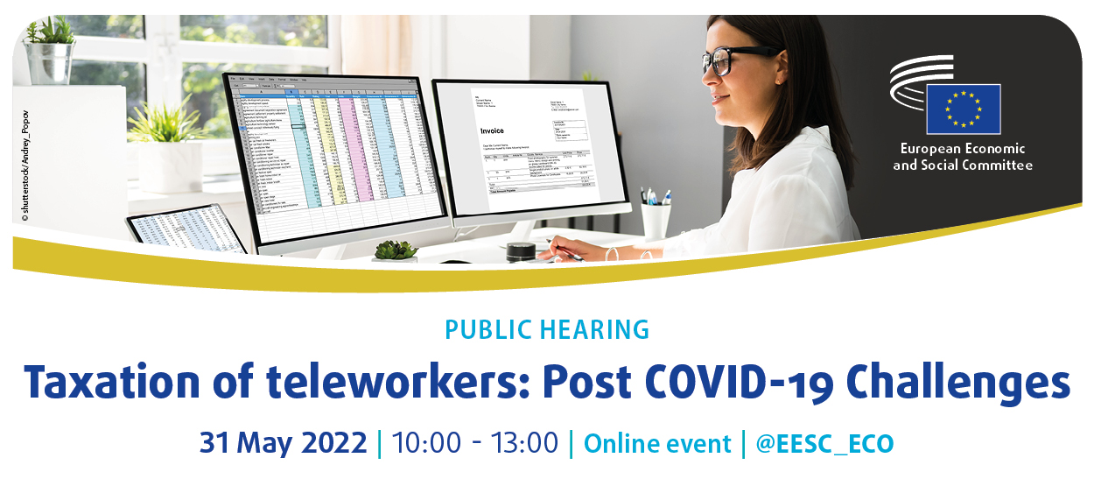
SPEAKERS

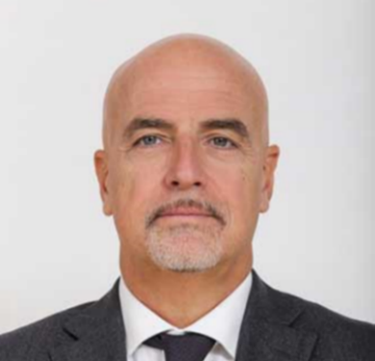
Stefano PALMIERI, President of the ECO Section, EESC

Stefano Palmieri has been president of the ECO Section of the EESC since April 2018. He has been a member of Group II (Workers' Group) of the EESC since 27 October 2009, and between 2013 and 2016 he served as President of the EESC Europe 2020 Steering Committee. He has held several positions at the Confederazione Generale Italiana del Lavoro (CGIL) including member of the International and European Department since 2016 and head of the Europe office in Brussels between 2009 and 2010. He has also held several research positions including Coordinator for "Local development and industrial policy" at the Instituto di Ricerche Economiche e Sociali (IRES) and member of the Trade Union Advisory Committee to the OECD (TUAC).

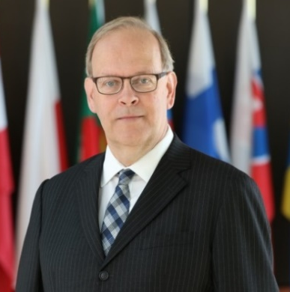
Krister ANDERSSON, Rapporteur for the EESC own-initiative opinion on "Taxation of cross-border teleworkers and their employers"

Krister Andersson has been a member of the EESC since 2015 and is Vice President of Group I (Employers' Group). He is currently a member of the European Commission's Platform for Tax Good Governance. He is a Senior advisor to the International Chamber of Commerce (ICC) Sweden and a professor in Economics at Lund University. Mr Andersson has been an economist at the IMF and he has been Chief Economist of the Swedish Central Bank. Between 2013 to 2019 he served on the Permanent Scientific Committee of the International Fiscal Association (IFA).

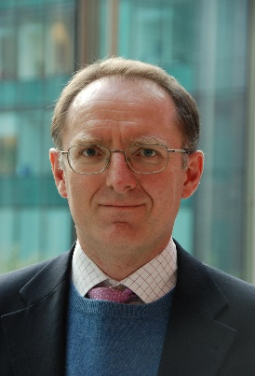
Albert RAEDLER, Policy Officers', DG TAXUD
After his studies in Business and Economics in Germany and a master in French taxation in Paris, Albert Raedler started his career in tax consulting in international tax matters. Albert Raedler joined the Commission in 2003 in the field of direct tax policy, and after assignments to the infringement units for state aid and direct taxes rejoined the direct tax policy field in 2020. He deals mainly with cross-border direct tax issues for citizens.

Henrik PAULANDER, Policy Officers', DG TAXUD
After studies in law in Stockholm and Strasbourg followed by a DESS in European Union law in Paris, Henrik Paulander has worked in the Swedish administration – Ministry of Finance and the Riksdag – and in EU institutions – Court of Justice and Commission. He joined DG TAXUD in 2006 and has worked as head of the Sector responsible for cross-border direct tax issues for citizens since 2020.

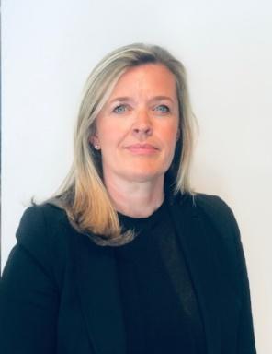
An DE REYMAEKER, International Tax Lawyer Vandendijk & Partners
She obtained her law degree at the University of Namur and the Catholic University of Leuven (KUL) (1992). She also was an ERASMUS student at the University of Poitiers (France) and obtained a special degree in Tax Law (“License spéciale en droit fiscal”) at the University of Brussels (ULB) in 1993.She started her career in 1993 as a Tax Consultant with Arthur Andersen and in 1997 she became a Tax Lawyer with Loyens and a member of the Brussels Bar. Since 2001 she is a Tax Lawyer and Partner of the Law Firm Vandendijk & Partners in Brussels. Her particular expertise relates to International Tax Law in the area of Personal Tax (for residents and non-residents). She is specialized in advising employees/directors and their companies with regard to the tax aspects of international employment, and more in particular with the application of salary splits, the expatriate tax status, employee benefits (stock options and share schemes), international pension plans and termination packages. She also assists with short and long term assignments to and from Belgium (application of double tax treaties and social security regulations). And she also defends her clients in the framework of administrative and legal tax procedures on personal tax related issues. She is since 2017 elected Vice Chair of the Tax & Legal Committee and Chair of the Employee Tax Subcommittee of AMCHAM (American Chamber of Commerce) in Belgium. She worked on different position papers : “Proposal for a new Inpatriate Tax Status in Belgium”; “New social security position on benefits from Long Term Incentive Plans granted by foreign entities to employees in Belgium”, “Increasing Belgium’s competitiveness by introducing a cap on social security contributions for employers”; ”Safeguard of Belgium’s primary R&D tax incentive and its attractiveness for investors”; “International tax implications related to “cross border workers” in the wake of the covid-19 pandemic”. And she obtained recently (March 2022) the AmChampion Award for “Most engaged small company” from AmCham Belgium. She is also since years a member of IFA (International Fiscal Association), and was a speaker recently with regard to the “Reform of the expat tax regime in Belgium”, (which is applicable since 1/1/2022). She speaks fluently Dutch, French and English.
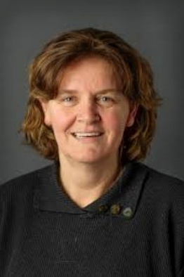
Prof Marjon WEEREPAS, Professor, University of Maastricht
Marjon Weerepas is working at the Maastricht University. She obtained her Phd on Principles of income tax and the practice of legislation. Since 1996 she is focusing her research on cross border employment. In that light she was posted to the Ministry of Finance, International Tax Affairs in The Hague for a while. Her current position is professor of Tax aspects of cross border employment. Her research is about elements of cross border employment, such as frontier workers and tax incentives for highly skilled employees. She is not only focusing on taxation but also on social security contributions and the (dis)coordination between these fields. In her publication she argues that with regard to solving problems of cross-border employment, both jurisdictions should be taken into account.

Dr Gabriele RAUTENSTRAUCH, Partner German Certified Tax Advisor Co-Head Global Service Line International Corporate Tax, WTS Group AG
Dr. Gabriele Rautenstrauch is an International Tax Partner at WTS in Germany and a German Certified Tax Advisor. She joined WTS Group AG in Munich on September 1st, 2018 in the International Corporate Tax department. Since July 2019 Gabriele acts as Co-Head of the Global Service Line International Corporate Tax. Previously, she worked more than 15 years with KPMG WPG AG, most recently as Director of International Corporate Tax in Munich. During this time, Gabriele was seconded for two years to DG TAXUD, European Commission, Brussels, working on the CCCTB Directive. Gabriele advises in particular globally active German multinational groups as well as US inbound groups and carries out projects on permanent establishment issues, in the area of withholding tax, CFC taxation, EU tax law as well as international restructurings, in particular carve-out of sub-groups and cross-border mergers, of international groups. Furthermore, she is leading the WTS center of excellence on the global minimum taxation (Pillar Two) at WTS in Germany and at WTS Global level. In addition, Gabriele is responsible for numerous client Pillar Two projects as well as in the area of DAC 6. Besides, she is a regular lecturer at the Bundesfinanzakademie (tax academy of the German Federal Ministry of Finance). Gabriele is heading WIN (Women of IFA Network) Germany and publishes regularly in international tax law journals.
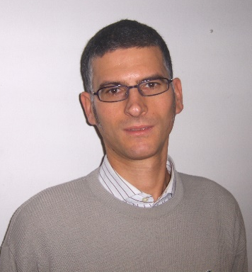
Michele BERTI, EURES expert, UIL
Michele Berti, 52 years old, is the UIL of Friuli Venezia Giulia (Friuli Venezia Giulia regional branch of the Italian Trade Union Confederation UIL https://uil.it) International Department’s Head. EURES Adviser since 2005, in this role he daily assists workers that move within all European Union and EFTA countries, and in particular frontier workers active among Italy, Slovenia and Croatia, in fields that very often represent concrete obstacles to their mobility, as social security and social advantages, direct taxation and tax advantages, labour legislation. He also is the President of the Upperadriatic Italo-Croatian CGIL, CISL, UIL, SSSH Interregional Trade Union Council – IRT.UC. (the Association established in 1995 between the trade unions of Friuli Venezia Giulia and of the regions and the neighbouring counties of Italy and Croatia, in charge of the activities and initiatives related to cross-border cooperation and the protection of frontier workers https://upperadriatic.irtuc.org) and, on behalf of UIL, member of the Pan-European Regional Council – PERC (https://perc.ituc-csi.org). Within 2011 and 2015 he has been President of the IR.T.U.Cs. Coordinating Committee of the ETUC and, in this role, for the same period, he has been member of the ETUC Executive Committee. At last, between 2014 and 2015, he has been part of the Group of experts on removing tax problems facing individuals who are active across borders within the EU, set up by the European Commission whit the task to write a report entitled “Ways to tackle cross-border tax obstacles facing individuals within the EU” (2015).

