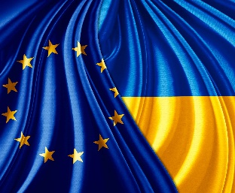

EU - Ukraine Domestic Advisory Group

6 May 2020
14:30

Virtual Meeting

DRAFT AGENDA

Adoption of the draft agenda

Implementation of the TSD provisions of the EU-Ukraine DCFTA – intervention by Mr Niall Lawlor, DG Trade, European Commission

Exchange of views on TSD – related provisions with
- Frederique Rychener, DG EMPL
- Niels Boelling, DG ENVI

Discussion on the study in the framework of the PI project

Tour de table – priorities of the DAG Members as related TSD agenda

