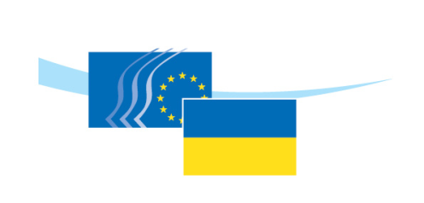

EU - Ukraine Domestic Advisory Group

27 June 2019
10:00-13:00

Brussels

Venue: European Economic and Social Committee (room JDE60)

DRAFT AGENDA

Adoption of the draft agenda

Adoption of the minutes of the last meeting held on 29 October 2018

Video-intervention by Mr Daniel Kramer, EU Delegation to Ukraine, tbc

- Presentation of the Priority areas for EU-Ukraine TSD implementation
- Discussion

Tour de table – priorities of DAG Members in the implementation of the TSD Chapter

Discussion on the action plan of the Ukrainian domestic advisory group

Regulatory alignment in the area of SPS and animal welfare

- Intervention by Mr Jan Bloemendal, DG SANTE, European Commission
- Discussion

