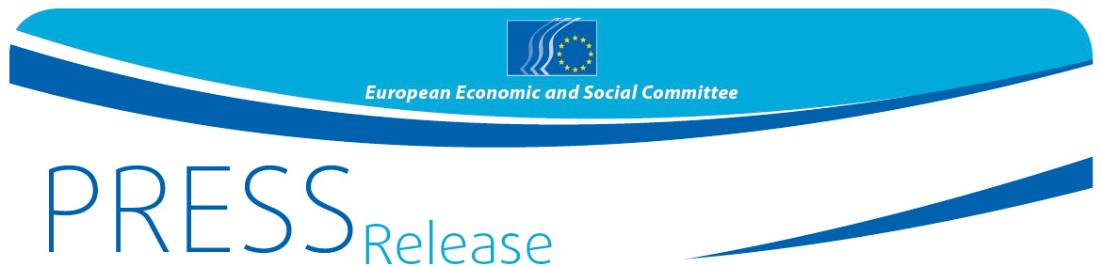
Nº/2018 | 16 May 2018
EN

Integration of the Western Balkan countries should remain a top EU priority, insist European and regional civil society organisations

More than 100 civil society representatives adopted their contribution to the EU-Western Balkans Heads of State Summit in Sofia

The participants at the high level conference, which took place on 15 May, were convinced that the enlargement of the EU, and in particular the spread of its democratic values and legal standards to the Western Balkan region, was in the interest of both the Western Balkan countries and the EU. Promoting EU values in the region guarantees security and stability, enhances social and economic development, as well as democracy and the rule of law in these countries which in turn means stability and security for the EU.

"The future of the region is a European future", Luca Jahier, President of the European Economic and Social Committee, underlined in his statement before the conference. "I am convinced that there is no other alternative for both the EU and the Western Balkan countries than to make steady, transformative and sustainable steps towards full membership."

"I truly believe that it is in the interest not just of the countries and citizens of the Western Balkans, but also of all of us in the EU, to integrate this region into our common Union as soon as possible", said Dilyana Slavova, President of the External Relations Section at the European Economic and Social Committee at the opening of the conference. “Organised civil society from the region and from the EU should and must have a prominent role in promoting this process, as an important controlling mechanism that guarantees the quality of its end result".

The Bulgarian Deputy Prime Minister for Judicial Reform and Minister of Foreign Affairs Ekaterina Zaharieva also underlined the need to involve civil society: "The social partners have an important role in the socio-economic development and cohesion in the Western Balkans." She expressed hopes to see two of the Western Balkans countries become EU members by 2025.

The economies of the Western Balkan countries continue to grow but, despite that, the countries of the region remain among the poorest in Europe. It is estimated that full convergence with EU living standards could take as long as 40 years. The participants recommended that social, economic and territorial cohesion be assessed when evaluating the fulfilment of EU membership criteria. The discussions emphasised the paramount role of education and of a free and independent media for overcoming the legacy of the past and for enhancing democratic values. The representatives of civil society organisations paid particular attention to the rights and empowerment of vulnerable groups in the region. They urged the national governments to do more to tackle challenges that women are facing such as domestic violence, limited labour market opportunities, harassment and violence in the workplace, salary and pension gaps between women and men, reproductive and maternity rights and unequal access to participation in high-level politics. The participants also stressed the need to pursue inclusive policies towards minorities in the Western Balkans.

The participants noted that the social partners and other civil society organisations, both at EU and national level, must be meaningfully involved in the entire process of integrating the Western Balkan countries into the EU. The conference called on the Heads of States at the EU summit in Sofia to set out their clear commitment to more consistent and direct support for civil society organisations at all levels and stressed the need to organise a joint event with representatives of civil society organisations from the Western Balkans and the EU ahead of each following summit.

Background: The Western Balkans Conference is a contribution from organised civil society to the EU-Western Balkans Heads of State Summit. It was jointly organised by the European Economic and Social Committee (EESC) and the Technical Assistance and Information Exchange Instrument of the European Commission (TAIEX), with the support of the Bulgarian Presidency of the Council of the EU and the Economic and Social Council of the Republic of Bulgaria. Representatives from employers' associations, trade unions and other civil society organisations from the EU and the Western Balkans, as well as representatives of EU institutions, Bulgarian officials and members of Bulgarian organised civil society gathered to discuss concrete recommendations from civil society to be put forward to the national authorities and the European institutions.

The final conclusions from the conference can be found here.

For more information, please contact:

EESC Press Unit – Siana Glouharova
+ 32 (0)2 546 92 76 – Mob: + 32 (0) 473 53 40 02
siana.glouharova@eesc.europa.eu
@EESC_PRESS
VIDEO: How has the EESC made a difference?

The European Economic and Social Committee is an institutional consultative body established by the 1957 Treaty of Rome. The Committee has 350 members from across Europe, who are appointed by the Council of the European Union. It represents the various economic and social components of organised civil society. Its consultative role enables its members, and hence the organisations they represent, to participate in the EU decision-making process.

If you no longer wish to receive these messages, please send an e-mail to: press@eesc.europa.eu

