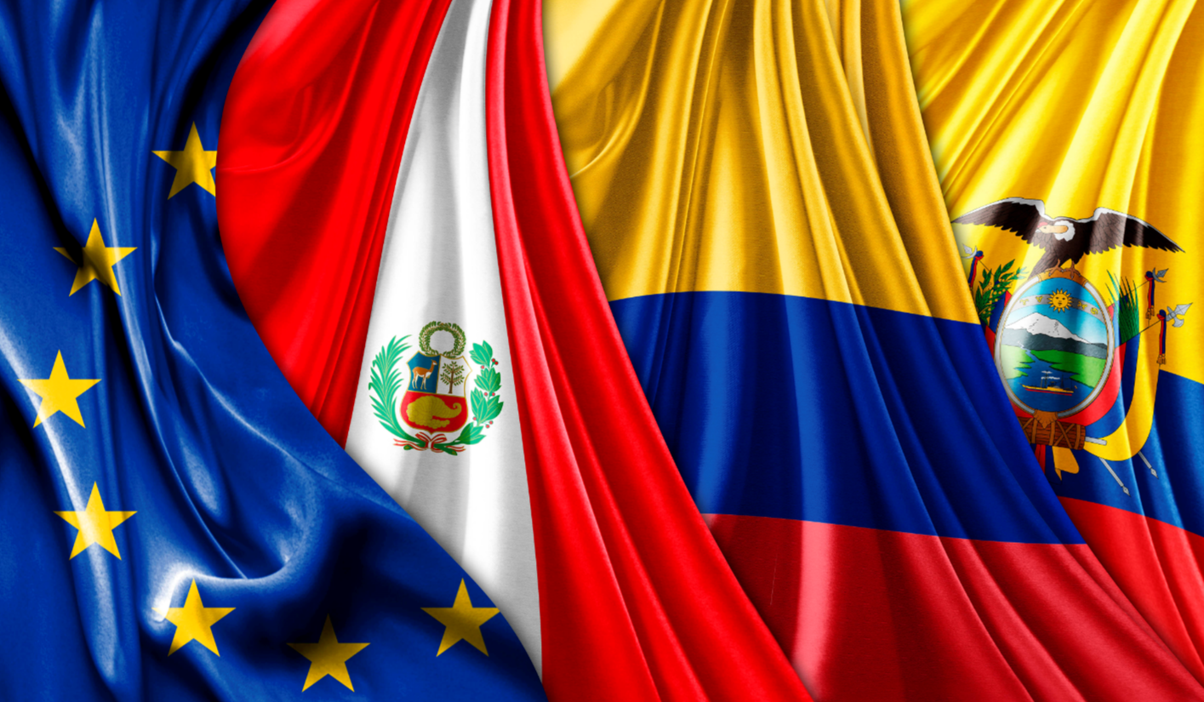

EU DAG composition / Composición del GA Europeo

Employers / Empresarios
 | BusinessEurope | Benedikt Wiedenhofer
 | EUCOFEL (Fruit Veg Europe) | Alba Ridao-Bouloumié
 | Eurochambres | Dominic Boucsein
 | Fair Trade Advocacy Office | Sergi Corbalán
 | FEDIOL | Denny Cobianchi
 | SMEunited | Rosa Solanes
 | European Economic and Social Committee | Paulo Barros Vale
Workers / Trabajadores
 | ACV-CSC | Renaat Hanssens
 | CGT (France) | Marie-Christine Naillod
 | CISL (Italy) | Giuseppe Iuliano
 | CNV (NL) | Maurica van Beers
 | UGT (Spain) | Ramiro Vega
 | European Economic and Social Committee | Dumitru Fornea
NGOs / other / ONGs y otros
 | Both ends | Fernando Hernandez Espino
 | Eurogroup for Animals | Stephanie Ghislain
 | Fairwatch | Alberto Zoratti
 | Friedrich-Ebert-Stiftung | Susanne Stollreiter
 | OIDHACO | Hendrine Rotthier
 | Plataforma Europa Peru | Géraldine Duquenne
 | Solidaridad | Joel Brounen
 | European Economic and Social Committee | Topolánszky Ákos

