Introduction
EN

The European Economic and Social Committee (EESC) was set up as a consultative body of the European Union in 1957 by the Treaty of Rome.

The EESC is an advisory assembly composed of 329 members from Europe's socio-economic sphere nominated by national governments and appointed in a personal capacity by the Council of the European Union. The EESC is a formal channel for its members to present the views of organised civil society on EU policies. Its opinions, prepared by the legislative sections and the Consultative Commission on Industrial change (known by its French acronym of CCMI, Commission Consultative des Mutations Industrielles), are addressed to the Council, the European Commission and the European Parliament. It thus has a key role to play in the Union's decision-making process.

History and Scope of the CCMI

The CCMI is the oldest EU body devoted solely to forecasting the future of industry. It succeeded the consultative committee of the ECSC (European Coal and Steel Community) when this expired on 23 July 2002, being established as a distinct body within the European Economic and Social Committee.

While CCMI's core business is rooted in its historic mission, namely the analysis of industrial change in traditional sectors, it also deals with all the phenomena at work today to shape tomorrow's industrial sectors. Therefore, the CCMI's remit does not only cover the traditional coal and steel sectors, but has been extended to embrace all sectors of industry in both manufacturing and services.

The CCMI promotes coordination and consistency of EU action on the main changes in industry within the enlarged European Union and ensures the right balance between the need to make changes that are socially acceptable and maintaining a competitive edge for European industry.

The CCMI focuses on how to predict changes in the economic and social environment and find ways of keeping pace with these and tackling them in a way consistent with the values of economic, social and environmental sustainability that underpin the European social model and dialogue.

More recently, the CCMI is addressing the huge challenge posed by the global pandemic and impact on the industry. It thus participates in the overall effort to shape EU policy to enable a strong economic, social and environmental recovery that guarantees the future of European industry and services, ensuring sustainability and resilience.

The CCMI is committed to ensuring that the industrial dimension is properly reflected in all the initiatives taken by the relevant directorates-general of the European Commission and at the European Parliament and the Council. In particular, it scrutinises the interplay between all the policies, which have not always been ideally coordinated.

The CCMI in practice

Thanks to its origins, which go back to the ECSC, the CCMI shares some of the features of the EESC's sections but also differs in some respects. Like the sections, the CCMI prepares opinions and reports which are adopted by the EESC Plenary assembly.

However, the composition of the CCMI differs from that of the EESC's legislative sections, which are composed solely of EESC members. The CCMI is thus made up of 51 EESC members and the same number of external delegates. The latter are appointed by the EESC from associations representing civil society at European level. Delegates fall into one of three categories (employers, employees and various interests), mirroring the structure of the three groups in the EESC. The CCMI benefits from this unique composition within the EESC by gaining – through the delegates – a direct source of information about forecasts coming from Europe's sectoral players themselves.

The CCMI president is an EESC member and the co-president a delegate.

The CCMI publishes its views in the same way as the EESC sections, namely in mandatory opinions under the Treaty, optional and exploratory opinions at the request of the European Parliament, the Council or the Commission, own-initiative opinions, and information reports.

Two CCMI characteristics also deserve to be highlighted:

- The extended use of own-initiative opinions in comparison to EESC sections allows the CCMI to put forward proposals on industrial sectoral issues which often have not yet been considered by the European Commission. This is a key part of its function in anticipating and managing industrial change;
- The CCMI can also adopt supplementary opinions to address opinions prepared by EESC sections from a sectoral perspective. Those opinions are annexed to the section's opinion.

Opinions and reports are drafted in a number of stages by a rapporteur (member) and a co-rapporteur (delegate) backed by a study group made up of members and delegates. Conferences and public hearings are often held to garner contributions from as broad a range of experts as possible.

As the CCMI addresses from a sectoral perspective changes common to all industries and services, such as the energy transition or digitalisation, its work takes into account the general policies addressed by the EESC sections. It is therefore only natural that the CCMI works in close cooperation with many of them, especially the Section for the Single Market, Production and Consumption (INT), the Section for Transport, Energy, Infrastructure and the Information Society (TEN) and the Section for Agriculture, Rural Development and the Environment (NAT).

Presidency and Bureau 2020-2023

CCMI president
Pietro Francesco De Lotto (Member, Group I – Employers, Italy)

Co-president
Monika Sitárová (Delegate, Category 2 – Employees, Slovakia)

Bureau members
Michal Pintér (Delegate, Category 1 – Employers, Slovakia)
Jacques Glorieux (Delegate, Category 3 - Various Interests, Belgium)
Norbert Kluge (Member, Group II – Employees, Germany)
Giuseppe Guerini (Member, Group III - Various Interests, Italy)

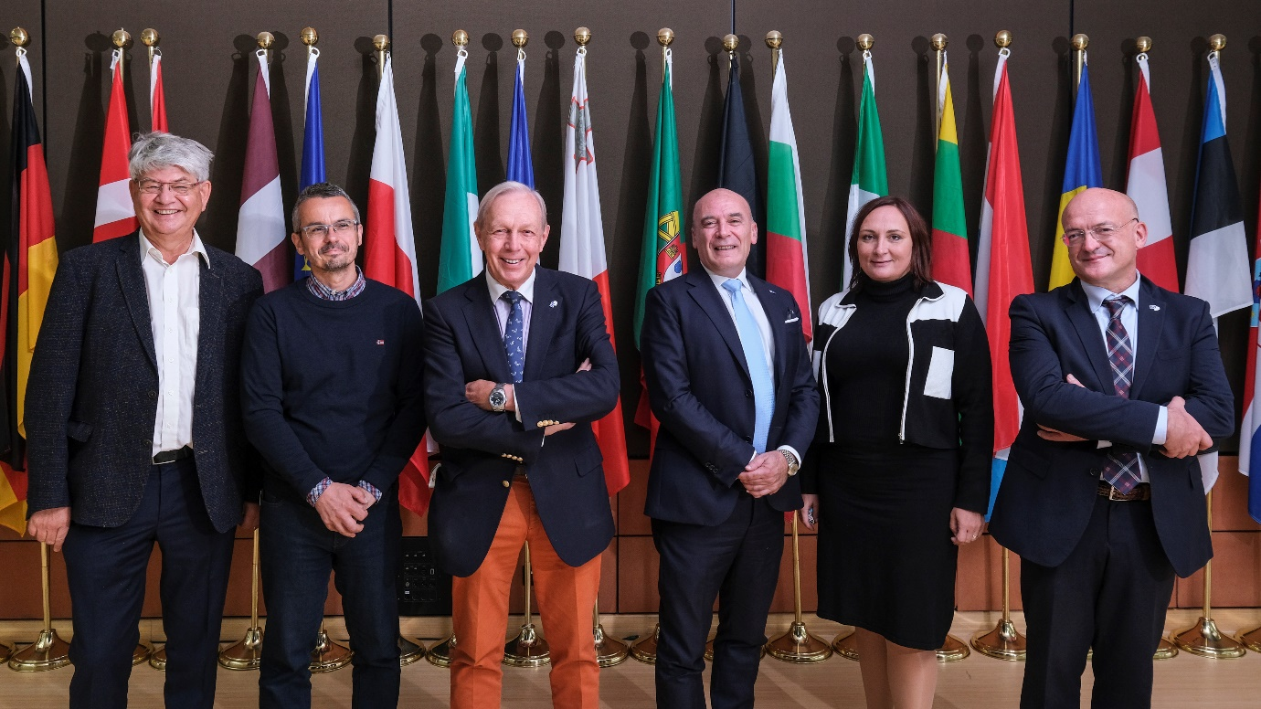

From left to right: N. Kluge, M. Pintér, J. Glorieux, P.F. De Lotto (president), M. Sitárová (co-president), G. Guerini.

CCMI Work Programme 2020-2023 main orientations

During this mandate, the EU is facing the huge challenge of the global pandemic and of the consequences this has had, is having and will have on the economy and industry. While the core business of the CCMI must continue to be anchored in its historical mission, namely the analysis of industrial change, it needs to focus on and tackle all the phenomena that are today accelerating and shaping these changes in the industrial paradigm.

As a result, the impact of the COVID-19 crisis on European industry and services sectors must clearly be a major focus of the CCMI. The pandemic has caused a European and global health, social and economic crisis. While it was unexpected and exposed a certain lack of preparedness in many respects, dealing with its consequences and finding viable solutions fall firmly within the CCMI's core business of anticipating and managing change. The CCMI therefore has an important role to play in the comprehensive effort to shape EU policy so as to foster a strong economic, social and environmental recovery which secures the future of Europe's industry and services, ensuring sustainability and resilience.

The CCMI will play its part in closely following the implementation and evaluation of the effects of the EU recovery plan on the industrial and service sectors. In particular, the impact of this crisis is not the same on all sectors. Some have been harder hit than others and, while COVID-19 has had a disruptive impact on some, for others, it has offered new opportunities and visibility. In many, it is accelerating existing structural changes to meet the challenges of digitalisation, automation, decarbonisation, and so on. The CCMI can provide expertise and long-established knowledge to the EU institutions in assessing the effects and the needs that the pandemic has created in the different industrial sectors.

The CCMI will also continue to contribute to the European Commission's flagship initiatives regarding European industry, open strategic autonomy and its overall competitiveness. Despite measures taken by the EU and some Member States to support employment (short-term work, furlough, income compensation, etc.), mass redundancies have already taken place within some sectors. Some industrial value chains are threatened by hostile takeovers from non-European companies and many, otherwise viable, companies are facing a liquidity cliff and overdriven financial leverage fuelled by uncertainty regarding how the COVID-19 pandemic will progress. The CCMI will continue to draw on its sectoral expertise to contribute to the Updated New Industrial Strategy for Europe, as well as to all actions connected to, inter alia, the circular economy, decarbonisation, the digital and energy transformations and raw materials.

In addition, the CCMI is determined to continue its work of providing analysis, input and agenda-setting on issues linked to the key transitions EU industry is undergoing, namely the green transition and the digital transition. In particular, the CCMI will leverage on its expertise to explore the impacts of these processes on the different industrial sectors/ecosystems, as well as in the different regions of Europe and on people's lives.

The instruments to pursue these objectives are at hand. Thanks to its composition and mission, the CCMI can rely on a very broad in-house pool of expertise constituted by its members and delegates, while seeking to enhance cooperation with the other sections of the EESC to maximise its contribution. At the same time, the CCMI has always had a strong commitment to dialogue with external stakeholders, which is a key feature in the formulation of its recommendations and conclusions. Equally importantly, the CCMI will pursue actions that clearly define its specialisation in questions of industrial change and analysis of sectoral industrial policy, thereby enhancing its complementarity with other EESC sections. It must capitalise on its unique assets and emphasise the essential role and dignity of the work it undertakes in reaching out to specific sectors of industry.

The CCMI will continue to make full use of the whole range of instruments at its disposal in carrying out its work. First and foremost, it must continue to make full use of own-initiative opinions, which are a tool that has proven essential in pursuing its mission. Referrals from other institutions are also among the EESC's "core business". Supplementary opinions have also proven to be an essential tool to ensure coherence and cooperation with the various EESC sections. Lastly, these "statutory" instruments will be complemented by direct dialogues with civil society, including conferences, roundtables, debates and hearings.

While the analysis of the impact of the pandemic and of the Recovery and Resilience Plans will be transversal to all actions carried out, the work of the CCMI will be based around three key pillars that structure its activities:

- A green transition for European industry
- A comprehensive effort to digitalise Europe's productive sectors
- Enhancing the global competitiveness of EU industry.

CCMI website: http://www.eesc.europa.eu/?i=portal.en.ccmi

Email: ccmi2@eesc.europa.eu

https://twitter.com/ccmi_eesc

European Economic and Social Committee
Rue Belliard/Belliardstraat 99
1040 Bruxelles/Brussel
Belgium
Tel. +32 2 546 9432 | Fax +32 2 546 9938
Catalogue No.: CESE- - - EN
www.eesc.europa.eu

The CCMI Work Programme is updated each year, in order to adapt to EU policy developments. Its most recent version can be found on the CCMI webpage.

