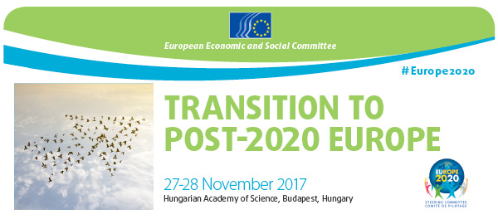

SPEAKERS

Welcome and introduction

Etele Baráth, President of the EU2020 Steering Committee (EESC)  Honorary professor at Corvinus University Budapest  Etele Baráth is President of the EU 2020 Steering Committee and represents Various Interests in the EESC. He was a member of the Hungarian parliament from 1996 to 2004 and Minister for European Affairs from 2004 to 2006. Mr Baráth co-authored and led the implementation of the first and second National Development Plan. He was also State secretary in three different governments between 1988 and 2004, responsible for public construction and infrastructure development. Mr Baráth has also been president of the National Association of Employers, vice-president of the Hungarian Economic Chamber and chairman of the Hungarian Canoe Federation from 1995 to 2016. | 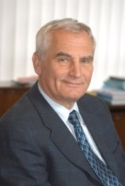
Katalin Langerne, Deputy State Secretary for Social Inclusion in the Ministry of Human Capacities  Katalin Langerne is a civil servant with experience in various Hungarian ministries. She was already Deputy State Secretary at the Ministry of Human Capacities from 2011 to 2013 and served as Director of the House of Hungarians in between. Ms Langerne served as departmental head in the Ministry of Public Administration and Justice, and Ministry of Education and Culture previously. | 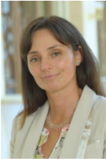
Eva Hegedüs, CEO of Granit Bank  Secretary General of the Hungarian Economic Association  Eva Hegedüs is the deputy Chairperson and CEO of Granit Bank in Hungary since 2010, and the Secretary General of the Hungarian Economic Association. She was the Chairperson of the BG Magyarország Ingatlanfinanszírozási, BG Magyarország Lízing and OTP Building Society previously. Ms Hegedüs also served as deputy state secretary in the Ministry of Economic Affairs (2000 – 2002) and the Ministry of Finance (1993 – 1997). | 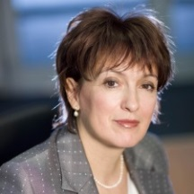
Luca Jahier, President of the Various Interest' Group (EESC)  International Relations of the Christian Association of Italian Workers  Luca Jahier is currently the President of the Various Interests' group in the EESC, where he has been a member since 2002. The most recent opinions which he has drafted as rapporteur include the European Pillar of Social Rights and the Social dimension of EMU. Mr Jahier was the President of the Italian Federation of Development Cooperation NGOs from 1994 to 2000 and was among the founders of the Italian Third Sector Forum. Mr Jahier also presided over the national council of the Association of Christian Workers of Italy from 2008 to 2012. | 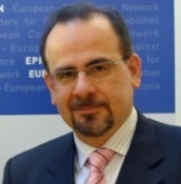
István Pál Székely, Director in the Directorate-General for Economic and Financial Affairs (European Commission)  Mr Székely is the Director for Economies of Member States in the Directorate-General for Economic and Financial Affairs (ECOFIN) and was previously in charge of economic studies and research. Mr Szekely holds a PhD in Economics from the University of Cambridge and is an honorary professor at the Corvinus University of Budapest. His research focuses on financial market and macroeconomic policy issues. | 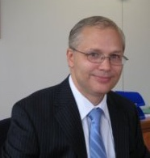
Philippe Lamberts, Co-Chair of Greens-EFA group (European Parliament)  Mr Lamberts trained as an engineer and followed a commercial career for 20 years, while being involved in politics with Ecolo, the Wallonian green party. He served Ecolo at the local and national level until being elected as a Member of the European Parliament in 2009. Mr Lamberts is co-chair of the Greens-European Free Alliance group since 2014 and focuses on fiscal policy, economic governance and industry, research and innovation policy. | 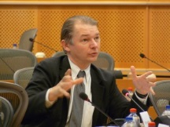

Balázs Molnár, Deputy State Secretary for European Affairs in the Prime Minister's Office  Mr Molnár has been Deputy State Secretary for EU affairs in the Prime Minister's Office since 2016. Previously he worked at the Permanent Representation of Hungary to the EU, where he covered social policy and youth. Mr Molnár also served as the Hungarian delegate to the horizontal working group of the Council of the European Union from 2004 to 2016. He also has considerable expertise in international drug prevention policy, having been the National Drug Prevention Coordinator from 2008 to 2012 and having served in related roles at the Ministry of Social Affairs previously. | 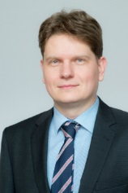
Gábor Iván, Director in the General Secretariat of the Council of the EU  Mr Iván is Director for General Policy in the General Secretariat of the Council of the European Union since 2016. He served the Hungarian Ministry of Foreign Affairs from 1991 onwards, including as Ambassador to Croatia, Permanent Representative to the EU and Secretary of State for EU Affairs from 2006 to 2009. | 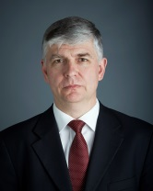
Debate with national Economic and Social Councils

Attila Szücs, Chairman of the Hungarian Economic and Social Council  Director of Eurotrade Kft.  Mr Szücs is Chairman of the Hungarian Economic and Social Council where he represents the Reformed Church in Hungary. Mr Szücs is not only a presbyter for his local congregation but also the Director of Eurotrade Kft., a commercial vehicle sales and maintenance company. | 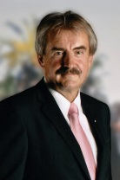
Paul Fourier, CGT representative in the French Economic, Social and Environmental Council  Mr Fourier is a representative of the General Confederation of Labour in the French economic, social and environmental Council, where he focuses on European and international affairs. Previously he was secretary general of the Transport federation in the CGT and board of the CGT executive. Mr Fourier is also an air steward at Air France. | 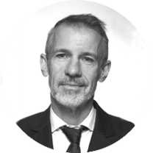
Panel 1 – Why do we need a successor to the EU2020 strategy?

Brenda King, President of the Sustainable Development Observatory (EESC)  Chief Executive, African & Caribbean Diversity  Ms King is Chief Executive of African & Caribbean Diversity and has represented the Employers' Group in the EESC since 2002. She was President of the African Caribbean and Pacific (ACP)–EU civil society forum from 2010 to 2013. Ms King is a member of the Third Sector Forum that advises the Government on Social Mobility and worked at Royal Mail for nearly 15 years in business process improvement and as a technical advisor to overseas administrations on postal sector reform. | 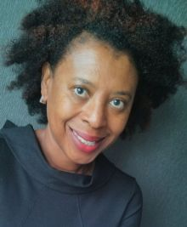
Enrico Giovannini, Professor of Economics at University of Rome 'Tor Vergata'  Prior to being the Minister of Labour and Social Policies from 2013 to 2014, he was the Chief Statistician of the Organisation for Economic Co-operation and Development (OECD) and President of the Italian Statistical Institute. As a renowned economist and statistician, Mr Giovannini has launched several initiatives on 'beyond GDP', including as a member of the Club of Rome and Stiglitz-Sen-Fitoussi Commission. | 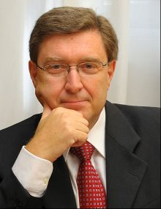
Péter Balázs, Professor of Economics at the Central European University  Mr Balász was the first European Commissioner from Hungary, responsible for Regional Policy in 2004. He has been a professor at the Central European University since, where he established a research center on EU enlargement. Mr Balász also served as Minister of Foreign Affairs from 2009 to 2010. | 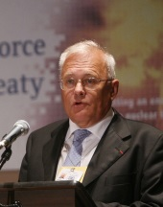
Tamás Halm, Editor-in-chief of the Economic Journal  Mr Halm is editor-in-chief of the monthly Economic Journal of the Hungarian Academy of Sciences. He teaches European integration and international finance at Budapest Business School as well as the National University of Public Service in Budapest. Mr Halm served as under-secretary of state in the National Development Office from 2003 to 2006 and as secretary-general of the Hungarian Economic and Social Council from 2006 to 2011. Between 1999 and 2014 he was secretary-general of the Hungarian Economic Association, where he is still a board member. | 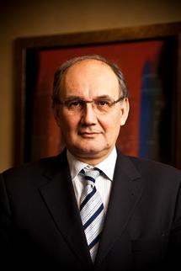
Csaba Kőrösi, Director in the Office of the President of Hungary  Mr Kőrösi is the Director for Environmental Sustainability in the Office of the President of Hungary. He was the Permanent Representative of Hungary to the UN from 2010 to 2014, prior to which he was head of the European Departments in the Ministry of Foreign Affairs. Mr Korosi joined the Ministry in 1983 and held posts in multilateral diplomacy, but has also served in the UAE, Israel and as Ambassador to Greece. | 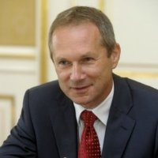
Juraj Sipko, Various Interests' Group member (EESC)  Director of the Institute of Economic Research, Slovak Academy of Sciences  Prof. Sipko is the Director of the Institute of Economic Research of the Slovak Academy of Sciences, professor at Tomas Bata University, and a member representing Various Interests in the EESC since 2015. Previously he worked as an advisor to the governors of the National Bank of Slovakia and the executive directors of both the International Monetary Fund and World Bank. Mr Sipko was also a director of international relations at the Slovak Ministry of Finance and a negotiator with the EU and OECD. | 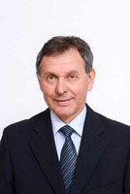
Gábor Bartus, Chairman of the Hungarian Council on Sustainable Development  Professor of Economics, Budapest University of Technology and Economics  Dr Bartus is an assistant professor of Environmental Economics at the Budapest University of Technology and Economics. He has 25 years of experience researching and teaching researching and teaching economic aspects of environmental and sustainability policies. Dr Bartus is also Secretary-General of the National Council for Sustainable Development (NFFT) and co-chair of the Working Group on Sustainable Development of the European Environmental and Sustainable Development Advisory Councils (EEAC). He is also a senior advisor to the Speaker of the National Assembly. | 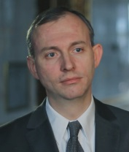
Panel 2 – What are the new trends in the society of transitions?

Pavel Trantina, President of the Social Affairs section (EESC)  EU Relations and Project Manager, Czech Council of Children and Youth  Mr Trantina is President of the Social Affairs Section of the EESC, where he has been a member since 2006. He also works as EU Relations and Project Manager for the Czech Council of Children and Youth. Previously he was a Director of EU Affairs in the Czech Ministry of Education and also works as a political analyst in the Office of the President of the Czech Republic. | 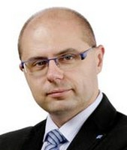

Seamus Boland, Various Interests' Group member (EESC)  Chief executive officer of Irish Rural Link  Mr Boland has been a member of the EESC since 2011, where he focuses on poverty reduction and wealth inequality. He is the director of Irish Rural Link, a rural development organisation, and Chairperson of Pobal, an organisation committed to community support and social inclusion policies. Mr Boland previously worked with young people, travellers and disabled people. | 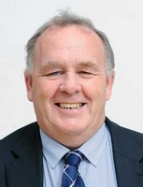
Anne Demelenne, Workers' Group member (EESC)  Ms Demelenne has been a member of EESC since 2014, where she has primarily focused on fair taxation and social inequalities. She was the general secretary and president of the Wallonian section of the Belgian Federation of Labour from 2006 to 2014 and has been active in trade unions in Luxembourg and Belgium since 1981. | 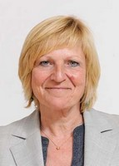
Bernadett Petri, Policy Assistant to Commissioner Navracsics (European Commission)  Ms Petri is a policy assistant in the Cabinet of Commissioner Navracsics, where her portfolio includes, inter alia, the coordination of the Erasmus Mobility Program, relations with the European Economic and Social Committee, Committee of the Regions, European Parliament and national parliaments. Previously Ms Petri worked for the EPP in the European Parliament regarding education and cultural policy. | 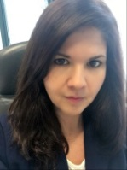
Stefano Palmieri, Workers' Group member (EESC)  European and international policy department, Italian General Confederation of Labour  Mr Palmieri is a former president of the EU2020 steering committee and has been a member of the EESC since 2009. He works with CGIL’s Department for economic and social cohesion policy. Mr Palmieri was previously Head of CGIL’s office in Brussels and Research Coordinator at the Institute for economic and social research (Istituto di Ricerche Economiche e Sociali – IRES) previously. He also worked for the Planning Studies Centre – Centro Studi Piani Economici and the Monitor lavoro srl. | 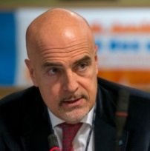
Kinga Joó, Various Interests' Group member (EESC)  Vice-President of the National Association of Large Families  Ms Joó has been a member of the EESC since 2010 and is currently preparing an opinion on work-life balance. She is the Vice-president of the National Association of Large families and a Board member of the National Cooperation Fund. | 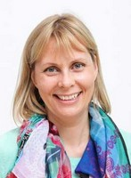
Stéphane Buffetaut, Employers' Group member (EESC)  President of ERIGERE & CILGERE  Mr Buffetaut has been a member of the EESC'Employers' Group since 2002 and is the Director for European public relations at Veolia. He is also the President of CILGERE, a social finance housing agency and ERIGERE, a real estate company specialising in social and middle-income housing. He was previously a member of the European parliament for the Movement pour la France, which he also served as Secretary General. | 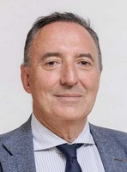

Panel 3 – What type of new governance do we need?

Péter Ákos Bod, Professor at the Corvinus University of Budapest  Mr Bod is a professor of economics with a long career in public service. He served as Minister of Industry and Trade in the first democratically elected cabinet and as Governor of the Hungarian National Bank from 1991 to 1994. Mr Bod also served as a member of the Board of the European Bank for Reconstruction and Development. His research focuses on economic policy making, public and business decisions and regime change. | 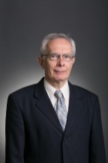
Carlos Trias Pinto, Various interests' representative (EESC)  Director of the Spanish General Consumer Association  Mr Trias Pinto represents Various Interests in the European Economic and Social Committee, where he was recently co-rapporteur on an Opinion about New sustainable economic models and is a member of the permanent study group on Economic and Fiscal Governance of the Euro Area. Mr Trias Pinto has been the director of the General Association of Consumers and Spanish Union of Consumers' Cooperatives since 2007. | 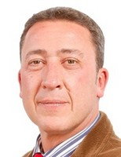
Gusztáv Báger, Member of the Monetary Council of the National Bank of Hungary  Mr Báger is a member of the Monetary Council of the National Bank of Hungary, Chairman of the Representatives of Sciences in the Hungarian Economic and Social Committee, and professor emeritus of the Pazmany Peter Catholic University. He was Director General of the Research Institute of the State Audit Office from 2003 to 2008 and worked for the National Planning Office previously. Mr Báger also served as a consultant to the Economic Commission for Europe of the United Nations. His research focuses on the public-private partnerships and the transparency of the public finances. | 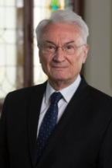
Tibor Faragó, Professor at St Istvan University  Dr Faragó is a mathematician and climate scientist with considerable experience in researching climate policy. From 1992 to 2010 he served the Ministry of the Environment in several roles, including as State Secretary for Environmental policy and as departmental head for International and EU cooperation. Dr Faragó has published extensively on multilateral climate policy and climate change. | 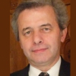
Conclusions: different scenarios for the future of Europe

Gábor Zupkó, Director of European Commission Representation in Hungary  Mr Zupkó is Head of Representation of the European Commission in Hungary since 2015. Before his appointment he served in different senior positions at the Commission in Brussels. Prior to that Mr Zupkó, obtained a Phd in Management from the Corvinus University Budapest, was Ambassador of Hungary to Finland and held various other government posts. | 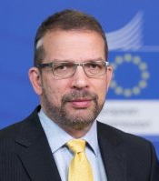
Gyula Pleschinger, Member of the Monetary Council of the National Bank of Hungary  Chairman of the Hungarian Economic Association  Mr Pleschinger has extensive experience in investment banking and public finance, having had a management role with OTP Securities and Raffeisen Bank. He was appointed as CEO of the Government Debt Management Agency in 2010, prior to becoming Secretary of State for Taxation and Fiscal Regulation in 2011. He is currently both a member of the Monetary Policy Council and Chairman of the Hungarian Economic Association. | 