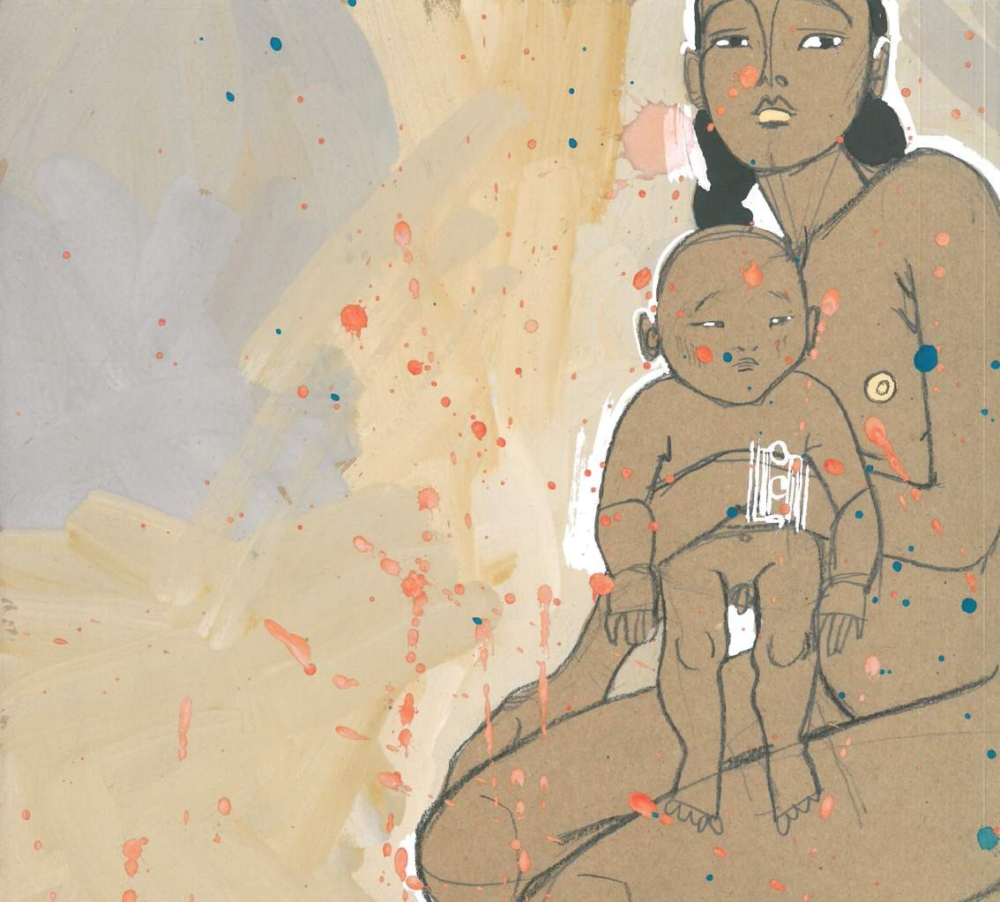

Assel KENZHETAYEVA

graphic artist, dress designer, illustrator
instagram handle @aselkenzhe_art
email azelyasha@mail.ru
country Kazakhstan

The illustration questions a traditional ethos that the sole role of women in reproduction. It hints at the importance of empowerment of women in all spheres of life, who, as the Kazakh proverb says “rule the world with the other hand”.
A woman rocks the cradle with one hand and rules the world with the other

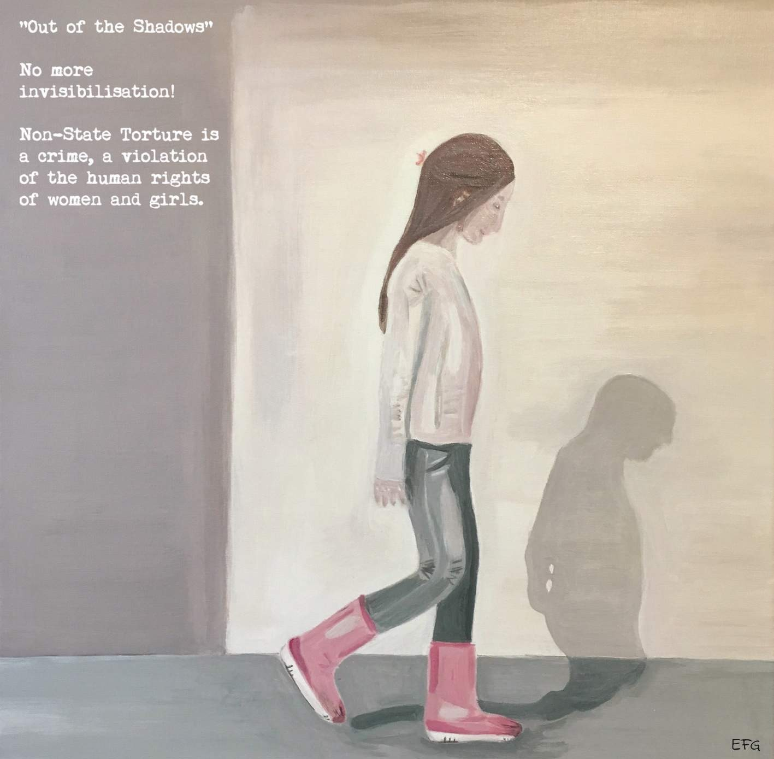

Elizabeth GORDON

instagram handle email
country
@artprintspace efgbass@gmail.com United Kingdom

Women and girls are tortured in their homes and other private spaces by parents, family, partners, traffickers, pornographers, buyers and johns. This is non-state torture. In the spirit of leaving no woman or girl behind, non-state torture must be specifically criminalised under law to ensure that states adopt appropriate legal protection thereby eliminating human rights discrimination against women and girls. I walk out of the shadows as a survivor of non-state torture to speak: No more “invisibilization”!
Out of the shadows ~ acrylic on canvas © 2018

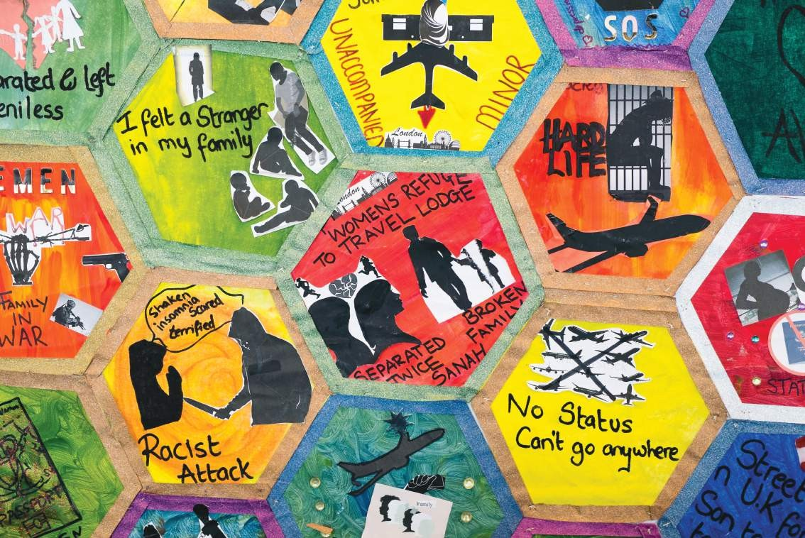

Salma ZULFIQAR

is an award-winning artist and peace activist

instagram handle email
website country
@salmazeecreative salmazulfiqar2001@yahoo.co.uk www.salmazulfiqar.com
United Kingdom

“I have created the Migration Blanket with women in the United Kingdom, showing their struggles, hopes and dreams about being included as part of society. From a racist attack to having no status and cultural clashes to opening her own department store and the free flow of Migration – the women and I expressed ourselves. These are themes that many migrant and refugee women all over the world can relate to. The Migration Blanket is comprised of some 60 patchwork panels, which were created individually by the women and me, each showing a unique life story. The artform is collage and drawing on canvas.”
Migration blanket

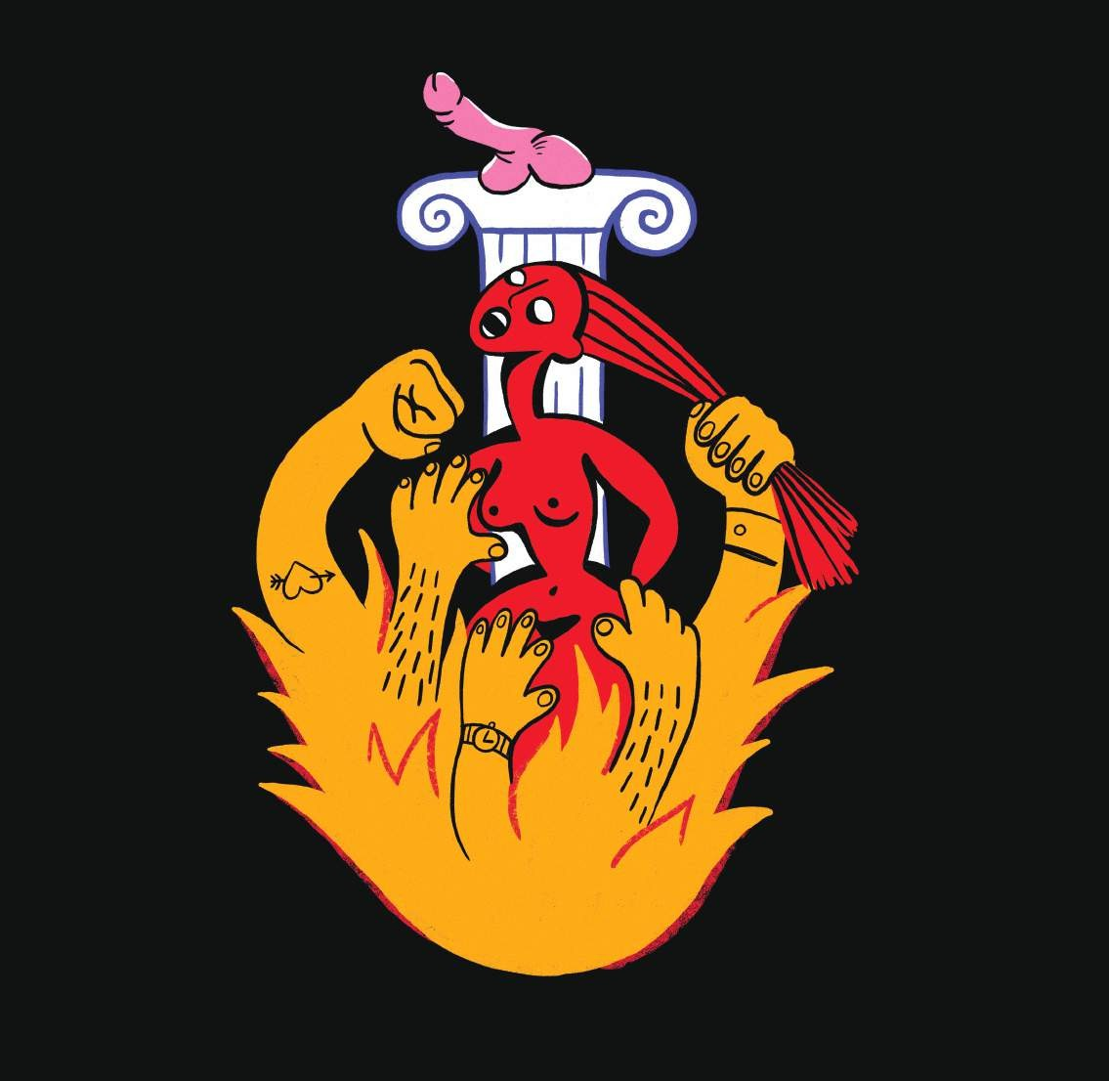

Ermina TAKENOVA

instagram handle email
country
@erminart erminatakenova@gmail.com United Kingdom

Misogyny is equivalent to burning witches, especially in patriarchal societies. It is absurd how people tend to judge a raped woman more than a rapist. Imagine going through a violent experience and then being told that somehow it was your fault. Sometimes the rapists and abusers are even pitied by society – because there is always the assumption that the woman somehow provoked the attack. Women’s lives and dignity are sacrificed for the sake of men’s privilege and comfort.
Victim blaming

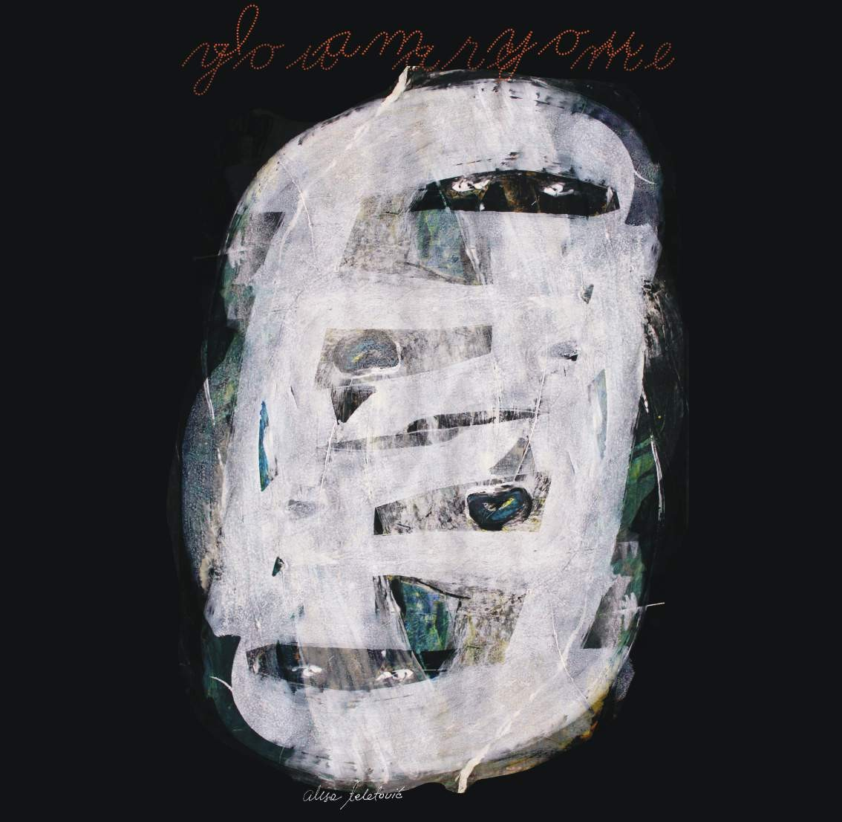

Alisa TELETOVIC

instagram handle email
country
@alisateletovicartist mail@alisateletovic.com Bosnia and Herzegovina

My art is intimate and personal. When we see inside ourselves, take off our masks, expectations, lack of love, then we can repair. I am you, you are me, inside we are the same and we are one – when we realize this, then there is hope.
I am you, you are me

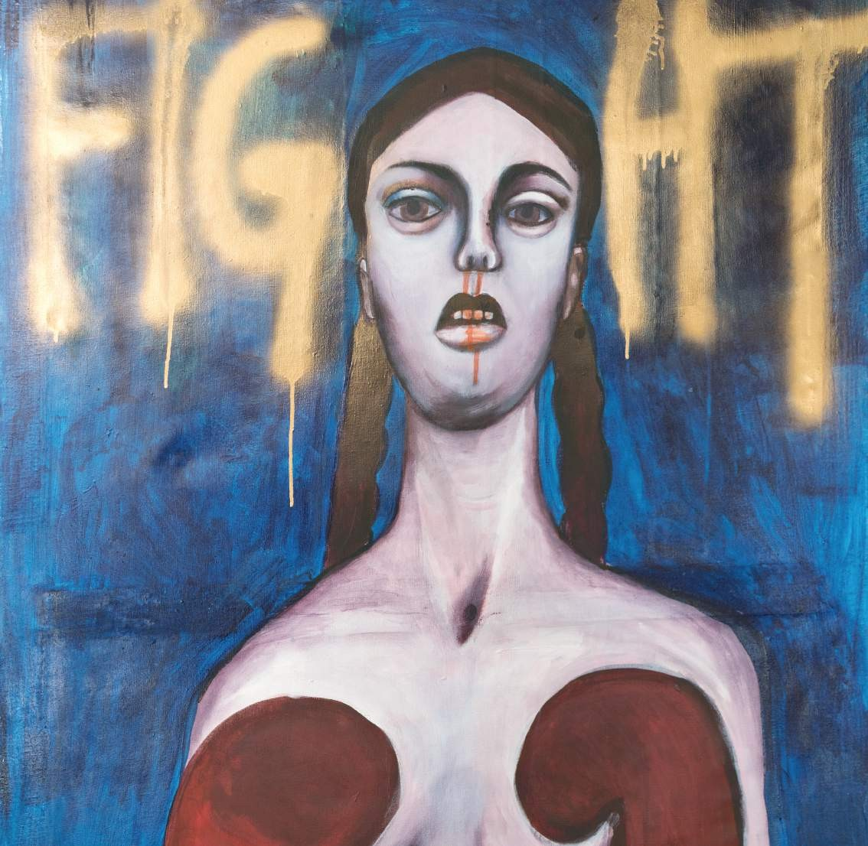

Ina RIEGLER

instagram handle email
website country
@rieglerina ina.riegler@gmx.at www.inariegler.com Austria

The painting explores the fact that too many women are still experiencing physical, psychological and structural violence every day. This piece is a self-portrait of the artist in boxing gear. Boxing is meant literally as well as symbolically for all kinds of fighting: “Never give up, fight for your rights!” Regarding the trauma-psychological terminology of “fight or flight”, the artist calls women to fight and not flee.
Fight

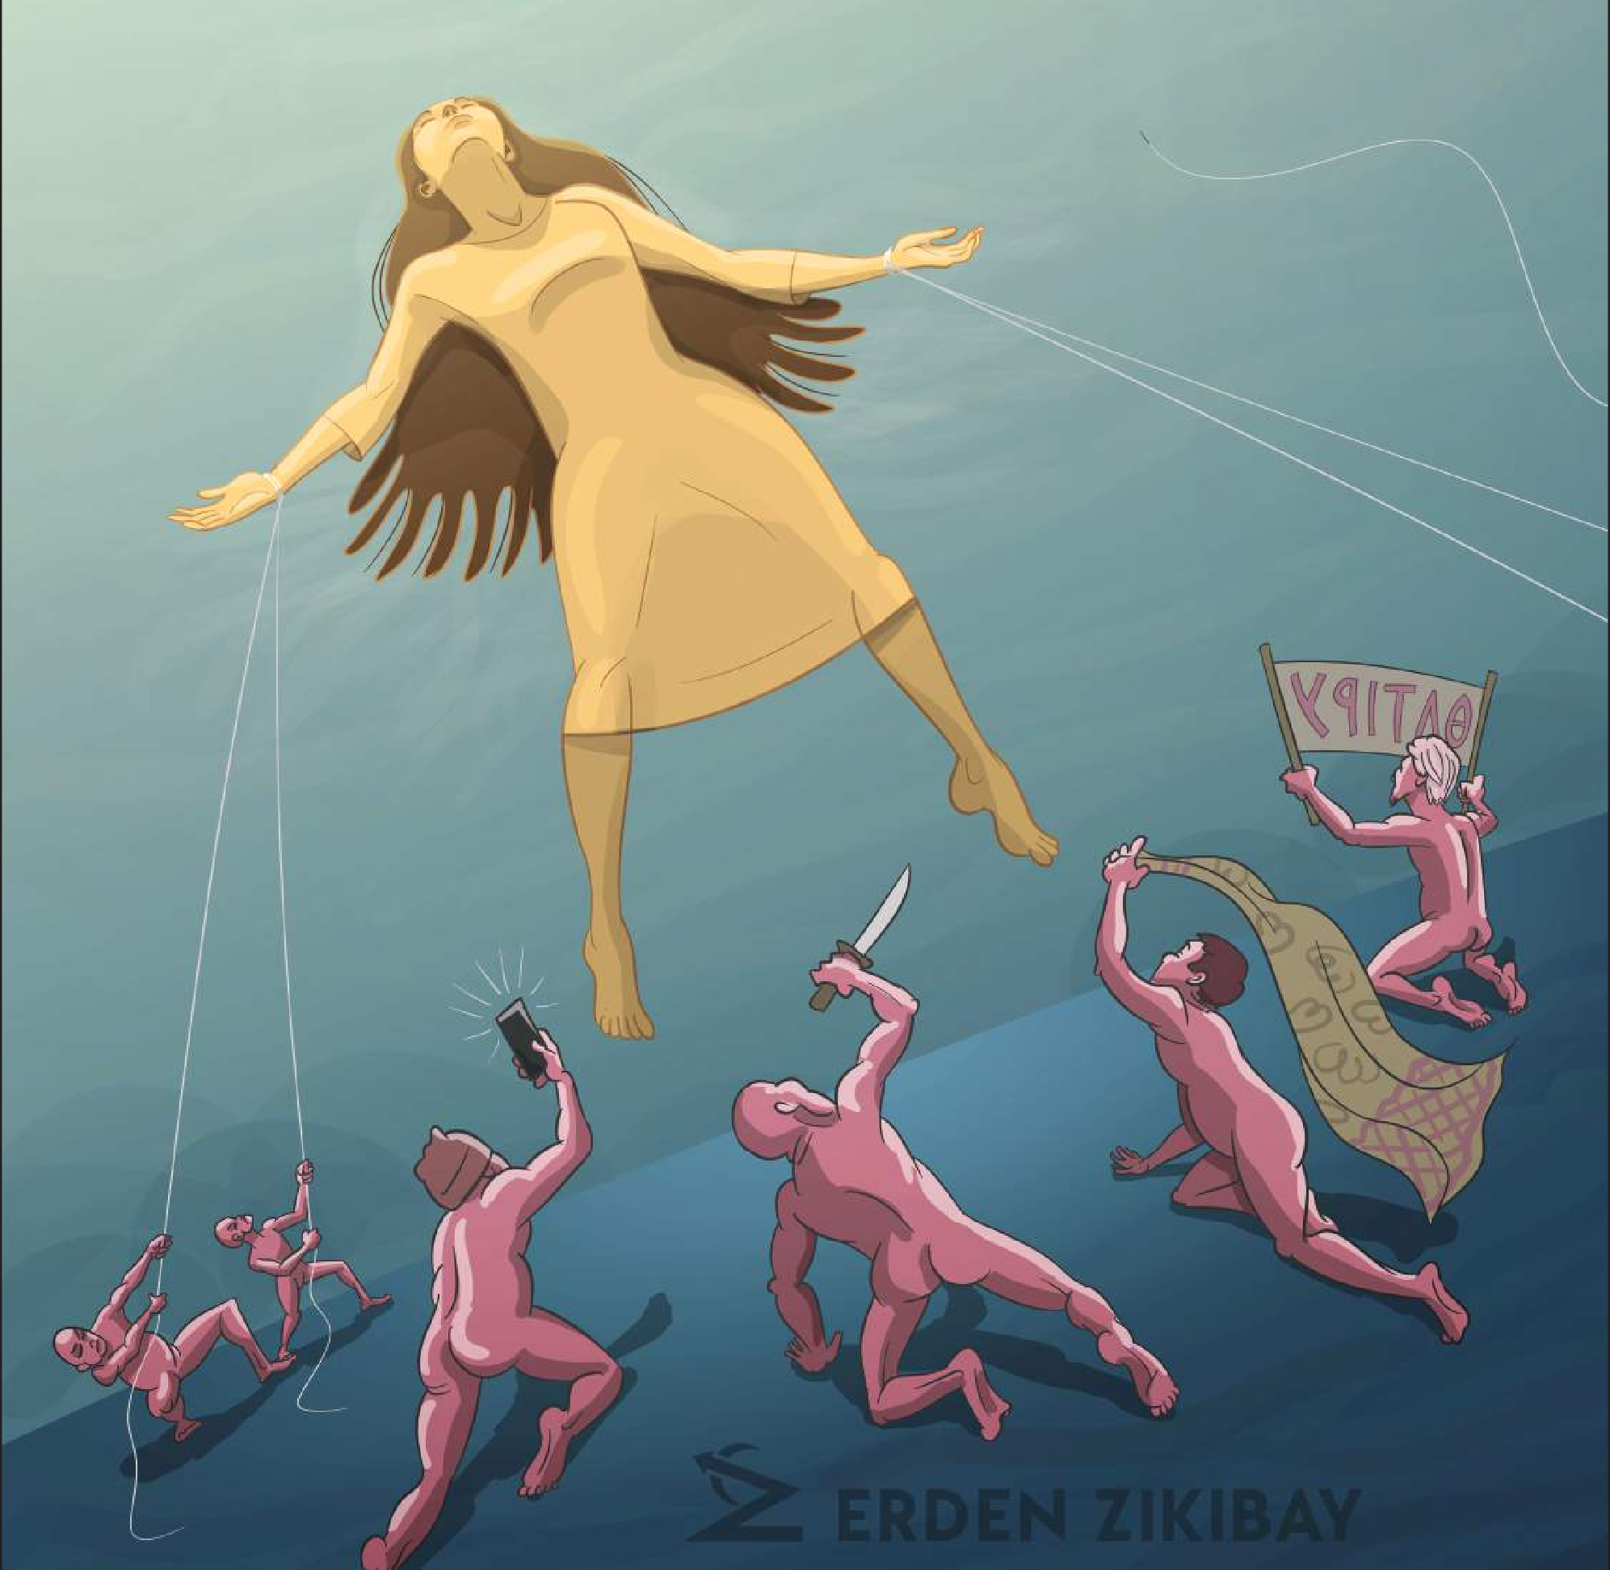

Erden ZIKIBAY

instagram handle email
website country
@zikibay zikibay.com zikibay@gmail.com Kazakhstan

More often than not, men in oppressive societies avoid challenging the systemic injustices that undermine their rights. Instead they tend to turn their frustration and anger on women who are seeking and fighting for emancipation.
Pseudo-Heroes

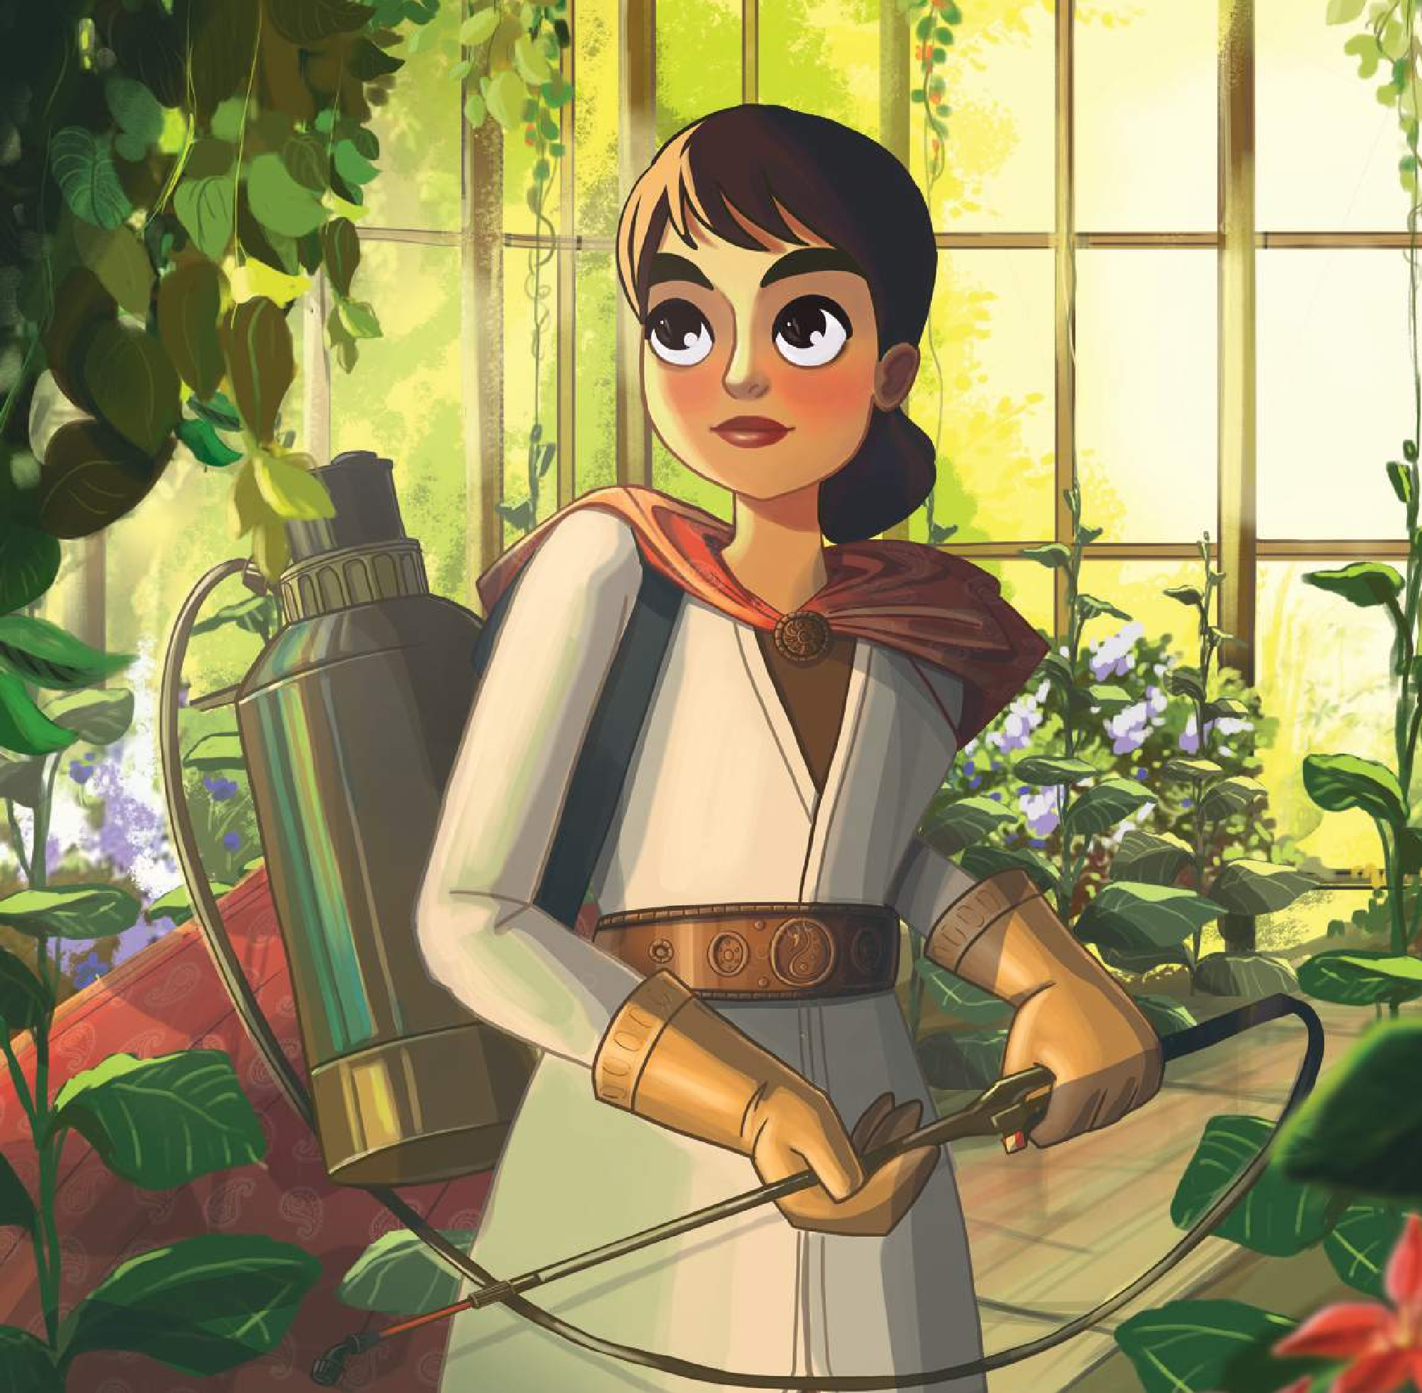

Lala GASIM

instagram handle email
country
@lalagasim Azerbaijan lalagasim@gmail.com

Empowering women is the world’s best bet to fight climate change. That’s why the Women Resource Centres in rural Azerbaijan help women to start businesses that safeguard the environment and promote sustainable agriculture. Meet Khalida, whose organic greenhouse farming protects the soil making it more resilient to floods, droughts and land degradation.
Mother nature

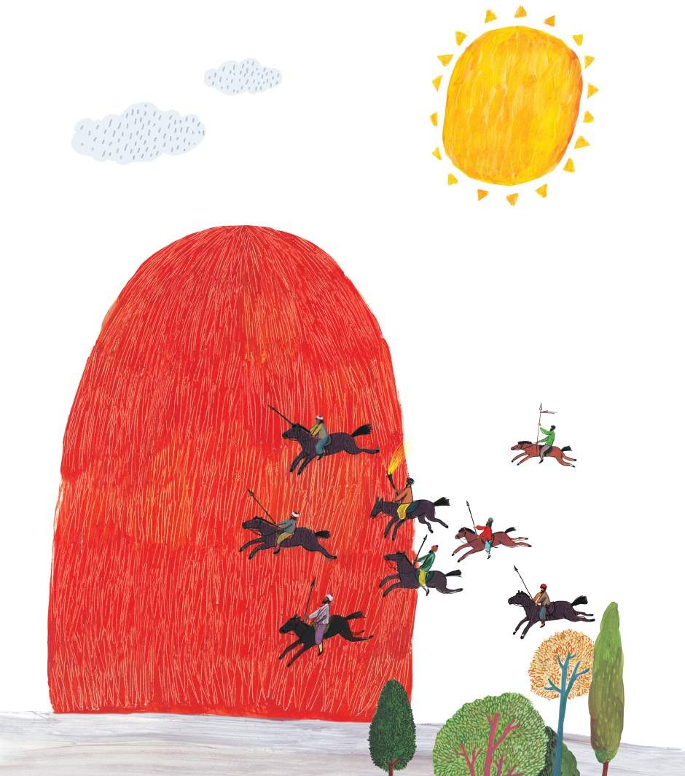

Natia KVARATSKHELIA

instagram handle email
country
@_natia.kvaratskhelia Natia.k@windfors.ge Georgia

Maia, the sun warrior
Maia Tskneteli is a popular Georgian national hero who lived in the second part of the 18th century. The story of this heroic woman, referred to as Mate the Bandit, has been passed down from generation to generation. According to a legend, Maia was still underage when she was raped by her master. Her parents couldn’t bear the grief and passed away soon after the incident. Maia killed the master, dressed in her father’s clothes, slung his gun across her shoulder, picked up a sword and a dagger and headed to King Heraclius’s court in Tbilisi. She introduced herself as Mate and asked for his protection. Since then, she served at King Heraclius’s court, fought, freed the children captured by Persians and protected the people. A story of Maia Tskneteli, by Teona Dolenjashvili
Changing the Narrative on Gender Stereotypes: A Collection of Tales from Europe and Central Asia
To mark the 25th anniversary of the Beijing Declaration and Platform for Action, UN Women Europe and the Central Asia Regional Office, with support from the Swiss Agency for Development and Cooperation, is producing a regional collection of tales. The tales are aimed at inspiring girls to succeed in non-traditional roles as portrayed by known and forgotten historical fictional female figures from across the region. The collection will showcase inspirational accomplishments by women and girls, and their positive contributions to their communities and society.

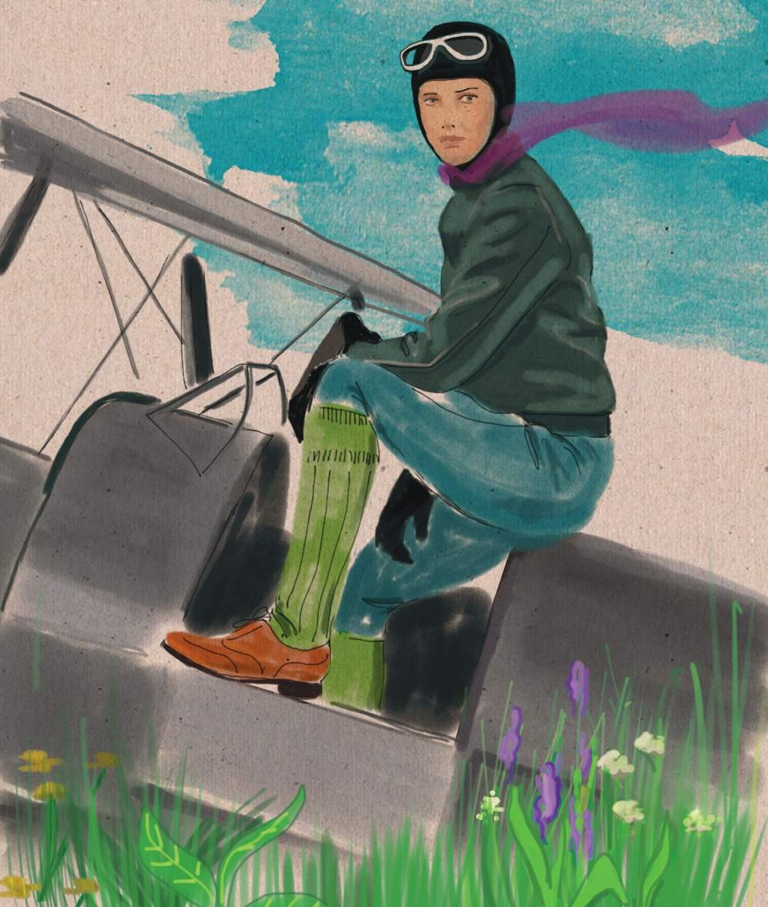

Maka JISHKARIANI

instagram handle email
country
@makajishkariani maka11@gmail.com Georgia

The first Georgian female pilot, Rusudan Zhordania, was born in Zugdidi in 1915. After finishing school, she was admitted to Tbilisi State Conservatory to learn piano. But, within a year, she realized that music wasn’t her calling. In 1935, Rusudan Zhordania enrolled in the Aviation School of Tbilisi. She dedicated her entire life to aviation. Rusudan Zhordania spent a grand total of 55,00 hours in the air. She knew how to fly 14 types of aeroplane. Rusudan Zhordania trained many pilots. After retiring, she worked as a teacher and wrote her memoirs.
Short and tall pots and flying into the sky

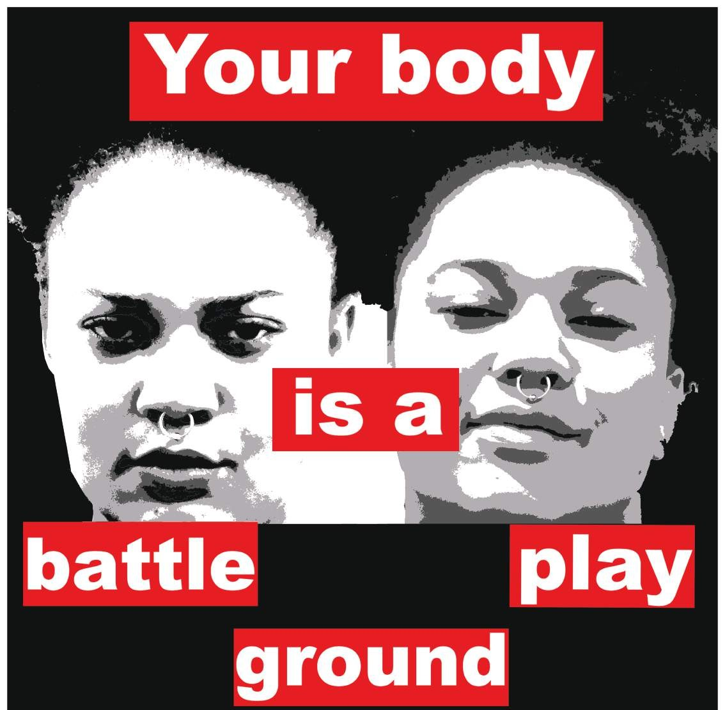

K.Angeline PITTENGER

instagram handle email
country
@k.angeline.pittenger angelinepittenger@gmail.com United States

This is an image derived from Barbara Kruger’s 1989 work, Untitled (Your Body Is a Battleground). Kruger’s piece was created when I was nine years old. The above image was made in humble homage and gratitude for the work that Kruger and other feminists that came before me (howsoever imperfectly) have done. Because of their work, I could legally and safely have an abortion, was able to explore my sexuality in relative safety with people of all genders. I have also had the privilege to be a part of feminist movements and spaces in both Europe and the United States. These were designed to allow us to safely, joyfully and playfully explore pleasure in our bodies in spaces that held up the ideals of intersectionality, body liberation and diversity. While our bodies continue to be battlegrounds, our bodies can more often be playgrounds. The model in the image is a young black feminist in Barcelona.
Battlegrounds and playgrounds

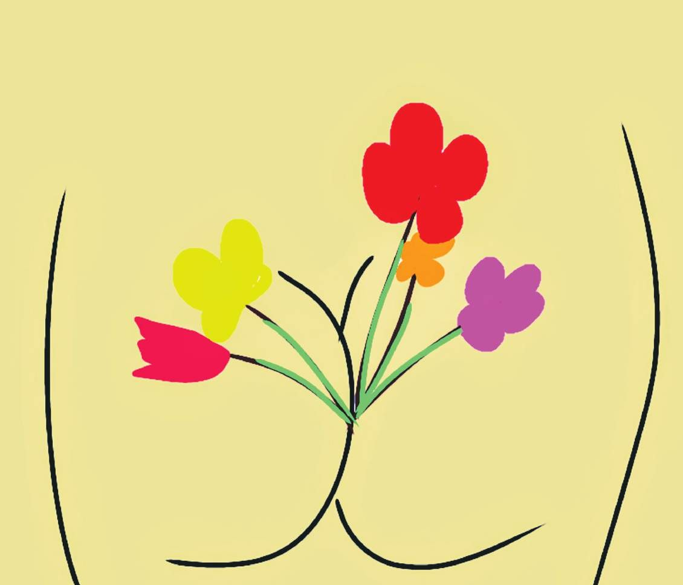

Nadiia Babynska VIRNA

instagram handle email
country
@nadiia_virna virnadiia@gmail.com Ukraine

Flowers for women, vodka for men. It was, and unfortunately is, about the traditions of former USSR countries’ perceptions of the International Women’s Day: flowers, sexist’s congratulations, drunk men. Since my childhood men have been giving us flowers on this day. Since my childhood men diminish the role and the sense of this day. Stop doing that! It is about rights, not flowers.
Rights not flowers (8 March 2019)

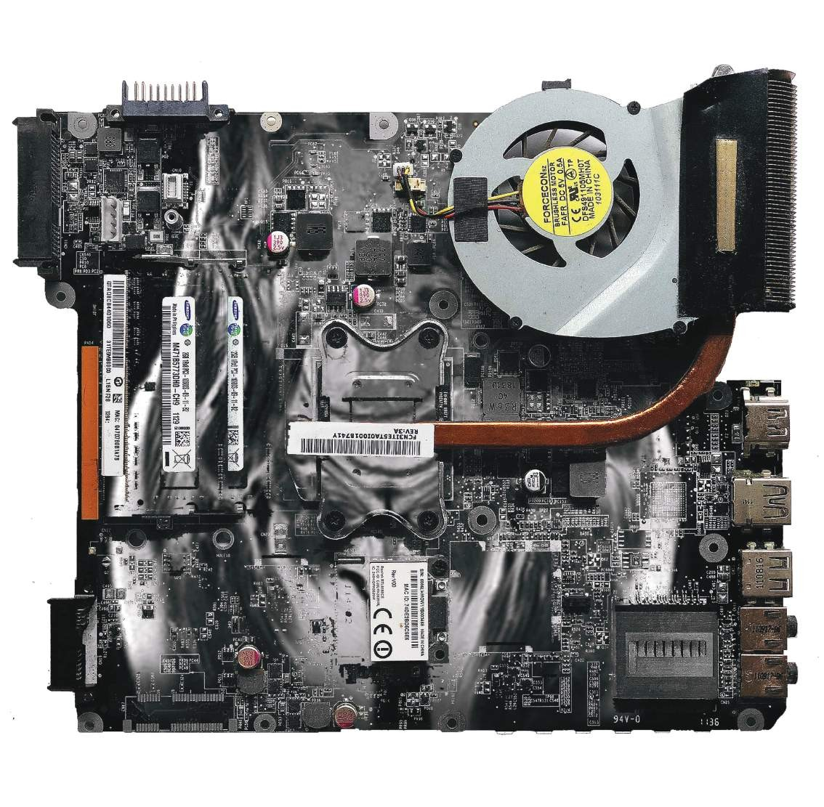

Medina BAZARGALI

instagram handle email
website country
@myodium medina.bazargaliyeva@gmail.com www.myodium.cc
Kazakhstan

The technical world has won. And, new people lack the usual existence given from their birth. For me, there is a semiotic game with a basis for any electronic machine, and a narrow perception of the ‘board’ which ‘constructs’ human life, and the intertext with Courbet in the new technological era of the world origin from the motherboard. Allthisformsmyunderstandingofvirtualitybythesecond, newbirth.
The origin of the world (2018) - motherboard, the MRI of my uterine tubes

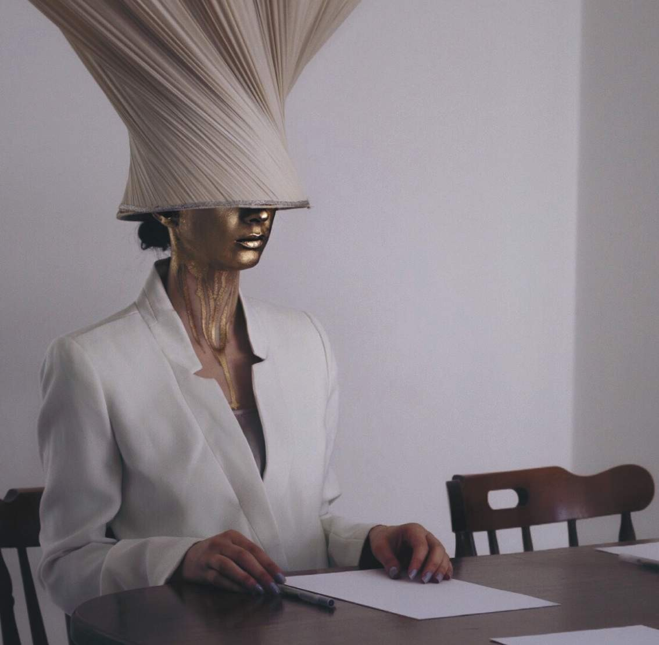

Rand JARALLAH

instagram handle email
country
@randistic rjrandoushka@gmail.com United Kingdom / Palestine

Ever felt like you were being treated as an accessory at the meeting table because you’re a woman? Whether at the work-place, a social gathering, or at home? Yeah, I’ve felt that too. It’s called sexism. What is sexism? It is prejudice or discrimination based on sex especially against women. It’s behaviour, conditions, or attitudes that foster stereotypes of social roles based on sex. Sexism is a form of oppression and domination. Don’t internalize this notion, you’ve got so much to add to the conversation. What we need is a cultural and social shift in our attitudes towards women. (Source: artist has gathered some of this information from @merriamwebster)
Sexism

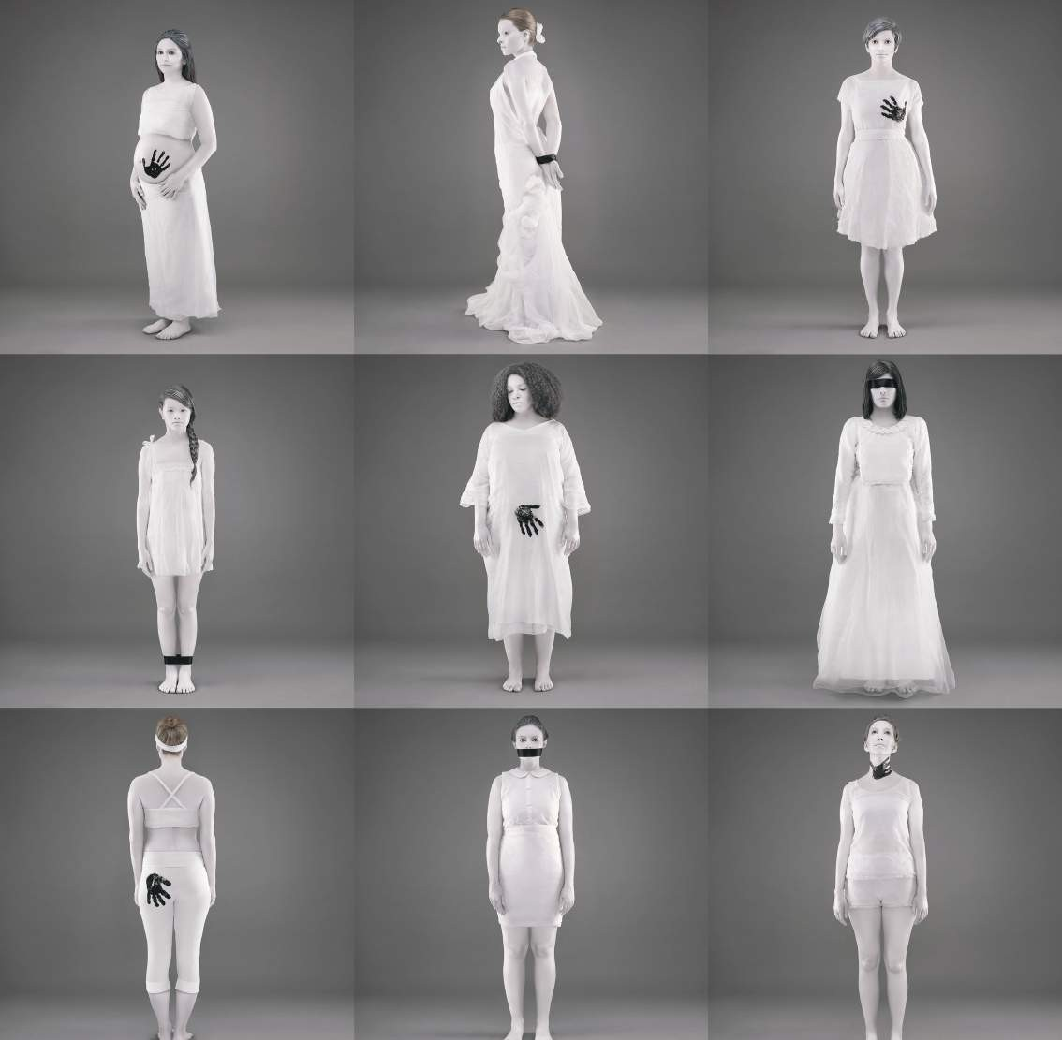

Bhargavi JOSHI

instagram handle email
website country
@bhargavijoshiproductions bhargavi.joshi@gmail.com www.bhargavijoshi.com Canada / India

Growing up in India, I was acutely aware of the harassment women face on a daily basis at home, on the streets, and in their workplace. Then, as I travelled and lived around the world, I realized that this isn’t as much an issue of the ‘third world,’ as it is of the ‘second sex’. It changes in form and degree, but at its core the issues remain the same – an imbalance in power creating opportunity for exploitation. Printed Violation was born out of that realization. I use my photography to create social campaigns that at first glance are simply beautiful images that draw people in; it’s only upon closer examination that the underlying (oftentimes uncomfortable) messages become clear. I use my work to fight for a more just and honest world.
Second sex

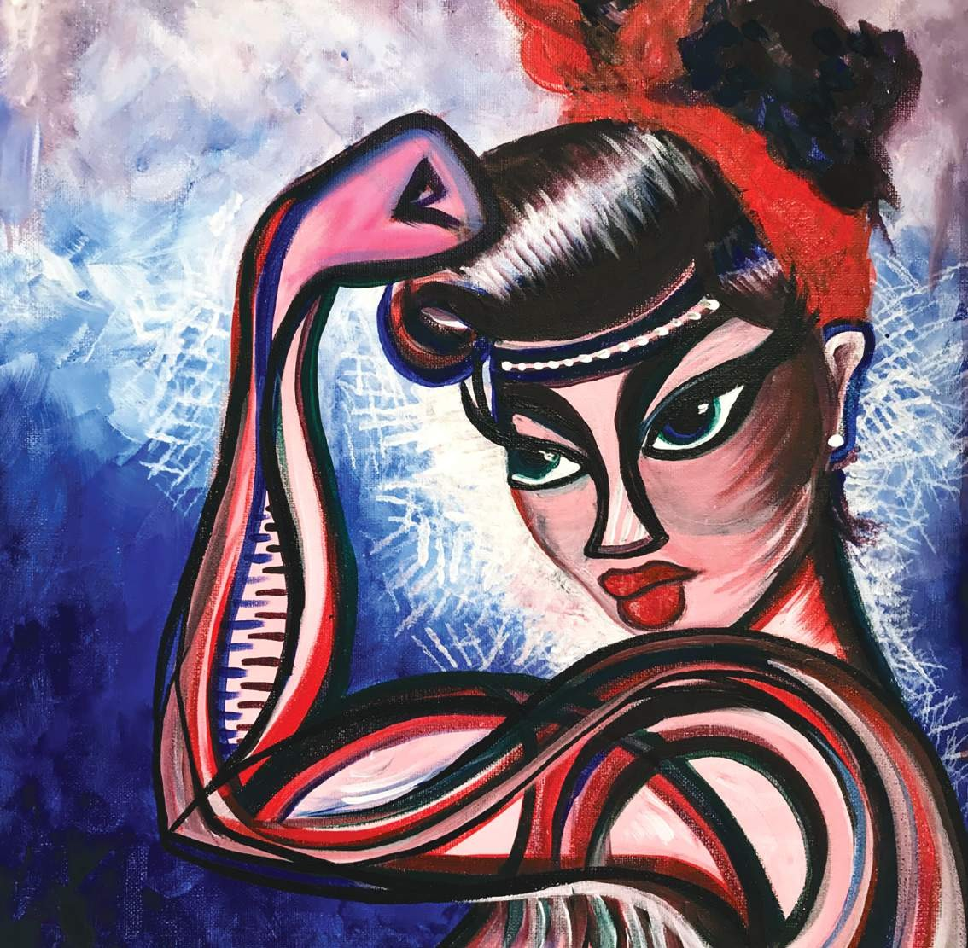

Brooke ESTIN

instagram handle email
website country
@brookeestinart www.brookeestinart.com brooke.estin@gmail.com Spain

phases of the complexity of relationships. The lesson is that when we learn to drop out of conflict and into our hearts, we can signal love, connection and forgiveness - even if that signal can’t yet be received.
many
represents the
piece
This
unexpected
in
world
the
in
heart, that energy can manifest
loving ways.
When one is centred on their

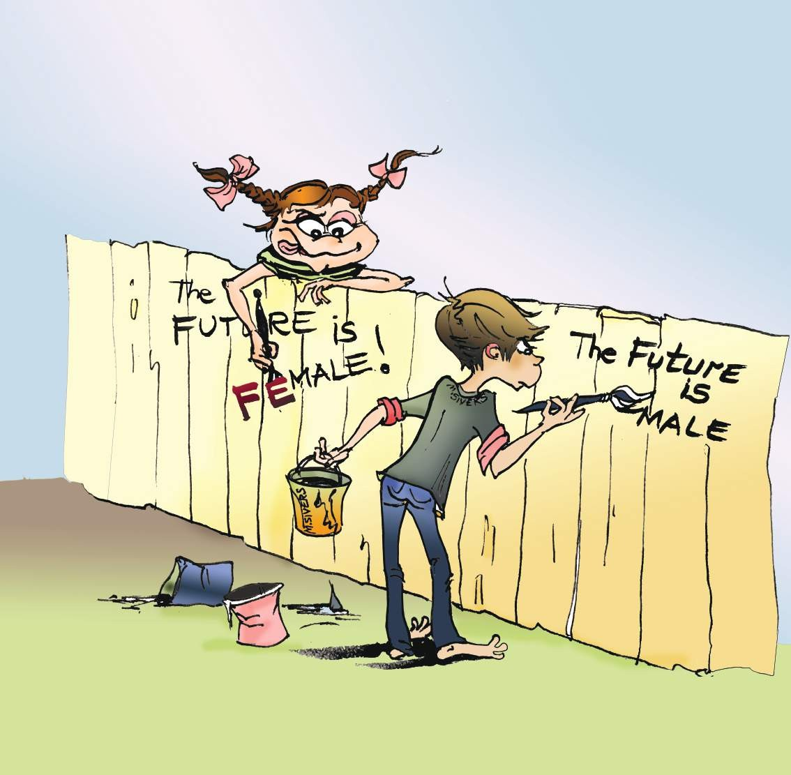

Maria SIVERS

instagram handle email
country
@artsivers dr.sivers@gmail.com Ukraine

Women and girls live in a historically patriarchal world, with many local and national structures still biased towards men. Globally, patriarchal structures are a major obstacle to the full enjoyment of human rights and fundamental freedoms for all people. The struggle for women’s rights is a challenge to be met that requires perseverance and creativity from all of us to remove the barriers to women’s full participation and offer a positive model to society at large.
Freedom and equality

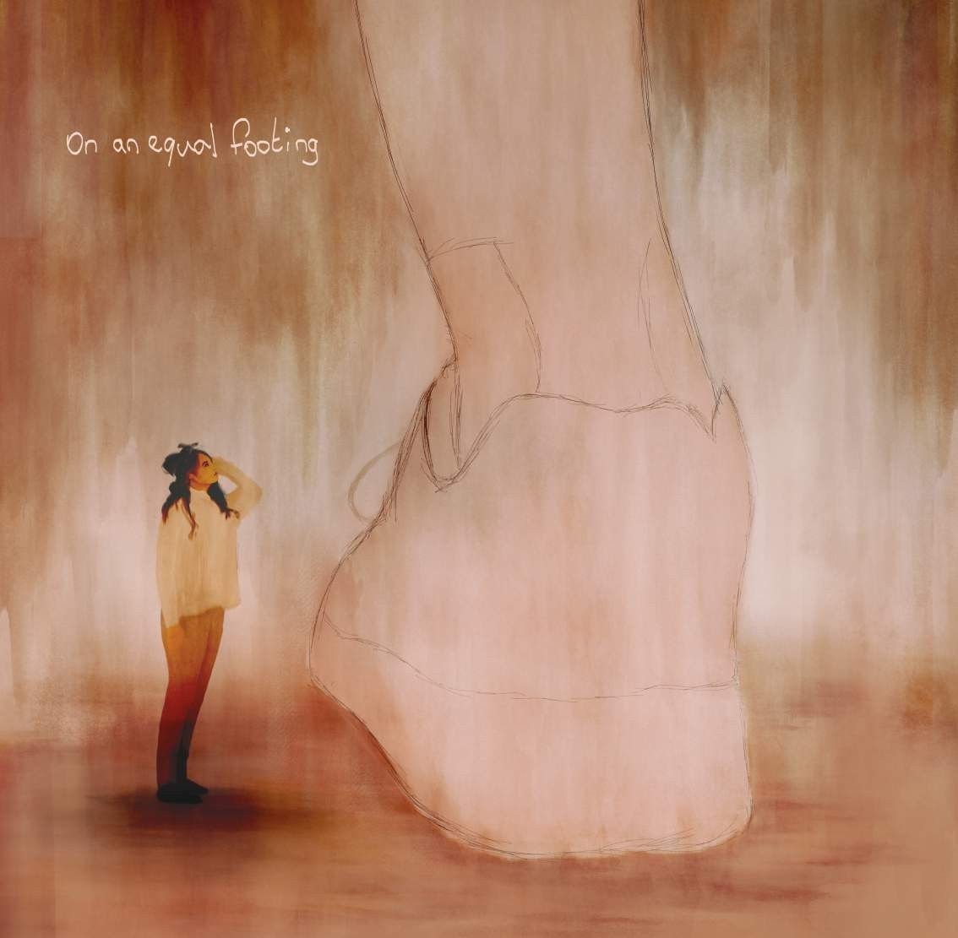

Tim MAATMAN

instagram handle email
country
@timladjimaatman
tim-maatman@hotmail.com The Netherlands

The illustration on an equal footing shows the leg of a white person (possibly a man), at least the bottom part of it, and a woman (possibly of another colour) looking up to this immense figure (demonstration of power?). It is one of the works on intersectional feminism produced by a small group of art-students (Femi, Jesper, Simone and myself, Tim) from the arts academy, AKV st. Joost in the Netherlands.

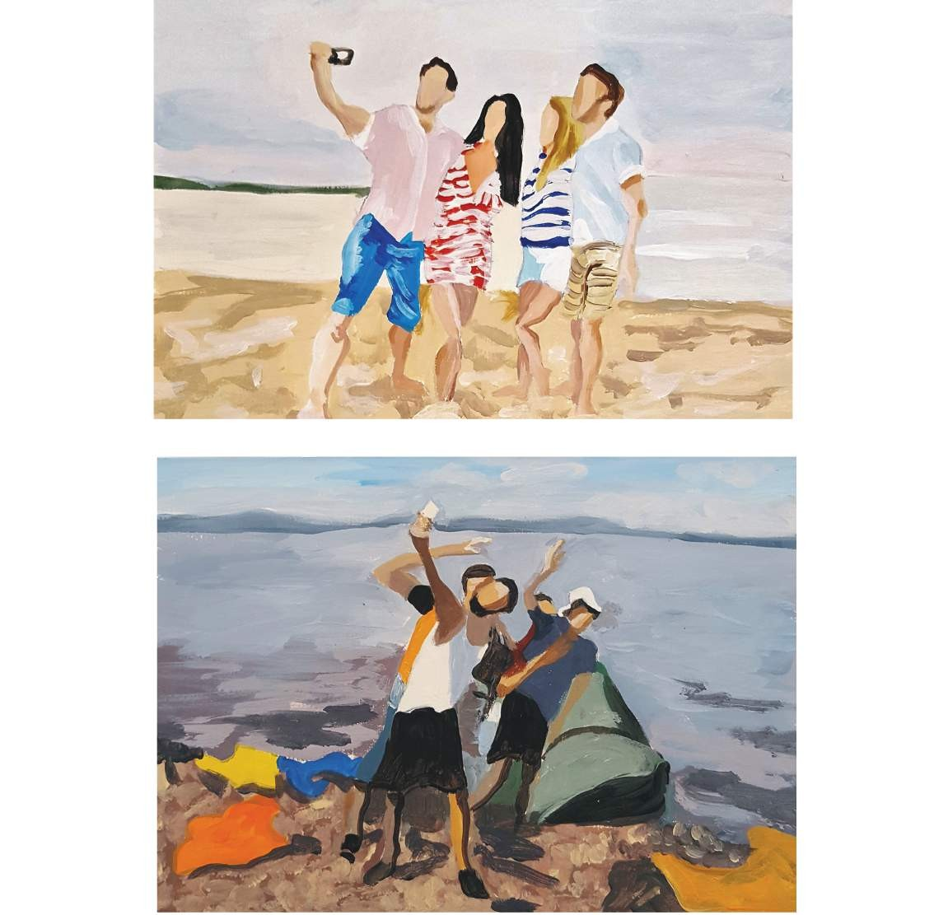

Rosemary RAUBER

instagram handle email
website country
@rosemaryrauber artplace88@gmail.com www.artplace.ch Switzerland

My project is contrasting images of people seeking refuge who have calculated their risks to leave their homes on perilous journeys against the calculated risks people make in their everyday lives. People on vacation often pay a premium price for an adventure. They want to encountersomethingorsomewheredifferentandnew,willingtopayforacontrolledexperience. People seeking refuge pay a premium price for the ‘privilege’ of risking their lives to get to a place of greater safety. We make the decision to do something based on known factors with the hope that the outcome will enrich our lives. When decisions are made for reasons of safety vs. self-actualization the ‘known’ is usually incredibly limited and the enrichment is purely surviving. Perceiving displaced people as being unique as opposed to different would be a start in changing attitudes. If we understood just how similar we are, despite our home countries, skin colour and religion, maybe we would do a better job at helping those in need.
Calculated risks

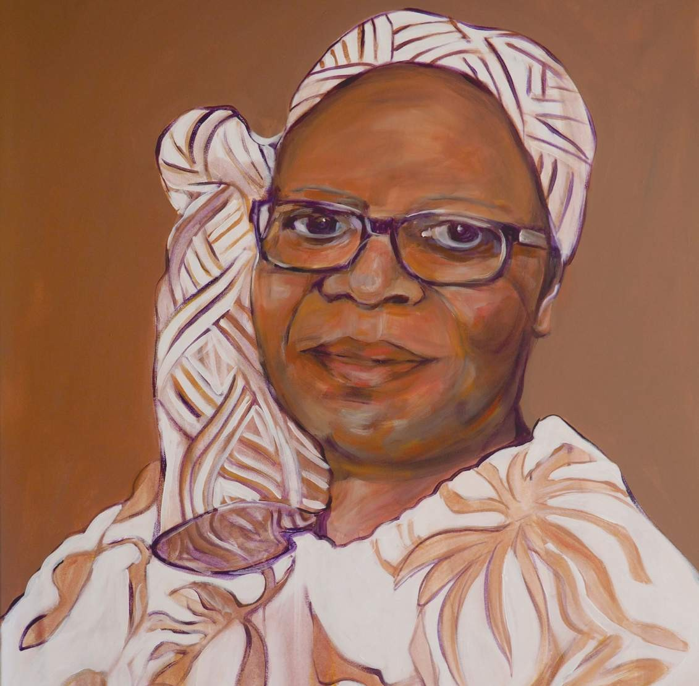

Marieke WARMELINK

instagram handle email
country
@maro_painting info@mariekewarmelink.com The Netherlands

This is Orsine Koorndijk, from Suriname, who lived in The Netherlands. Orsine was a special woman, socially involved and a talented writer. Her novels highlight cruel corporal punishment within Roman Catholicism in Suriname and structural exclusion of people with dark skin. Orsine has helped raise her voice for a world of equal respect. She died in 2019. Every brave act, every action, every word is kept in the heart of her family members and beyond.
Orsine Koorndijk

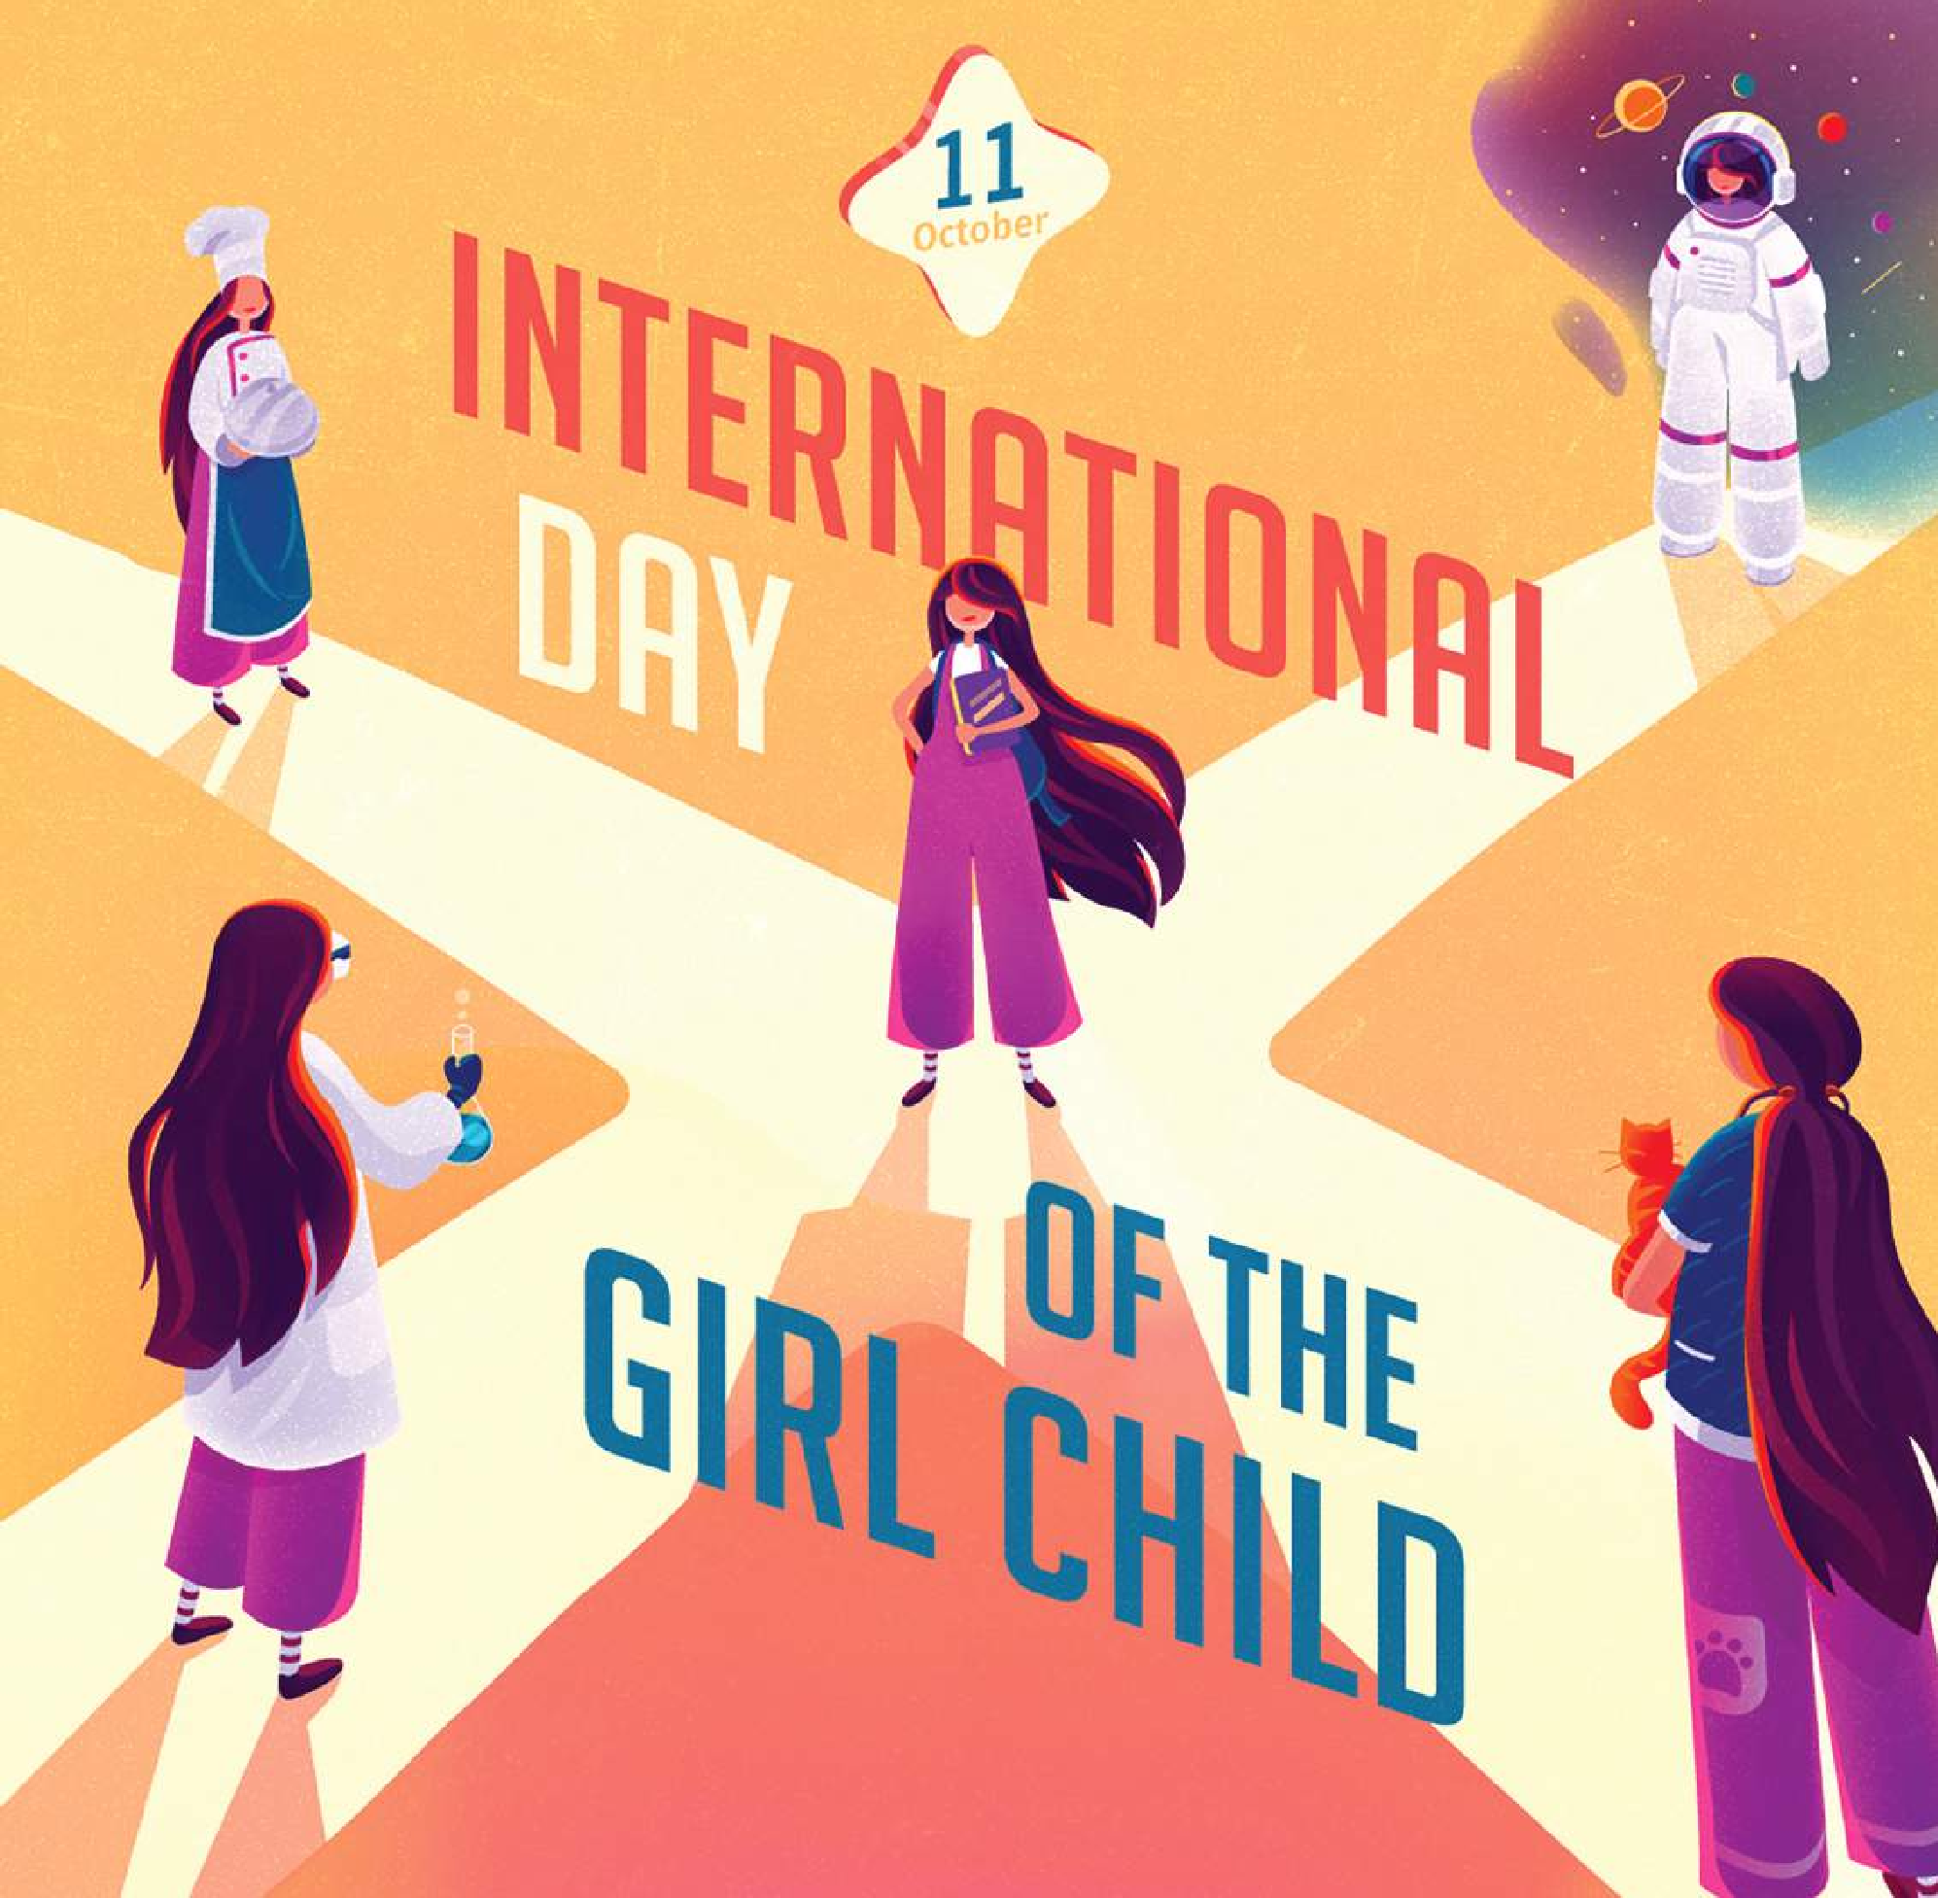

Ia Ninoshvili/Forset

instagram handle email
country
@ia_ninoshvili forset.ge ia@forset.ge
Georgia

At the age of 10, a girl is at a crossroads. Which path she takes does not only matter for her own life. It matters for the lives of all of us.
Credited to UNFPA Georgia
International Day of the Girl Child

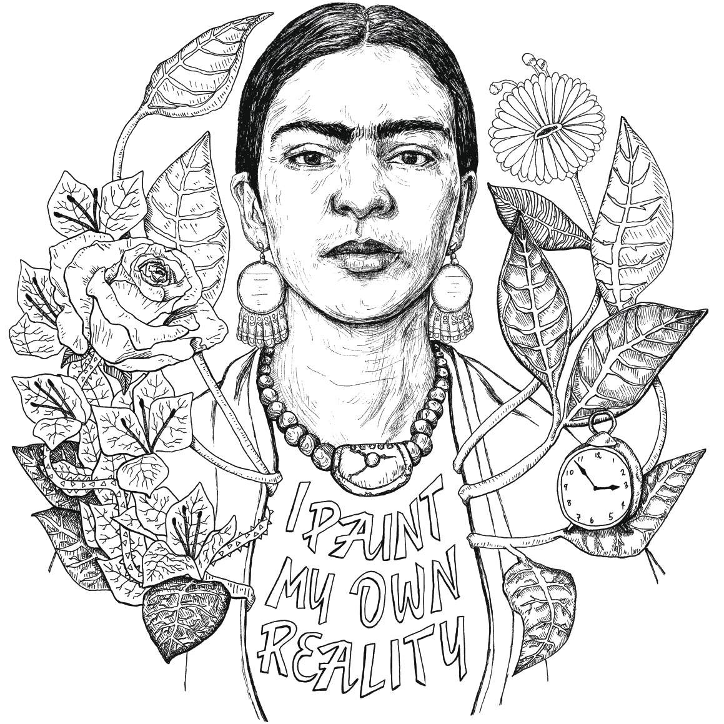

Emily GREGORIOU

instagram handle email
country
@emilyeggz fineart.emily@gmail.com England, United Kingdom

Frida Kahlo has become an icon in Europe, and all around the world. Though this may seem positive (in highlighting women artists) the way she is often showcased
- immortalised on objects and as decoration - goes instead to devalue her complex life, struggles and activism. Striped down to a black and white drawing, these words by the artist herself feed out of her soul along with other elements that reference her haunting and exotic self-portraits and subsequently her life and reality.
“I never paint dreams or nightmares. I paint my own reality”

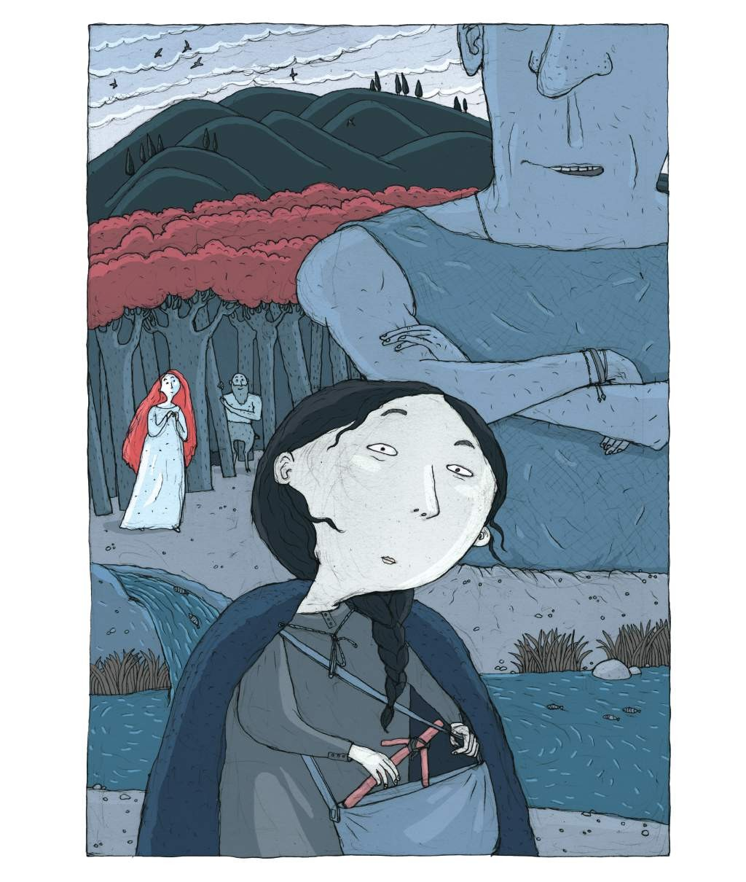

Sophia KIRTADZE

instagram handle country
@kirtadzesofo Georgia

Nino was originally from Cappadocia. According to various sources, her parents – mother, Sosana, and father, Zabulon, a military man – chose the way of monasticism and went to live in Jerusalem. Nino, who was 12 years old at the time, was sent to live with Niofora-Sarah of Bethlehem, a Christian woman who often told her stories about the life and crucifixion of Jesus. It was also her who told Nino that Georgia was the resting place of the Seamless Robe of Jesus. Saint Nino, equal to the Apostles, came to Georgia in approximately 323 AD through the mountains of Javakheti. She was carrying a grapevine cross gifted to her by Saint Mary. Nino arrived in Mtskheta and began to preach Christianity. In 326 AD, Christianity was declared the state religion of Georgia. Saint Nino passed away on January 27, 338 AD. She is buried at the Bodbe Monastery. A story by Teona Dolenjashvili
The broken shadows

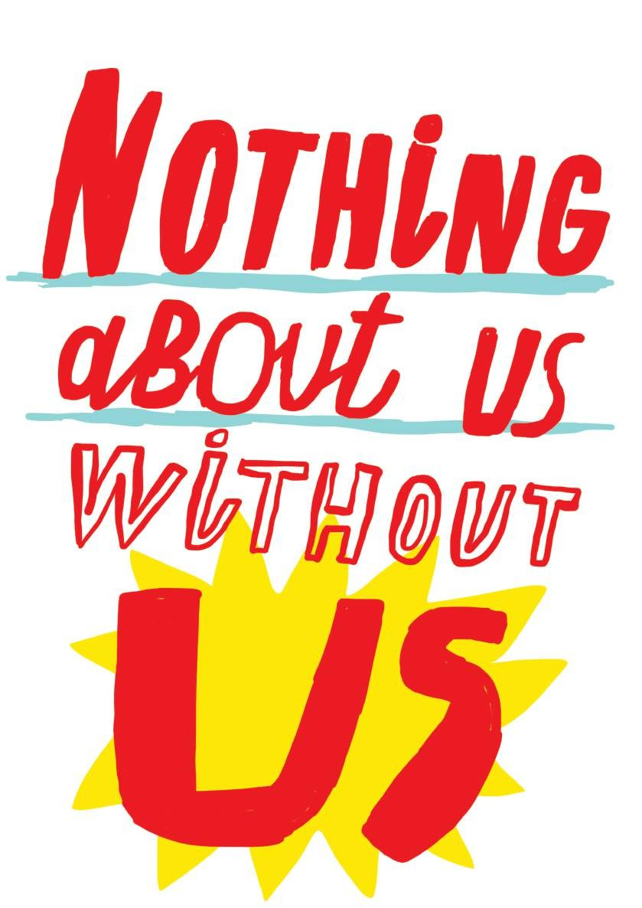

Anna SARVIRA

instagram handle email
country
@anna.sarvira anna.sarvira@gmail.com Ukraine

Ukraine
Women
UN
to
Credited
of
full and direct participation
the
without policy!
women affected by that
policy should be decided
No
decision-making.
from
marginalized
often
are
factors,
geographic location and HIV status among
ethnicity, disability,
sex, other
their
of
because
discrimination
of
forms
multiple
facing
Women

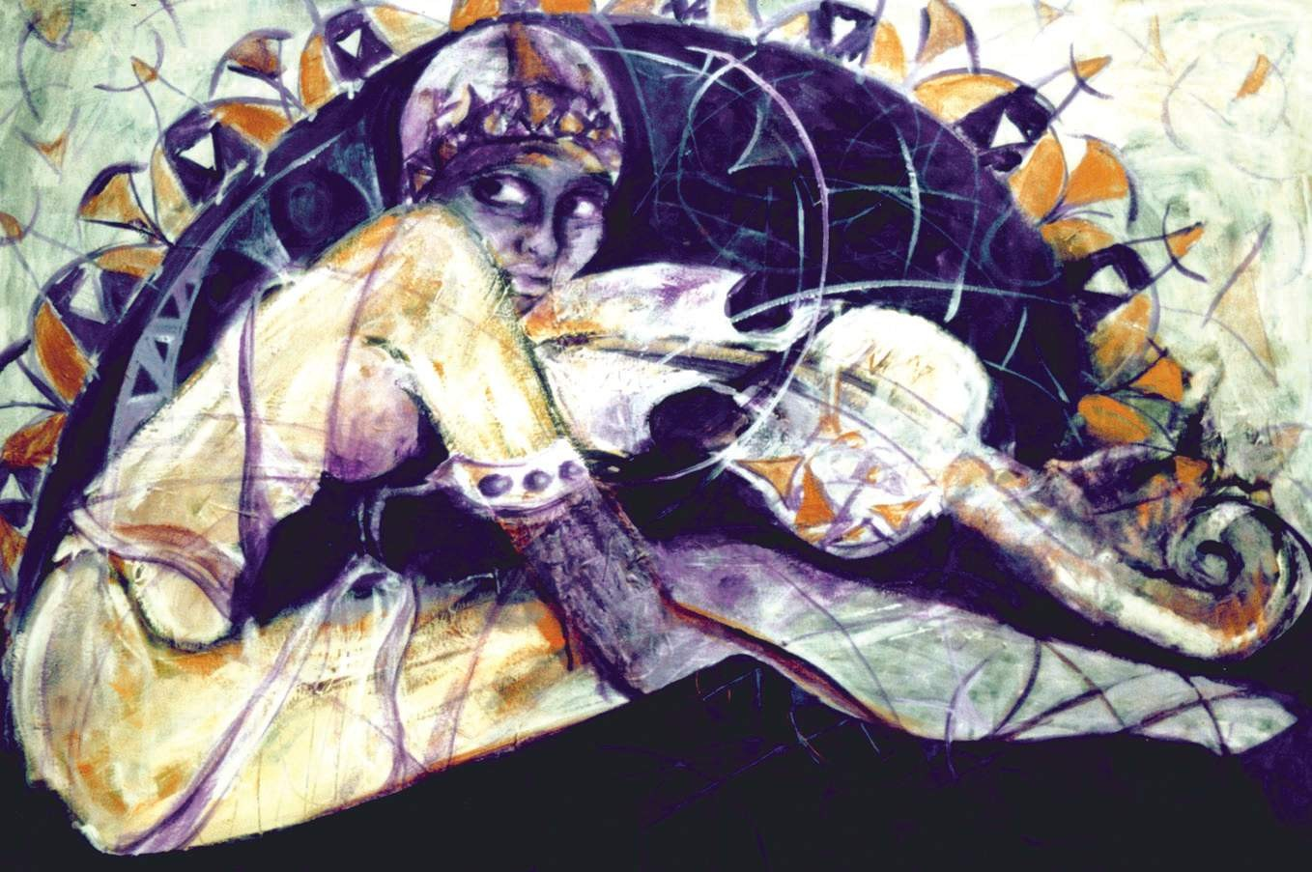

Şule ÖZBAHAR

instagram handle email
country
@suleozbahar suleozbahar@gmail.com Turkey

Humanity will always be incomplete unless it ensures equality between women and men in every aspect of life. None of its members can speak about freedom, before women’s liberation from oppression and domination all over the world. Gender equality for a free world! Feminism for equality!
Untitled

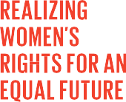#Artivism for gender equality

These 25 art pieces celebrate the 25th anniversary of the Beijing Declaration and Platform for Action, the most visionary agenda for women’s rights and empowerment everywhere.
This exhibition highlights struggles for gender equality and women’s rights in Europe, the United States of America, Canada, the Caucasus and Central Asia countries.
This exhibition was conceptualized by Women’s Major Group and UN Women Regional Office for Europe and Central Asia.
The content of this exhibition represents the values of the artists and does not necessarily reflect the views and the position of Women’s Major Group, UN Women, EuropeAid and Women2030.

#Artivism #GenerationEquality

