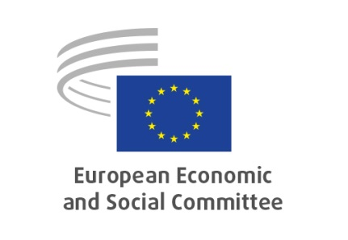
Public Hearing on
EN
A renewed EU action plan against migrant smuggling
Via Interactio, online platform
Friday, 4.02.2022 from 10:00 to 13:00, VMA 3

Agenda

9:30-10:00 | Log on to platform / Interactio testing
10:00-10:30 | Welcome and opening session  - Tomas Wroblewski, Study group President  - Jose Antonio Moreno Diaz, EESC rapporteur  - Pietro Vittorio Barbieri, EESC co-rapporteur  Intervention by Matthijs Korzilius on the renewed EU action plan against migrant smuggling, European Commission
10:30-11:30 | Panel I: Mapping out the general situation in the area of migrant smuggling  moderator: Pietro Vittorio Barbieri  - Filippo Spiezia, Eurojust  - Lina Vosyliute, Centre for European Policy Studies (CEPS)  - Carmine Conte, Migration Policy Group  - Morgane Nicot, UNODC  - Stefano Failla, Frontex  Open floor discussion
11:30-11:45 | Break
11:45-12:45 | Panel II: Views from civil society  moderator: Jose Antonio Moreno Diaz  - Catherine Woollard, European Council on Refugees and Exiles (ECRE)  - Marta Gonco, Platform for International Cooperation on Undocumented Migrants (PICUM)  - Cristian Castaño, CCOO Trade Union and SASEMAR (Spanish Maritime Safety and Rescue Society)  Open floor discussion
12:45-13:00 | Closing remarks  - Tomas Wroblewski, Study group President  - Jose Antonio Moreno Diaz, EESC rapporteur  - Pietro Vittorio Barbieri, EESC co-rapporteur

Participants can speak in English, Italian, Spanish, Polish & Lithuanian (tbc) and can listen to English, Italian, Spanish & Polish

