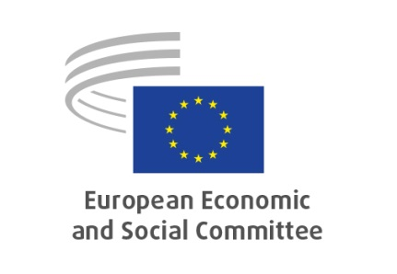
Public Hearing on
EN
A Union of equality: EU anti-racism action plan 2020-2025
Via Interactio, online platform
Thursday, 18.03.2021 from 10:00 to 13:00

Agenda

9:30-10:00 | Log on to platform / Interactio testing for speakers.
10:00-10:20 | Welcome and introduction  - Ms Helena DE FELIPE LEHTONEN, EESC Study Group President.  - Introduction by Mr Cristian PÎRVULESCU, EESC Rapporteur.
10:20-11:15 | Panel I: Racism and racial discrimination – the state of play at EU level  moderator: Ms Helena DE FELIPE LEHTONEN, EESC Study Group President  - Mr Thibault Balthazar, Secretariat-General, Equality task force, European Commission  - Ms Joanna GOODEY, Head of Unit for Research and Data, Fundamental Rights Agency (FRA)  - Ms Maria Daniella Marouda, Chair, European Commission against Racism and Intolerance (ECRI)  - Ms Aleksandra WESOŁY, Unit D3 "Prevention of radicalization", DG HOME, European Commission
11:15-11:45 | Break
11:45-12:45 | Panel II: How to achieve an effective and sustainable action plan – further perspectives  moderator: Ms Helena DE FELIPE LEHTONEN, EESC Study Group President  - Ms Yoomi Renström, rapporteur for the EU anti-racism action plan, CoR  - Mr Csaba Asztalos, President, Romanian Council for the Combatting of Discrimination  - Ms Marie Mescam, SOS Racisme  - Ms Juliana Wahlgren, Senior Advocacy Officer, ENAR
12:45-13:00 | Closing remarks  - Mr Cristian PÎRVULESCU, EESC Rapporteur
Participants can speak and listen to EN and PT

