CCMI FACTSHEET:

EU INDUSTRIAL MARITIME STRATEGY

(CCMI/258)
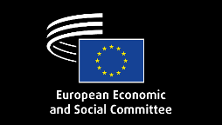
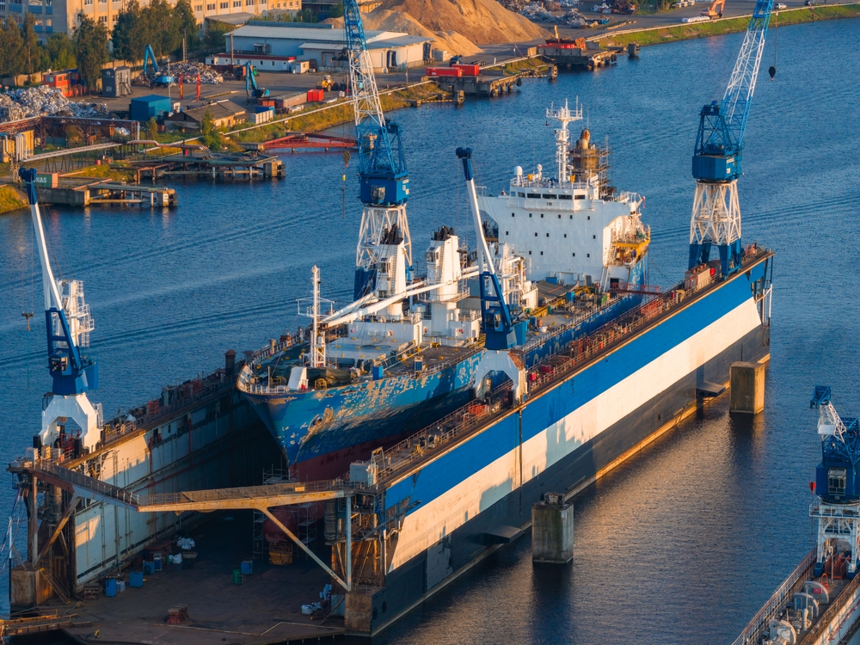

On 4 March 2026, the European Commission adopted the EU Industrial Maritime Strategy, alongside the EU Ports Strategy, structured around six pillars — Build, Equip & Repair; Transport & Connect; Secure & Protect; Access to Innovation; Access to Finance & Investment; and Access to Skills & Quality Jobs — to strengthen the competitiveness, sustainability and resilience of Europe’s maritime manufacturing and shipping industries. Opinion CCMI/258 presents the EESC’s assessment of the Strategy.
The EESC welcomes the Strategy as an unprecedented achievement and a strategic pillar of the EU economy. The Committee calls for an inclusive EU Industrial Maritime Value Chains Alliance and a high-level Maritime Industries and Ports Board, a dedicated decarbonisation funding mechanism, stronger finance access for shipping, shipyards and SMEs, binding marine fuel supply obligations, and a long-term public order pipeline — while ensuring skills, safety and quality jobs keep pace with the sector’s green and digital transformation.

KEY FACTS: THE URGENCY TO ACT

  35% — European shipping’s share of the global fleet, a key geopolitical asset ensuring resilient supply chains and secure energy flows  75% — share of the EU shipping sector represented by bulk/tramp shipping, a segment existing instruments like the Innovation Fund have failed to serve  90% / 75% — share of world trade, and of the EU’s external trade, transported by sea |   7,000-10,000 — sustainable and digitalised vessels the EU maritime manufacturing industry aims to supply or retrofit by 2035    Up to 40% — share of the maritime manufacturing workforce expected to retire by 2030    ~10% — share of sustainable marine fuels currently produced in Europe



RECOMMENDATIONS FROM EESC OPINION
The EESC:
- welcomes the adoption of the EU Industrial Maritime Strategy as an unprecedented achievement for the maritime sector

- welcomes the proposal to set up an EU Industrial Maritime Value Chains Alliance and a high-level Maritime Industries and Ports Board.

- welcomes the strategy’s objective of strengthening the competitiveness, sustainability and resilience of the European maritime sector as a strategic pillar of the EU economy.

- highlights the essential role of European shipping in ensuring energy, food and supply chain security and underlines the importance of preserving its global competitiveness, maintaining open markets and ensuring fair trade conditions based on reciprocity while avoiding protectionist measures.

- supports the strategy’s vision of consolidating Europe’s global leadership in high-tech ships, maritime equipment, energy efficiency technologies for shipping, positioning Europe as a leader in emerging segments and strengthening its industrial position in strategic segments.

- underlines the importance of ensuring the availability safe, sustainable, affordable, scalable and regulation-compliant marine fuels across EU ports and calls on the Commission to introduce binding obligations on fuel suppliers to guarantee the supply of compliant fuels.

- fully supports the call for revenues generated under the EU ETS and FuelEU Maritime to be reinvested in the maritime sector and supports the creation of a dedicated funding mechanism to accelerate decarbonisation.

- stresses the need to facilitate access to competitive ship finance by reducing regulatory constraints, notably under the EU Taxonomy, and limiting administrative and financial burdens, including for SMEs.

- insists on the need to facilitate access to finance – both public and private – to address the current difficulties faced by the maritime sector in accessing finance.

- supports the strategy’s plan to facilitate a long-term pipeline of public procurement orders for EU/EEA buyers while preparing the maritime manufacturing industry to meet such demand.

- highlights the role of the sectoral social dialogue committee (SSDC) in maritime transport and that in shipbuilding and ship repair in addressing labour, social and regulatory issues, including skills, working conditions and workforce development.

- appreciates the strategy’s focus on access to skills and quality jobs and fully supports its proposals to identify skill gaps, to develop re/upskilling programmes, to map maritime professions, and to support the creation of a network of maritime higher education institutions and vocational training centres across the EU.

- calls for EU rules to be aligned with international developments at IMO level once a global agreement is reached, as a lack of alignment could lead to regulatory fragmentation, double payments for the same emissions, and unfair competition, ultimately weakening both climate effectiveness and the global competitiveness of EU shipping.

