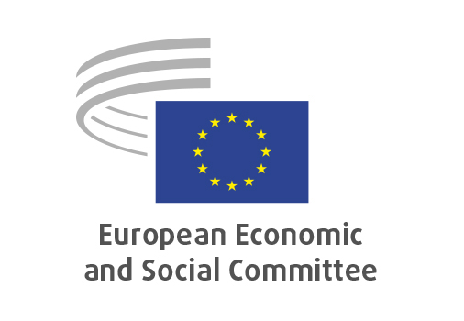
EN

REX/614
Strengthening EU economic security

Brussels, 17 June, 2026

RECORD OF THE PROCEEDINGS
European Economic and Social Committee
Strengthening EU Economic Security
_____________

606th plenary session
Brussels
17-18 June 2026
_____________

Meeting of 17 June 2026
_____________

Agenda item 12
_____________

The president moved that the Committee turn to agenda item 9 - adoption of an opinion on the

Strengthening EU Economic Security

The preliminary work had been carried out by the Section for External Relations (president: Mr Luca JAHIER (IT-III). The rapporteur was MS Milena ANGELOVA (BG-I).

The section adopted its opinion on 22 May 2026 with 107 votes in favour, 0 vote against and no abstentions.

Ms Milena ANGELOVA (BG-I), rapporteur, introduced the opinion as the EESC’s assessment of the latest European Commission Communication on strengthening EU economic security. She welcomed the fact that several points raised in previous EESC work had been take onboard, while stressing that economic security must now become a crucial EU objective requiring urgent, integrated and coordinated action across a wide range of policy fields.

She underlined the need for clear responsibilities and effective coordination between the EU and national levels, as well as cross-sectoral cooperation covering, among others, innovation, energy, transport, digital, industrial, economic, trade and international partnership policies. Economic security, she stressed, should also be understood as part of comprehensive security, alongside defence capacity, democratic resilience, diplomatic capabilities and cooperation with like-minded partners.

The rapporteur highlighted the importance of horizontal high-impact measures to strengthen the EU’s competitiveness, investment attractiveness and resilience. This includes reinforcing the EU’s internal foundations, notably macroeconomic stability, solid innovation and production capacity, a well-functioning single market, secure access to key inputs such as critical raw materials, and a stronger skills base. She also stressed the need for substantially increased public and private investment, from research and innovation to deployment and production, supported by stronger EU financial markets.

Ms ANGELOVA further pointed to the need to enhance secure and sustainable supply chains and infrastructure, strengthen the EU’s production base and top-tier know-how in key technologies, and address dependencies through a risk-based approach that clearly distinguishes between low- and high-risk dependencies. At the same time, she warned against a defensive or inward-looking approach, noting that building a “technology fortress Europe” would be counterproductive. In a fragmenting world, the EU must be ready and strong enough, while remaining open and engaged with reliable partners.

She concluded by thanking the members of the study group and all colleagues who had contributed to the work, which had made it possible to reach unanimity in the Section, and expressed appreciation for the support received during the process.

Ms Tanja Buzek (DE-II) welcomed this opinion as a good outcome, and highlighted three points:
1) The 2023 Strategy fell short of the challenges it was called to address; several but not all the points we made in our previous opinion have now been taken on board.
2) Former DG Sabine Weyand (DG TRADE) recently shared her surprise at how little EU companies have done – so far – with regards to their own security and supply diversification.
3) For future work, we might want to cover the potential collaboration with EU's like-minded partners (Japan, South Korea and others) who have been working on their own economic security strategies.

Mr Élő (HU-II) highlighted the issue of our IT/tech dependencies on US providers.

Mr Fornea (RO-III) stressed that this is an important topic at this time, also to reflect on what we have or not have done over the past decade. We need to secure our own surroundings, including MENA; these are key for CRM, energy etc.

Mr Jahier (IT-III) the debate was intense but productive. We are still very far from understanding what economic security actually means. Looking at comparable documents by US and China, this still falls short. Not everything is lost, there are positive developments (India, Mercosur…) but they require strong and coordinated action.

Mr Schaffenrath (AT-III) the message we're sending is clear: we need to bolster our economic and industrial foundations, including innovation capacity. Important to involve civil society in this effort – economic security is a precondition for many other important policies with far-reaching impacts on all of us.

Ms Angelova warned against the risks of building a tech fortress for Europe, which would be counterproductive. In a fragmenting work, we need to be ready and strong enough.

Vote: 180 yes, 1 abstention

_____________

