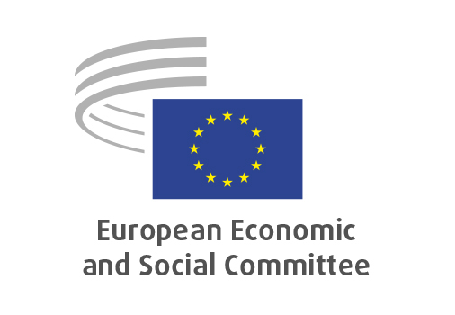
EN

NAT/995
Prohibition to export mixed municipal waste destined for recovery

Brussels, 17 June 2026

RECORD OF THE PROCEEDINGS
European Economic and Social Committee
Proposal for a Regulation of the European Parliament and of the Council amending Regulation (EU) 2024/1157 as regards the prohibition to export mixed municipal waste destined for recovery

COM(2026) 183 final – 2026/0099(COD))
_____________

606th plenary session
Brussels
17-18 June 2026
_____________

Meeting of 17 June 2026
_____________

Agenda item 5
_____________

The president moved that the Committee turn to agenda item 5 - adoption of an opinion on the

Proposal for a Regulation of the European Parliament and of the Council amending Regulation (EU) 2024/1157 as regards the prohibition to export mixed municipal waste destined for recovery
COM COM(2026) 183 final – 2026/0099(COD)

The preliminary work had been carried out by the Section for Agriculture, Rural Development and the Environment (president: Stoyan Tchoukanov).

Since the Committee endorses the contents of the proposal and has already set out its views on the subject in its earlier opinion Waste shipments – revision of EU rules, adopted on 23/2/2022, it decided unanimously not to hold a general discussion and to put the opinion straight to the vote (Rules 64(4) and 76(3)).

The opinion was adopted by 204 votes in favour, 1vote against and 1 abstention.

_____________

OJ C 275, 18.7.2022, p. 95.

