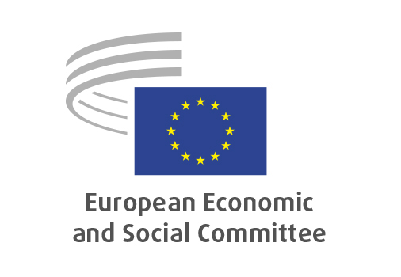
EN

NAT/991
Transposition of measures of regional fisheries management organisations - RFMOs II

Brussels, 17 June 2026

RECORD OF THE PROCEEDINGS
European Economic and Social Committee
Proposal for a Regulation of the European Parliament and of the Council amending Regulation (EU) 2017/2107 laying down management, conservation and control measures applicable in the Convention area of the International Commission for the Conservation of Atlantic Tunas (ICCAT), Regulation (EU) 2018/975 laying down management, conservation and control measures applicable in the South Pacific Regional Fisheries Management Organisation (SPRFMO) Convention Area, Regulation (EU) 2019/833 laying down conservation and enforcement measures applicable in the Regulatory Area of the Northwest Atlantic Fisheries Organisation, Regulation (EU) 2021/56 laying down management, conservation and control measures applicable in the Inter-American Tropical Tuna Convention area, Regulation (EU) 2022/2056 laying down conservation and management measures applicable in the Western and Central Pacific Fisheries Convention Area, Regulation (EU) 2022/2343 laying down management, conservation and control measures applicable in the Indian Ocean Tuna Commission (IOTC) Area of Competence, and Regulation (EU) 2023/2053 establishing a multiannual management plan for bluefin tuna in the eastern Atlantic and the Mediterranean

(COM(2026) 198 final – 2026/0111(COD))
_____________

606th plenary session
Brussels
17-18 June 2026
_____________

Meeting of 17 June 2026
_____________

Agenda item 5
_____________

The president moved that the Committee turn to agenda item 5 - adoption of an opinion on the

Proposal for a Regulation of the European Parliament and of the Council amending Regulation (EU) 2017/2107 laying down management, conservation and control measures applicable in the Convention area of the International Commission for the Conservation of Atlantic Tunas (ICCAT), Regulation (EU) 2018/975 laying down management, conservation and control measures applicable in the South Pacific Regional Fisheries Management Organisation (SPRFMO) Convention Area, Regulation (EU) 2019/833 laying down conservation and enforcement measures applicable in the Regulatory Area of the Northwest Atlantic Fisheries Organisation, Regulation (EU) 2021/56 laying down management, conservation and control measures applicable in the Inter-American Tropical Tuna Convention area, Regulation (EU) 2022/2056 laying down conservation and management measures applicable in the Western and Central Pacific Fisheries Convention Area, Regulation (EU) 2022/2343 laying down management, conservation and control measures applicable in the Indian Ocean Tuna Commission (IOTC) Area of Competence, and Regulation (EU) 2023/2053 establishing a multiannual management plan for bluefin tuna in the eastern Atlantic and the Mediterranean
(COM(2026) 198 final – 2026/0111(COD))COM COM(2026) 183 final – 2026/0099(COD)

The preliminary work had been carried out by the Section for Agriculture, Rural Development and the Environment (president: Stoyan Tchoukanov).

Since the Committee has already set out its views on the content of the proposal in question in its opinions:
- Amendment to regulations concerning international fisheries (NAFO, SPRFMO, IOTC, WCPFC, IATTC and ICCAT), adopted on 16/07/2025,
- Fisheries – NAFO, adopted on 15/06/2023,
- Conservation and enforcement measures – NAFO, adopted on 24/03/2022,
- Conservation of Atlantic Tunas (ICCAT), adopted on 15/06/2022,
- Bluefin tuna catch documentation, adopted on 27/01/2021,
- Fisheries – transposition of IATTC measures, adopted on 02/12/2020,
- Conservation and enforcement measures – NAFO, adopted on 18/09/2020,
- Multiannual management plan for bluefin tuna, adopted on 07/05/2020,
- Conservation and control measures in the Northwest Atlantic Fisheries Organisation, adopted on 23/01/2019,
- Conservation of Atlantic tunas, adopted on 19/10/2016,
- Fishing Authorisations, adopted on 25/05/2016,

it decided unanimously not to hold a general discussion and to put the opinion straight to the vote (Rules 64(4) and 76(3)).

The opinion was adopted by 201 votes in favour, no vote against and 1 abstention.

_____________

OJ C C/2025/5154, 28.10.2025.
OJ C 293, 18.8.2023, p. 144.
OJ C 290, 29.7.2022, p. 149.
OJ C 365, 23.9.2022, p. 55.
OJ C 123, 9.4.2021, p. 72.
OJ C 56, 16.02.2021, p.59.
OJ C 429, 11.12.2020, p.279.
OJ C 232, 14.7.2020, p. 36.
OJ C 159, 15, 5.2019, p. 60.
OJ C 34, 2.2.2017, p.142.
OJ C 303, 19.8.2016, p.116.

