CCMI FACTSHEET :

ReSource EU Action Plan

(CCMI/259)
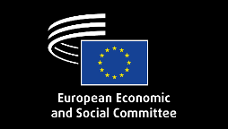
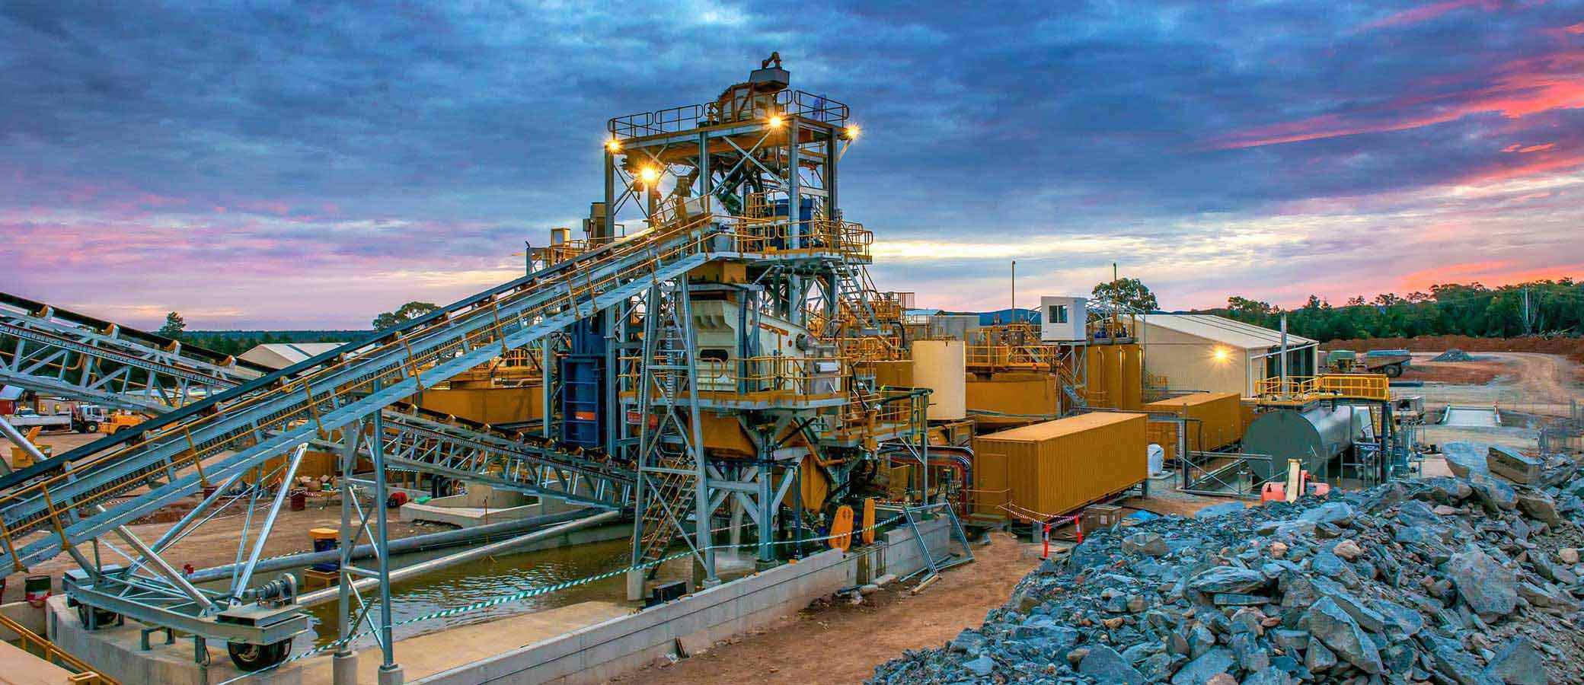
The European Commission presented the RESourceEU Action Plan in response to growing geopolitical tensions, rising global competition for critical raw materials (CRMs), and Europe’s continued strategic dependencies on third countries for the supply and processing of key resources essential for the green, digital and defence transitions. The initiative aims to strengthen the resilience of EU value chains by accelerating strategic projects, diversifying supply sources, supporting recycling and circularity, and reducing vulnerabilities linked to market concentration and supply disruptions.
The EESC supports the overall direction of the Action Plan but stresses that the Commission’s proposal remains insufficient in several key areas. The Committee calls for a more ambitious financing framework, stronger measures to reduce structurally high industrial energy costs, and greater support for domestic extraction, refining, processing and recycling capacities. The EESC also underlines that circularity must become a central pillar of the strategy and insists that faster permitting must not weaken environmental standards, water protection, social safeguards, democratic participation or public trust. Europe’s strategic autonomy can only be achieved through a balanced approach that combines competitiveness, sustainability and social acceptance.

KEY FACTS: THE URGENCY TO ACT
  The EU remains far from meeting its 2030 CRMA targets in extraction, processing and recycling. Dependency is particularly acute for highly critical materials such as heavy rare earth elements and magnesium, where the EU remains heavily reliant on single-country suppliers for extraction and refining.    In some critical raw material value chains, energy costs account for up to 50% of operating expenses, making Europe’s structurally high energy prices a major competitiveness challenge.    At the same time, recycling rates for several key clean-tech materials, particularly rare earths used in wind turbine magnets, remain low, while circular recovery of battery materials such as lithium remains insufficient to meet rising demand. |   A single strategic gallium project in the EU could cover up to 100% of European demand, illustrating the major potential of scaling up domestic production and processing.  The Commission has announced EUR 3 billion to support critical raw materials, but the EESC warns that investment needs are significantly higher if Europe is to achieve genuine strategic autonomy.      In late 2025, the United States committed up to USD 465 million to secure a Brazilian rare earth project—just days before EU engagement—highlighting the speed of global competition for strategic resources.

RECOMMENDATIONS FROM EESC OPINION
- Accelerate strategic projects: Speed up permitting for critical raw materials projects while preserving strong environmental, social, and democratic safeguards.
- Reduce industrial energy costs: Lower structurally high energy prices and expand long-term renewable power purchase agreements (PPAs) to improve competitiveness.
- Support electrification and financing: Adapt state aid and financing tools to better support energy-intensive industries and strategic raw materials projects.
- Create an enabling regulatory framework: Revise frameworks such as the EU Taxonomy and related funding rules to facilitate access to finance for strategic projects.
- Strengthen recycling and circularity: Expand recycling, reuse, repair and material recovery to reduce dependencies and improve resource resilience.
- Retain strategic materials in Europe: Introduce measures to limit raw material leakage, improve scrap retention, and boost EU processing and manufacturing capacity.
- Improve market transparency: Enhance monitoring of material flows, stock levels, and allocation decisions to support better governance and strategic planning.
- Balance stockpiling with domestic capacity: Use strategic stockpiles as a complementary tool while prioritising EU extraction, processing and recycling.
- Build resilient international partnerships: Diversify supply chains through transparent and fair partnerships that uphold environmental, labour, and social standards.

ALIGNMENT WITH EU COMMISSION PRIORITIES FOR IMPLEMENTATION (2025-2029)
- Emphasise strengthening European strategic autonomy, particularly by reducing dependencies on third countries for critical raw materials and reinforcing supply-chain resilience.
- Support the Commission’s objective of a stronger and more competitive industrial base, calling for increased EU extraction, processing, refining, and manufacturing capacity for critical raw materials.
- Align with the Commission’s Clean Industrial Deal by stressing the need to reduce industrial energy costs, facilitate electrification, and improve access to affordable clean energy for energy-intensive industries.
- Reinforce the Commission’s focus on circularity and resource efficiency, promoting recycling, reuse, eco-design, and improved recovery of secondary raw materials to support the clean transition.
- Support innovation and investment as key enablers of industrial transformation, calling for targeted financing, better access to EU funding, and regulatory frameworks that accelerate strategic projects.
- Reflect the Commission’s commitment to support faster permitting and administrative simplification without weakening environmental protection or public participation.
- Support the Commission’s emphasis on social fairness and quality jobs, highlighting worker protection, skills development, social dialogue, and community engagement.

