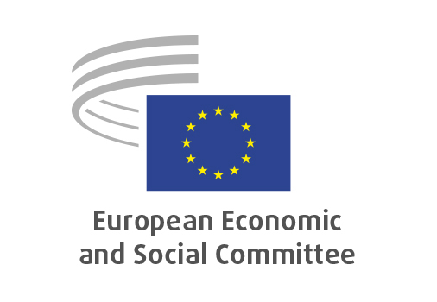
EN

ECO/691
National reform and investment proposals and their implementation: 2025-2026 European Semester cycle

Brussels, 18 June 2026

RECORD OF THE PROCEEDINGS
European Economic and Social Committee
The point of view of organised civil society in the EU Member States on national reform and investment proposals and their implementation (2025-2026 European Semester cycle)
_____________

606th plenary session
Brussels
17-18 June 2026
_____________

Meeting of 18 June 2026
_____________

Agenda item 20
_____________

The vice-president, Alena Mastantuono, instructed those present to turn to agenda item 20 – The adoption of an information report on:

The point of view of organised civil society in the EU Member States on national reform and investment proposals and their implementation (2025-2026 European Semester cycle).

Preliminary work had been carried out by the Section for Economic and Monetary Union and Economic and Social Cohesion (president: Elena Calistru). The rapporteurs were Gonçalo Lobo Xavier, Andrea Mone and Luca Jahier.

Mr Lobo Xavier highlighted that through written responses to a questionnaire in 22 Member States, and 5 dedicated round-table discussions, we had engaged with 110 stakeholders, whose contributions had enriched our work. He stated that this important exercise was possible thanks to the commitment and support of 81 EESC members. Then he moved on to the first key conclusion that had emerged from this consultation: stakeholders had highlighted several recurring challenges regarding the implementation of the national medium-term fiscal-structural budget plans: limited resources, heavy administrative burdens and fragmented processes regarding the monitoring of the implementation of those plans and the annual progress report. He underlined that much remained to be done within the European Semester framework to strengthen stakeholder involvement and improve policy processes. In particular, he underlined the need to strengthen stakeholder structures and consultation mechanisms to better integrate civil society perspectives into policymaking.

Mr Jahier noted that the report itself provided only a summary of the findings. He emphasised that a substantial annex accompanied the report containing extensive material and detailed contributions from stakeholders. The annex represented the richest and most valuable part of the exercise and deserved particular attention from the European institutions. He highlighted two key findings from the consultation. Firstly, while formal consultation mechanisms existed in most Member States, social partners and civil society organisations felt that their participation in the European Semester process was insufficient. They reported that consultations often occurred too late in the policy cycle, limiting their influence on final decisions. Secondly, stakeholders noted a tension between strengthening EU-level coordination and concerns over increased centralisation. While aligning the European Semester with the next multiannual financial framework (MFF) could improve coherence and effectiveness, there were concerns about national autonomy, democratic oversight and possible imbalances in decision-making processes.

Mr Mone addressed the findings on country-specific recommendations (CSRs), noting that social partners and civil society generally found them relevant to their countries’ key challenges. However, stakeholders identified shortcomings in the implementation of the CSRs at national level, particularly in translating recommendations into actionable policies, and in their limited involvement in the process. They emphasised that economic and fiscal objectives often took precedence over social objectives. He said that they called for a more balanced approach in order to enhance legitimacy and public support for reforms. Strengthening stakeholder involvement and improving CSR implementation was essential for achieving this balance within the European Semester framework.

Following this presentation, Javier Doz Orrit took the floor and emphasised that the information report offered valuable insights for both the EESC and wider European institutions. The findings reflected the experiences and concerns of on-the-ground stakeholders, aiding in the design and implementation of European policies. He highlighted the significance of the consultation exercise as a key Committee activity, fostering direct dialogue with social partners and civil society organisations. This process enhanced the democratic legitimacy, relevance and quality of the Committee’s work, contributing to a more inclusive European policymaking approach.

Two votes were needed for the information report: one on the adoption of the report and another on the transmission of the report to the EU Institutions. As no amendments had been tabled, the information report was put straight to the vote. It was adopted by 157 votes for, with 2 abstentions. Following the second vote, with a result of 167 votes for, with 1 abstention, it was decided that this information report would be transmitted to the EU Institutions.

_____________

