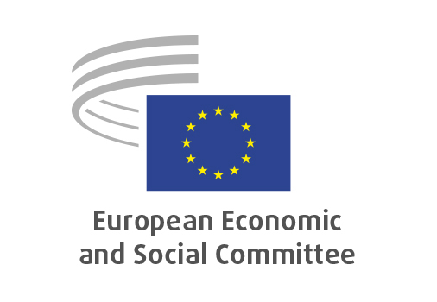
EN

ECO/692
The reform and investment proposals as part of the 2025-2026 European Semester cycle

Brussels, 18 June 2026

RECORD OF THE PROCEEDINGS
European Economic and Social Committee
The EESC’s recommendations on the reform and investment proposals formulated as part of the 2025-2026 European Semester cycle
_____________

606th plenary session
Brussels
17-18 June 2026
_____________

Meeting of 18 June
_____________

Agenda item 21
_____________

The vice-president Mastantuono moved that the Committee turn to agenda item 21 - adoption of a resolution on

The EESC’s recommendations on the reform and investment proposals formulated as part of the 2025-2026 European Semester cycle.

The preliminary work had been carried out by the Section for Economic and Monetary Union and Economic and Social Cohesion (president: Ms Elena Calistru). The rapporteurs were Gonçalo Lobo Xavier, Andrea Mone and Luca Jahier.

Mr Lobo Xavier stated that, building on the views and experiences shared by stakeholders across the Member States, the rapporteurs formulated a number of key recommendations. The first recommendation was to enhance the partnership principle, step by step, as the governance of the Multiannual Financial Framework (MFF) and the European Semester converge. Stakeholder involvement should evolve from a procedural requirement into a genuine driver of policy effectiveness. Secondly, the resolution called on the Commission to improve both the quality and the timing of the information and consultation processes within the European Semester. In addition, the resolution called for the introduction of a mandatory assessment of the quality and impact of the partnership. This assessment should not examine not only whether partners have been consulted, but also the extent to which their input has shaped final operational programmes. Finally, he stressed that this should be accompanied by a radical simplification of delivery mechanisms.

Mr Jahier noted that the resolution focused on ten key priorities and is accompanied by a 13-page report and a 71-page annex, which the relevant European institutions should properly consider. First, it called on the Commission to better integrate the four forms of capital: economic, human, social and environmental, moving beyond a GDP-centred approach toward broader prosperity based on resilience, cohesion and sustainability. Second, regarding the link between the next MFF and European Semester, it supported closer, more coherent integration to align the EU budget with national finances and strategic priorities. It also called for the implementation of the single market, paying particular attention to the capital markets union, to be fully integrated into the European Semester and the Country-Specific Recommendations (CSRs). He stressed that in order to pursue and deliver genuine European added value through the intertwining of the European Semester and the MFF, it was crucial to unlock the EU’s potential while preserving flexibility, subsidiarity and multilevel governance. Finally, he stated that they firmly rejected the logic of punitive macroeconomic conditionality, and recommended, instead, a structure of positive incentives, whereby the European Semester identified strategic bottlenecks and the MFF provided targeted support to address them.

Mr Mone added that the resolution highlighted that in order to ensure the long-term sustainability of the EU’s strategic objectives and the resilience of its economy, fiscal space should be created to achieve the EU’s common social objectives. In particular, it should contribute to the Social Investment Hub recently launched by the European Commission. He stressed that the implementation of social CSRs has historically been inadequate, inefficient or even non-existent. He underlined that the rapporteurs called for government action to be mandated and strengthened in order to trigger the necessary dynamism at national level. He said that it was essential to accelerate the design, implementation and delivery of reforms, as well as their democratic evaluation. He said that in order to achieve this objective, the European Union had to develop a more robust collaborative framework. Within such a framework, results and performance were rewarded through targeted technical assistance and flexibility in co-financing. At the same time, due account should be taken of the specific characteristics of national and regional contexts.

Following this presentation, Mr Doz Orrit took the floor and noted that there may be significant challenges in implementing CSRs at the national level, which could affect the overall coherence and effectiveness of the European Semester framework. He added that, at the same time, the EU was facing major geopolitical and economic challenges. Defence commitments, recovery efforts and long-term strategic planning all required a higher degree of coordination between Member States and at EU level. He stressed that countries too often acted individually rather than in a coordinated, collective manner, limiting the effectiveness of common responses to shared challenges. Against this background, the broader policy environment remained demanding. Finally, he stressed that stronger coordination and a more collective approach were essential to address both current and future challenges effectively.

As no amendments has been tabled, the resolution had been put straight to the vote.

The opinion was adopted by 175 votes to 3.

_____________

