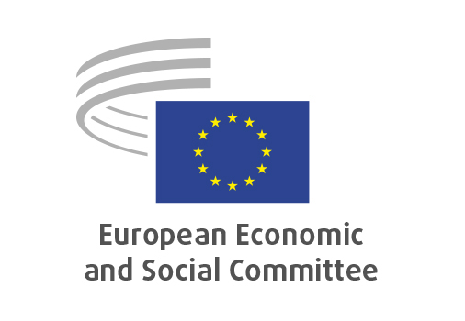
EN

CCMI/261
Blue Deal Accelerator

Brussels, 18 June 2026

RECORD OF THE PROCEEDINGS
European Economic and Social Committee
Blue Deal Accelerator – technology, skills and finance for a water-resilient future
(own-initiative opinion)

_____________

The 606th plenary session
Brussels
17-18 June 2026
_____________

Meeting of 18 June 2026
_____________

Agenda item 18
_____________

The president moved that the Committee turn to agenda item 18 - adoption of an opinion on the

Blue Deal Accelerator – technology, skills and finance for a water-resilient future
(own-initiative opinion).

The preliminary work had been carried out by the Consultative Commission on Industrial Change (president: Alain COHEUR). The rapporteur was Magdalena RZECZKOWSKA. The co-rapporteur was Lea APPULO.

The CCMI adopted the opinion on 20 May 2026 by 28 votes in favour, 1 vote against and 0 abstentions.

The adoption of the opinion was preceded by the high-level debate entitled "From the EU Blue Deal and water resilience to global water action" with Jessika Roswall, European Commissioner for Environment, Water Resilience and a Competitive Circular Economy, Hildegard Bentele, Member of the European Parliament, vice-chair of the Committee on Development (DEVE) and chair of the MEP Water Group, and Pedro Arrojo-Agudo, UN Special Rapporteur on the human rights to safe drinking water and sanitation.

Ms RZECZKOWSKA and Ms APPULO presented the opinion during the debate.

The Assembly then examined the following two amendments to the opinion:

Amendment 1 (tabled by Carole DESIANO, Thomas KATTNIG, Florian MARIN and Monika SITAROVÁ)

Point 1.11
Amend as follows:

Section opinion | Amendment
With water scarcity, climate impacts and competing uses are already affecting key sectors of the EU economy, the EESC calls for water to be treated as a critical production factor underpinning competitiveness and strategic autonomy, and as a strategic, standalone priority across all EU policies. | With water scarcity, climate impacts and competing uses already affecting key sectors of the EU economy, whilst emphasising that water is a human right and a public good, the EESC calls for water to be treated as a critical production factor underpinning competitiveness and strategic autonomy, and as a strategic, standalone priority across all EU policies.

The amendment was approved.

Amendment 2 - (tabled by APPULO Lea, DESIANO Carole, KATTNIG Thomas, MARIN Florian, RZECZKOWSKA Magdalena, SITÁROVÁ Monika)

Point 2.1
Amend as follows:

Section opinion | Compromise
The EESC underlines the importance of an integrated approach to water policy linking social, environmental, industrial, innovation, skills and infrastructure policies. The BDA should translate strategic priorities into tangible measures supporting the transition towards a water-smart society and economy, and provide a practical framework to connect industrial transformation, the use of water-smart technologies, workforce development and investments. It should promote integrated approaches combining grey infrastructure with NbS, including wetlands[1], which act as natural ‘sponges’ that store, regulate and purify water.  [1] In this opinion we define wetlands according to the 1971 Ramsar Convention on Wetlands of International Importance Especially as Waterfowl Habitat. | The EESC emphasises that water is a human right and underlines the importance of an integrated approach to water policy linking social, environmental, industrial, innovation, skills and infrastructure policies. Water governance and financing frameworks should safeguard the public interest and ensure universal, affordable, and equitable access to water and sanitation. Private-sector participation can contribute additional resources and expertise, provided that public authorities maintain full responsibility and accountability for service provision and access outcomes. The BDA should translate strategic priorities into tangible measures supporting the transition towards a water-smart society and economy, and provide a practical framework to connect industrial transformation, the use of water-smart technologies, workforce development and investments. It should promote integrated approaches combining grey infrastructure with NbS, including wetlands[1], which act as natural ‘sponges’ that store, regulate and purify water.  [1] In this opinion we define wetlands according to the 1971 Ramsar Convention on Wetlands of International Importance Especially as Waterfowl Habitat.

A compromise was proposed and accepted by the Assembly.

The opinion thus amended was put to the vote and was adopted by 183 votes in favour, 0 votes against and 7 abstentions.

_____________

