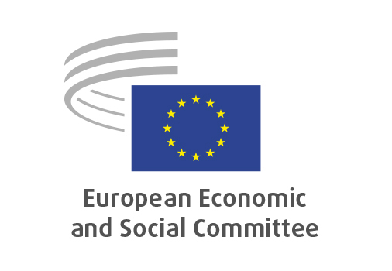
EN

CCMI/259
RESourceEU Action Plan

Brussels, 17 June 2026

RECORD OF THE PROCEEDINGS
European Economic and Social Committee
RESourceEU Action Plan
(COM(2025) 945 final)
_____________

606st plenary session
Brussels
17-18 June 2026
_____________

Meeting of 17 March 2026
_____________

Agenda item 13
_____________

The president moved that the Committee turn to agenda item 13 - adoption of an opinion on

RESourceEU Action Plan
(COM(2025) 945 final)

The preliminary work had been carried out by the Consultative Commission on Industrial Change (President: Alain COHEUR). The rapporteur was Konstantinos DIAMANTOUROS. The Co-rapporteur was Agata MEYSNER.

The section adopted its opinion by 22 votes in favour, no vote against and no abstention by CCMI Members, and by 27 votes in favour, no vote against and no abstention by CCMI Delegates on 11 June 2026.

Mr DIAMANTOUROS and Ms MEYSNER presented the opinion and raised the following points:

- critical raw materials (CRMs) are currently a major issue for Europe;
- affordable energy is essential for maintaining competitiveness;
- while the Emissions Trading System (ETS) plays a central role in the EU policy architecture, in the current geopolitical context it can also represent a cost burden that hampers the competitiveness of CRM-related industries;
- circularity should become a central pillar of industrial policy, including enhanced resource stewardship and recycling efforts;
- transparency, accountability and social acceptance are essential elements of a successful CRM strategy;
- any revision of the Water Framework Directive should not lead to a weakening of water protection standards.

In the ensuing debate, Mr TRACEVIČIUS, Mr COHEUR, Ms DESIANO, Mr FORNEA, Mr SCHWARTZ, Mr BÉGUINET and Ms SCHOEMAKERS took the floor and raised the following points:

- stressed the importance of strengthening the EU's strategic autonomy through increased domestic supply, local production and circularity;
- underlined the need for the involvement of local communities and that social standards must be maintained;
- recalled that critical raw materials are not only a strategic issue for Europe's future but are also closely linked to the historical mandate of the CCMI and its origins in the European Coal and Steel Community;
- warned against the relocation of jobs outside the EU;
- stressed the importance of securing supplies from international partners;
- underlined the need to reduce Europe's environmental footprint and highlighted the global implications of environmental degradation;
- financing remains the key challenge: EUR 3 billion is welcome but insufficient to meet Europe’s ambitions.
The Assembly then examined the following amendment to the opinion:

Point 3.1 – amendment tabled by COMER John and NEIIENDAM Juliane Marie
Amend as follows:

Amendment 1

Section opinion | Amendment
The EESC stresses that regulatory frameworks exist to safeguard public interests, environmental integrity and workers’ rights and should therefore be improved. The current framework faces implementation bottlenecks, particularly due to administrative capacity constraints, energy price volatility and fragmented coordination across Member States. Social acceptance is a decisive condition for project viability and legitimacy and requires meaningful community engagement and strong social dialogue from the earliest stages, including permitting, financing and partnerships. Public funding should, alongside corporate project development, support local authority capacity, independent expertise for communities and monitoring and enforcement. | The EESC stresses that regulatory frameworks exist to safeguard public interests, environmental integrity and workers’ rights and should therefore be improved. The current framework faces implementation bottlenecks, particularly due to administrative capacity constraints, energy price volatility and fragmented coordination across Member States. Social acceptance is a decisive condition for project viability and legitimacy and requires meaningful community engagement and strong civil and social dialogue from the earliest stages, including permitting, financing and partnerships. Public funding should, alongside corporate project development, support local authority capacity, independent expertise for communities and monitoring and enforcement.

Reason
This amendment means to state the importance of civil dialogue.

The amendment was accepted by the rapporteur and co-rapporteur and was subsequently adopted unanimously by the Assembly without a vote.

The opinion was adopted by 174 votes in favour, 0 against and 1 abstention.

_____________

