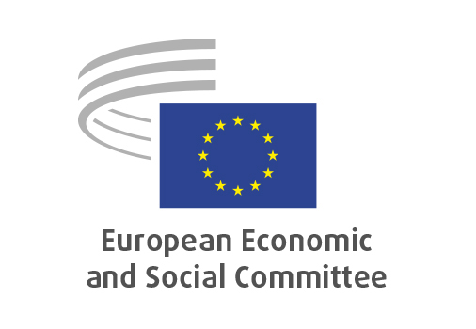
EN

CCMI/254
UN Water Conference 2026

Brussels, 18 June 2026

RECORD OF THE PROCEEDINGS
European Economic and Social Committee
EESC Contribution to the UN Water Conference 2026: from the EU Blue Deal and Water Resilience Strategy to global water action
(own-initiative opinion)
_____________

606st plenary session
Brussels
17-18 June 2026
_____________

Meeting of 18 June 2026
_____________

Agenda item 16
_____________

The president moved that the Committee turn to agenda item 13 - adoption of an opinion on

EESC Contribution to the UN Water Conference 2026: from the EU Blue Deal and Water Resilience Strategy to global water action
(own-initiative opinion)

The preliminary work had been carried out by the Consultative Commission on Industrial Change (President: Alain COHEUR). The rapporteur was Paul RÜBIG. The Co-rapporteur was Hervé JEANNIN.

The CCMI adopted its opinion by 33 votes in favour, no votes against and no abstentions by CCMI Members, and by 33 votes in favour, no vote against and no abstentions by CCMI Delegates on 20 May 2026.

The adoption of the opinion in the EESC Plenary was preceded by the high-level debate entitled "From the EU Blue Deal and water resilience to global water action" with Jessika Roswall, European Commissioner for Environment, Water Resilience and a Competitive Circular Economy, Hildegard Bentele, Member of the European Parliament, vice-chair of the Committee on Development (DEVE) and chair of the MEP Water Group, and Pedro Arrojo-Agudo, UN Special Rapporteur on the human rights to safe drinking water and sanitation.

Mr RÜBIG and Mr JEANNIN presented the opinion during the debate.

The Assembly then examined the following amendment to the opinion:

Amendment 1 (tabled by Brigitta HIDVÉGHINÉ PULAY)

Point 1.8
Amend as follows:

Section opinion | Amendment
Increased investment is critical, but public resources alone will not be sufficient. The EESC calls for the phase-out of environmentally harmful subsidies [3], as well as stronger and clear enabling conditions for the mobilisation of private investments, including via evidence-based risk assessment and risk-sharing mechanisms. Blended finance approaches should mobilise public and private capital and support a robust pipeline of bankable SDG 6 projects. Experience shows that the provision of drinking water by the public sector is a sound option for citizens as the public sector is committed to the public sustainable infrastructure., Consequently, the financing of drinking water and wastewater services should primarily come from public funds and no tax on water should be granted.  [3] NAT/946 Phasing out fossil fuel subsidies while ensuring European competitiveness, mitigating the cost-of-living crisis, and promoting a just transition. | Increased investment is critical, but public resources alone will not be sufficient. The EESC calls for the phase-out of environmentally harmful subsidies, as well as stronger and clear enabling conditions for the mobilisation of private investments, including via evidence-based risk assessment and risk-sharing mechanisms. Blended finance approaches should mobilise public and private capital and support a robust pipeline of bankable SDG 6 projects. Experience shows that the provision of drinking water by the public sector is a sound option for citizens as the public sector is committed to the public sustainable infrastructure., Consequently, the financing of drinking water and wastewater services should primarily come from public funds and no tax on water should be granted.

The amendment was approved.

The opinion thus amended was put to the vote and was adopted by 182 votes in favour, 0 against and 4 abstentions.

_____________

