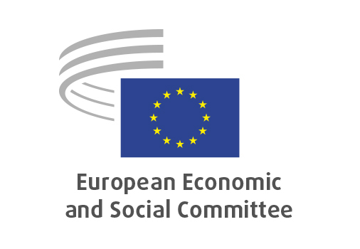
EN

SOC/857
EU Drugs Strategy

Brussels, 29 April 2026

RECORD OF THE PROCEEDINGS
European Economic and Social Committee
Communication from the Commission to the European Parliament and the Council
on the EU Drugs Strategy
(COM(2025) 743 final)

Communication from the Commission to the European Parliament and the Council
on the EU Action Plan against drug trafficking
(COM(2025) 744 final)
_____________

605th plenary session
Brussels
29-30 April 2026
_____________

Meeting of 29 April 2026
_____________

Agenda item 22
_____________
The president moved that the Committee turn to agenda item 22 - adoption of an opinion on the

EU Drugs Strategy
COM(2025) 743 final, COM(2025) 744 final

The preliminary work had been carried out by the Section for Employment, Social Affairs and Citizenship (president: Cinzia DEL RIO). The rapporteur was Diego DUTTO.

The opinion was adopted by 193 votes and one abstention.

_____________

