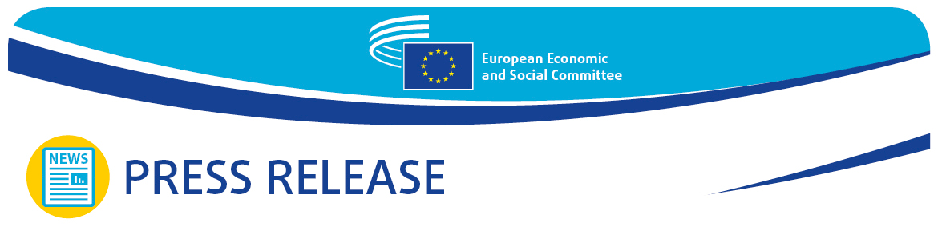
No 25/2026 | 9 May 2026

EN
2026 Open Day: EESC marks #EuropeDay with a unique opportunity to experience the spirit of engagement first hand

The European Economic and Social Committee (EESC) held an open day to celebrate Europe and highlight the important role played by organised civil society in the achievements of the European Union.

Thousands of people visited the EESC headquarters in Brussels on Saturday 9 May 2026, when the EU’s oldest consultative body opened its doors for the traditional Open Day.

9 May, Europe Day, marks the 76th anniversary of the Schuman Declaration, the historic speech by French foreign minister Robert Schuman in 1950 which paved the way for European integration. Europe Day is a chance to acknowledge the achievements of the European project and to celebrate the community of values that the EU represents and that we, as Europeans, protect and nourish every day.

‘Europe Day is a really important day to take stock and celebrate the achievements of the European project, including peace, democracy, and inclusion,’ Séamus Boland, the EESC President said. ‘It was a genuine pleasure to host visitors to our open day today and celebrate this spirit of participation.’

‘I am very happy that the EESC could host an open-door and festive celebration for Europe Day,’ added Marija Hanževački, the EESC Vice-President for Communication. ‘Europe Day is a celebration of joy and unity for citizens of all ages to share European values and build a Europe for all. The Open Day offers a unique opportunity to experience the spirit of engagement first hand, to discover the workings of the Committee and to learn how complex debates are turned into opinions.’

The EESC is the only EU institution representing organised civil society. Its members come from all social and professional backgrounds and have a vast range of knowledge and experience. They represent employers’ associations, industry, chambers of commerce, associations of small and medium-sized enterprises (SMEs), trade unions, consumers, farmers, disability campaigners, academia, women’s rights groups, environmentalists, cooperatives, youth organisations, human rights organisations and many more.

EESC members come from all EU Member States and speak for those whose voice could not otherwise be heard. They bring their expertise and make sure that, when advising EU institutions, EESC opinions reflect citizens’ views, concerns and expectations.

During the EESC Open Day, visitors were able to step inside the Committee building and discover how it gives a voice to organised civil society across the EU and thus contributes to European democracy. They had the opportunity to meet the people behind the work, explore how EESC opinions are drawn up, and experience personally how inclusive dialogue helps to shape Europe’s future and build a stronger Union.

In short, the Open Day was a key moment to:

- Meet EESC members and staff and see with their own eyes how organised civil society has an impact on EU policies;

- Find out more about the EESC’s role and activities and how it contributes to EU decision-making;

- Learn about the EESC President’s programme, the Committee’s current work and past achievements.

The event was an opportunity for openness, exchange and celebration for the public and EESC members and staff, and included engaging discussions, interactive experiences, visits to themed stands and guided tours of the facilities in the Jacques Delors building.

For more information about the EESC, please visit our website.

For more information, please contact:

EESC Press Unit – Marco Pezzani
+32 (0)2 546 97 93 · Mob. +32 (0)470 881 903
marco.pezzani@eesc.europa.eu

@EESC_PRESS

_______________________________________________________________________________
The European Economic and Social Committee represents the various economic and social components of organised civil society. It is an institutional consultative body established by the 1957 Treaty of Rome. Its consultative role enables its members, and hence the organisations they represent, to participate in the EU decision-making process.
_______________________________________________________________________________

