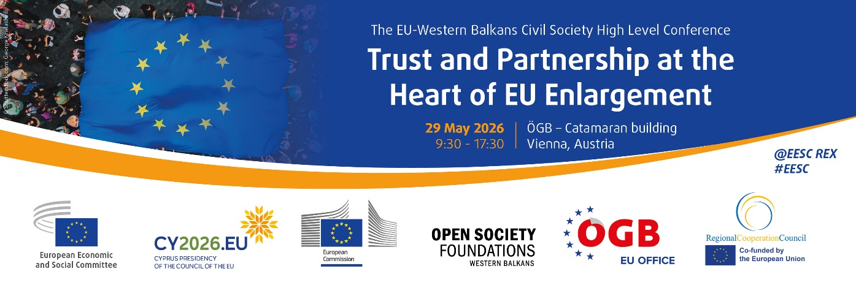
EN
PROGRAMME

Friday, 29 May 2026
Johann-Böhm-Platz 1, 1020 Vienna
09:00 | Registration of participants
09:30 | Welcoming addresses  - Séamus Boland, President of the EESC  - Wolfgang Katzian, President of the Austrian Trade Union Federation and the President of the European Trade Union Confederation  - Marilena Raouna, Deputy Minister of European Affairs, Cyprus Presidency of the Council of the EU (video message)
09:45 | Opening session - The Western Balkans on the Road to the EU: Trust, Democracy, Civil Society  Moderator: Corina Stratulat, European Policy Centre (EPC)  - Séamus Boland, President of the EESC  - H.E. Ulrike Hartmann, Special Envoy for Southeast Europe and EU-Enlargement, Federal Ministry for European and International Affairs of the Republic of Austria  - Eva Liebmann, Deputy Secretary-General, Austrian Federal Economic Chamber  - Thomas Waitz, Member of the European Parliament  - Wojciech Kowalski, Advisor on the Western Balkans, Directorate-General for Enlargement and Eastern Neighbourhood, European Commission  - Andi Dobrushi, Director of Open Society Foundations – Western Balkans  DISCUSSION
11:00 | Coffee break
11:30 | Enlargement and European Security: Public Expectations, Political Readiness and Civil Society’s Role  Moderator: Corina Stratulat, European Policy Centre (EPC)  - Patrick Lobis, Head of the European Commission Representation in Austria  - Danijela Gacevic, Head of the Programme Department in the Secretariat of the Regional Cooperation Council  - Frauke M. Seebass, Associate Researcher at the Hellenic Foundation for European & Foreign Policy (ELIAMEP) and Visiting Fellow, SWP Brussels  - Veronika Móra, Co-President of the European Civic Forum  - Andreas Accardo, Head of Unit, Institutional Cooperation and EU Charter, EU Agency for Fundamental Rights (FRA)  DISCUSSION
13:00 | Lunch offered by the Regional Cooperation Council (RCC)
14:30 | Reform Momentum and the Multiannual Financial Framework (MFF): Opportunities for Civil Society
14:30 | Session I: Civil Society and the Growth Plan: Best Practices from the Region  Moderator: Violeta Jelić, President of the EESC’s Western Balkans Follow-up Committee  - Andrej Zorko, Vice-President of the EESC’s Western Balkans Follow-up Committee  - Simonida Kacarska, Reform Monitor for the EU Growth Plan for the Western Balkans – TEN network (Director of the European Policy Institute – Skopje)  - Srđan Majstorović, Chair of the Governing Board, European Policy Centre Serbia  - Jorida Shytaj, Executive Director of Europe Plus  - Uroš Bulatović, President of the Young Entrepreneurs Union of Montenegro  DISCUSSION
15:45 | Session II: The Next MFF: Funding Civil Society and Accelerating Socio-Economic Convergence  Moderator: Ionuţ Sibian, Vice-President of the EESC’s Western Balkans Follow-up Committee  - Umur Gökçe, Deputy Head of the OECD’s South-East Europe Division  - Branimir Jovanović, Economist at the Vienna Institute for International Economic Studies (wiiw)  - Agon Nixha, Senior expert on Competitiveness, Regional Cooperation Council (RCC)  - Egzona Shala, Executive Director, Youth Ecological and Security Zone-EcoZ  - Klotilda Kosta, Board Chair, Balkan Civil Society Development Network (BCSDN)  - Aida Daguda, Director, Center for Civil Society Promotion (CPCD)  DISCUSSION
17:00 | Key Takeaways and Closing Remarks  - Violeta Jelić, President of the EESC’s Western Balkans Follow-up Committee

Interpreting: DE/EN/BS-HR-MN-SR/MK/SQ into DE/EN/BS-HR-MN-SR/MK/SQ

More information on the EESC:

balkans@eesc.europa.eu
www.eesc.europa.eu
http://www.eesc.europa.eu/en/tags/western-balkans
@EESC_REX #EESC_WB

