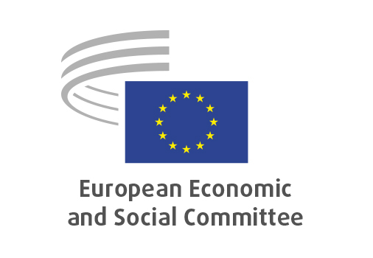
EN

NAT/971
Food and feed simplification omnibus

Brussels, 29 April 2026

RECORD OF THE PROCEEDINGS
European Economic and Social Committee
Proposal for a Directive of the European Parliament and of the Council amending Council Directive 98/58/EC and Directive 2009/128/EC of the European Parliament and of the Council as regards the simplification and strengthening of food and feed safety requirements, and repealing Council Directives 82/711/EEC and 85/572/EEC
[COM(2025) 1021 final – 2025/0409 COD]
Proposal for a Regulation of the European Parliament and of the Council amending Regulations (EC) No 999/2001, (EC) No 1829/2003, (EC) No 1831/2003, (EC) No 852/2004, (EC) No 853/2004, (EC) No 396/2005, (EC) No 1099/2009, (EC) No 1107/2009, (EU) No 528/2012, (EU) 2017/625 as regards the simplification and strengthening of food and feed safety requirements
[COM(2025) 1030 final – 2025/0410 COD]
_____________

605 plenary session
Brussels
29-30 April 2026
_____________

Meeting of 29th of April
_____________

Agenda item 17
_____________

The president moved that the Committee turn to agenda item 23 - adoption of an opinion on the

Proposal for a Directive of the European Parliament and of the Council amending Council Directive 98/58/EC and Directive 2009/128/EC of the European Parliament and of the Council as regards the simplification and strengthening of food and feed safety requirements, and repealing Council Directives 82/711/EEC and 85/572/EEC COM(2025) 1021 final – 2025/0409 COD Proposal for a Regulation of the European Parliament and of the Council amending Regulations (EC) No 999/2001, (EC) No 1829/2003, (EC) No 1831/2003, (EC) No 852/2004, (EC) No 853/2004, (EC) No 396/2005, (EC) No 1099/2009, (EC) No 1107/2009, (EU) No 528/2012, (EU) 2017/625 as regards the simplification and strengthening of food and feed safety requirements COM(2025) 1030 final – 2025/0410 COD.

The preliminary work had been carried out by the Section for Agriculture, Rural Development and the Environment (president: Mr Stoyan TCHOUKANOV). The rapporteur was Mr Felipe MEDINA MARTIN and co-rapporteur Mr John COMER. In the ensuing debate, Mr Tchoukanov took the floor. The main issues discussed were the following:

- The complexity of the EU simplification package for food and animal feed which combines many different legislative proposals from the Commission.
- The fact that the simplification effort must not undermine workers’ safety and rights, food safety, or environmental protection. The goal is simplification, not deregulation, while maintaining the highest food standards.
- The opinion generally welcomes the EC proposal with specific recommendations and while also looking beyond the Commission’s original scope, including elements that were initially left out, with strong reflection on the single market and on improving EU competitiveness, including greater engagement with innovative and digital solutions such as the use of drones.
- Simplifications for plant protection (including biocontrol) products are a major element of the package and require caution, while also presenting significant potential savings, both economic and environmental. The removal of import tolerances for some of these products need a full impact assessment.

3 amendments by Mr MARIN Florian and Ms UHL Susanne were compromised and accepted by the rapporteurs and the floor.

The opinion thus amended was put to a vote and adopted by the Assembly by 171 votes in favour, two votes against and one abstention.

_____________

