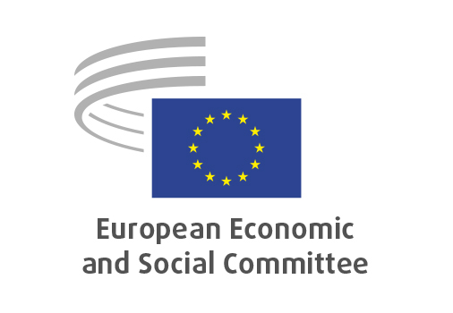
EN

NAT/970
Nature-based biodegradable materials

Brussels, 29/4/2026

RECORD OF THE PROCEEDINGS
European Economic and Social Committee
A comprehensive strategy for nature-based biodegradable materials to foster circularity and resource efficiency, strengthen the agri-food sector and scale-up the EU bioeconomy
(own-initiative opinion)
_____________

605th plenary session
Brussels
29-30 April 2026
_____________

Meeting of 29 April 2026
_____________

Agenda item 12
_____________

The president moved that the Committee turn to agenda item 12 - adoption of an opinion on the

A comprehensive strategy for nature-based biodegradable materials to foster circularity and resource efficiency, strengthen the agri-food sector and scale-up the EU bioeconomy
(own-initiative opinion).

The preliminary work had been carried out by the Section for Agriculture, Rural Development and the Environment (president: Stoyan TCHOUKANOV). The rapporteur was Stoyan TCHOUKANOV (BG-III).

Mr. Stoyan TCHOUKANOV presented the opinion and highlighted the following points:

- Nature-based biodegradable materials offer a novel approach and an alternative to fossil-based materials while strengthening European competitiveness.
- Nature-based biodegradable materials can replace small, hard-to-collect products on industrial scale and prevent microplastic pollution.
- The valorisation of residues provides an additional source of income for farmers and fishermen.

In the ensuing debate, Ms. Corina MURAFA BENGA, Mr. Josep PUXEU ROCAMORA, Mr. Domantas TRACEVIČIUS, Mr. Simo TIAINEN, Mr. Jaume BERNIS CASTELLS, Ms. Maria NIKOLOPOULOU, Mr. Marc DECOSTER, Mr. Christophe BEGUINET took the floor to comment. The main points raised were as follows:

- The bioeconomy must be circular within planetary boundaries, and the priority must be waste prevention.
- Biomass and bio-based solutions have limited potential and need strong environmental safeguards. Not all bio-based or biodegradable products are sustainable in practice.
- The bioeconomy is a strategic opportunity, especially for agriculture and industry: it can support climate neutrality, new supply chains, added value, innovation, and job creation if applied wisely.

The opinion was adopted by 211 in favour, 0 against and 3 abstentions.

_____________

