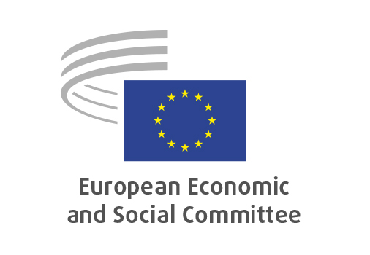
EN

SOC/854
Ban on conversion practices in the EU

Brussels,

RECORD OF THE PROCEEDINGS
European Economic and Social Committee
Ban on conversion practices in the European Union
(own-initiative opinion)
_____________

605th plenary session
Brussels
29-30 April 2026
_____________

Meeting of 29 April 2026
_____________

Agenda item 10
_____________

The president moved that the Committee turn to agenda item 10 - adoption of an opinion on the

Ban on conversion practices in the European Union
(own-initiative opinion).

The preliminary work had been carried out by the Section for Employment, Social Affairs and Citizenship (president: Cinzia Del Rio). The rapporteur was Pascal Debay and the co-rapporteur was Ionuţ Sibian.

The own-initiative opinion was adopted by 169 votes in favour, 3 votes against and 9 abstentions.

_____________

