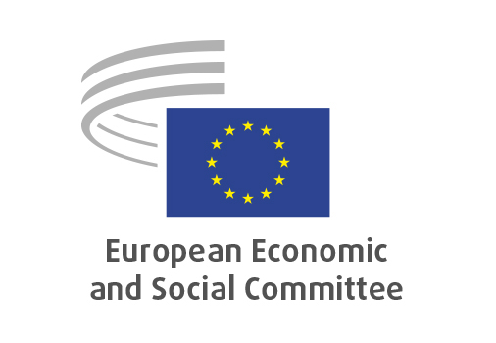
EN

INT/1114
Drug precursors

Brussels, 29 April 2026

RECORD OF THE PROCEEDINGS
European Economic and Social Committee
Proposal for a Regulation of the European Parliament and of the Council on monitoring and controlling drug precursors and repealing Regulations (EC) No 273/2004 and (EC) No 111/2005
[COM(2025) 747 final – 2025/0384 (COD)]
_____________

605th plenary session
Brussels
29-30 April 2026
_____________

Meeting of 29 April
_____________

Agenda item 22
_____________

The president moved that the Committee turn to agenda item 22 - adoption of an opinion on the

Proposal for a Regulation of the European Parliament and of the Council on monitoring and controlling drug precursors and repealing Regulations (EC) No 273/2004 and (EC) No 111/2005
COM(2025) 747 final – 2025/0384 (COD).

The preliminary work had been carried out by the Section for Single Market, Production and Consumption (president: Émilie PROUZET). The rapporteur was Diego DUTTO.

As the section had adopted its opinion at unanimity on 15 April 2026 and no amendments had been tabled, the Committee decided unanimously not to hold a general discussion and to put the opinion straight to the vote (Rules 64(4) and 76(3)).

The opinion was adopted by 195 votes with one abstention.

_____________

