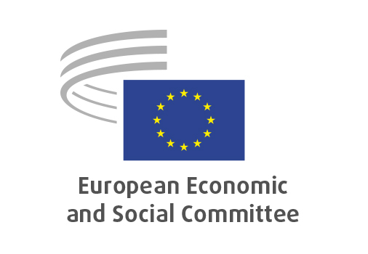
EN

INT/1107
2030 Consumer Agenda

Brussels, 29 April 2026

RECORD OF THE PROCEEDINGS
European Economic and Social Committee
Communication from the Commission to the European Parliament, the Council, the European Economic and Social Committee and the Committee of the Regions
2030 Consumer Agenda and action plan for consumers in the single market
‘A new impulse for consumer protection, competitiveness and sustainable growth’
[COM(2025) 848 final]
_____________

605th plenary session
Brussels
29-30 April 2026
_____________

Meeting of 29 April 2026
_____________

Agenda item 20
_____________

The president moved that the Committee turn to agenda item 20 - adoption of an opinion on the

Communication from the Commission to the European Parliament, the Council, the European Economic and Social Committee and the Committee of the Regions
2030 Consumer Agenda and action plan for consumers in the single market
‘A new impulse for consumer protection, competitiveness and sustainable growth’
COM(2025) 848 final.

The preliminary work had been carried out by the Section for the Single Market, Production and Consumption (president: Émilie PROUZET). The rapporteur was Thierry LIBAERT.

The rapporteur presented the opinion.

In the ensuing debate, Mr TRACEVIČIUS and Mr MITOV took the floor and raised the following issues:
- the persisting problem of greenwashing;
- the need for an ambitious circular economy;
- the need to take into consideration social challenges and to tackle digital asymmetry.

The opinion was adopted by 191 votes to one, with one abstention.

_____________

