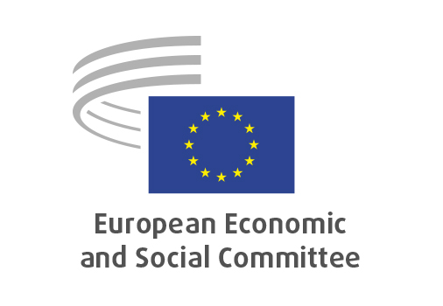
EN
REX/612
Civil Society’s Role in Supporting Reform under the Growth Plans for the Western Balkans and Moldova, as well as in Ukraine’s Reform Path

Brussels, 29 April 2026

RECORD OF THE PROCEEDINGS
European Economic and Social Committee
REX/612
Civil Society’s Role in Supporting Reform under the Growth Plans for the Western Balkans and Moldova, as well as in Ukraine’s Reform Path
(exploratory opinion)
_____________

605th plenary session
Brussels
29-30 April 2026
_____________

Meeting of 29 April 2026
_____________

Agenda item 15
_____________

The president moved that the Committee turn to agenda item 15 - adoption of an opinion on the

Civil Society’s Role in Supporting Reform under the Growth Plans for the Western Balkans and Moldova, as well as in Ukraine’s Reform Path
(exploratory opinion at the request of the Cyprus Presidency)

The preliminary work had been carried out by the Section for External Relations (president: Stefano PALMIERI). The rapporteur was Oleg ROIBU (RO-I) and the co-rapporteur was Andrej ZORKO (SI-II).

The section adopted its opinion on 17 April 2026 with 67 votes in favour, 0 votes against and 0 abstentions.

Mr Roibu presented the opinion stressing the need for the systematic structural framework and institutionalised role of the social partners and CSOs, as co-drivers in the implementation of the reforms within the three facilities. He pointed out that tight deadlines should not be an excuse for not including organised civil society in all stages of the reform implementation.

Mr Zorko stressed that the opinion builds upon previous work of the EESC on EU enlargement. He pointed out that the EU enlargement is very important geo-political process that changes lives of the citizens both in the EU candidate countries and in the EU member states. Even though the situation of social and civil dialogue in candidate countries varies from one country to another, the genuine inclusion of organised civil society should be universally promoted since it makes the process real for the citizens.

In the subsequent debate, Monika PANAYOTOVA (BG-I), Tanja BUZEK (DE-II), Lidija PAVIĆ-ROGOŠIĆ (HR-III), Andris GOBIŅŠ (LV-III) and Ionuţ SIBIAN (RO-III) took the floor. In their interventions they praised the inclusion of Enlargement Candidate Members (ECMs) in the hearing and the study group and pointed out to the best practices of some EU candidate countries when it comes to the inclusion of the organised civil society in the EU accession negotiations. They stressed that EU enlargement is a strategic investment in the future of Europe and that experience of EU member states that recently joined the EU is precious for the current EU candidate countries. They pointed out that consultations need to be genuine and not just a formality and that financing needs to be long-term and predictable. Representatives of organised civil society form the Western Balkans, Moldova and Ukraine should be more often included in all the work of the EESC, since this would help combat disinformation and misinformation about EU enlargement, as well as promote European values and European social and economic model.

There were no amendments.

The opinion was adopted by 193 votes in favour, 1 vote against and 4 abstentions.

_____________

