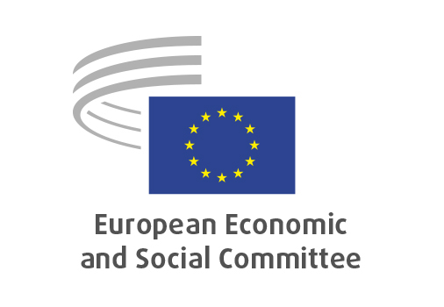
EN

INT/1120
Standardisation/single market

Brussels, 29 April 2026

RECORD OF THE PROCEEDINGS
European Economic and Social Committee
Strategic standardisation for a stronger single market
(own-initiative opinion)
_____________

605th plenary session
Brussels
29-30 April 2026
_____________

Meeting of 29 April 2026
_____________

Agenda item 22
_____________

The president moved that the Committee turn to agenda item 22 - adoption of an opinion on the

Strategic standardisation for a stronger single market
(own-initiative opinion).

The preliminary work had been carried out by the Section for the Single Market, Production and Consumption (president: Émilie PROUZET). The rapporteur was Angelo PAGLIARA.

As the section had adopted its opinion with less than five votes against on 15 April 2026 and no amendments had been tabled, the Committee decided unanimously not to hold a general discussion and to put the opinion straight to the vote (Rules 64(4) and 76(3)).

The opinion was adopted by 184 votes, with seven abstentions.

_____________

