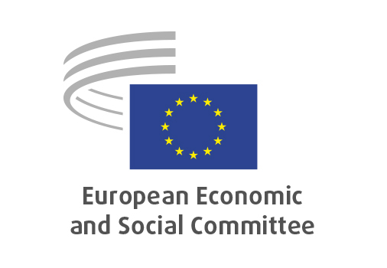
EN

TEN/869
Military mobility

Brussels, 18 March 2026

RECORD OF THE PROCEEDINGS
European Economic and Social Committee
Proposal for a Regulation of the European Parliament and of the Council on establishing a framework of measures to facilitate the transport of military equipment, goods and personnel across the Union
(COM(2025) 847 final – 2025/0847 (COD))

_____________

604th plenary session
Brussels
18-19 March 2026
_____________

Meeting of 18 March 2026
_____________

Agenda item 10
_____________

The president moves that the Committee turn to agenda item 10 - adoption of an opinion on the

Proposal for a Regulation of the European Parliament and of the Council on establishing a framework of measures to facilitate the transport of military equipment, goods and personnel across the Union
(COM(2025) 847 final – 2025/0847 (COD)).

The preliminary work had been carried out by the Section for Transport, Energy, Infrastructure and the Information Society (president: Marcin NOWACKI). The rapporteur was Tomas ARVIDSSON.

As the section had adopted its opinion with no votes against on 9 March 2026 and no amendments had been tabled, the Committee decided unanimously not to hold a general discussion and to put the opinion straight to the vote (Rules 64(4) and 76(3)).

The opinion was adopted by 204 votes to 5 and 12 abstentions.

_____________

