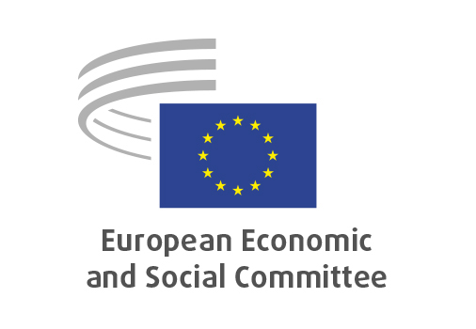
EN

TEN/864
EURATOM – Research and Training Programme 2028-2032

Brussels, 18 March 2026

RECORD OF THE PROCEEDINGS
European Economic and Social Committee
Proposal for a Council Regulation establishing the research and training programme of the European Atomic Energy Community for the period 2028-2032, complementing Horizon Europe, the Framework Programme for Research and Innovation, and providing for the Community’s contribution to the ITER project, and repealing Regulation (Euratom) 2025/1304
(COM(2025) 594 final – 2025/0594 (NLE))
_____________

604th plenary session
Brussels
18-19 March 2026
_____________

Meeting of 18 March 2026
_____________

Agenda item 5
_____________

The Vice-President asked that the Committee turn to agenda item 5 – adoption of an opinion on the

Proposal for a Council Regulation establishing the research and training programme of the European Atomic Energy Community for the period 2028-2032, complementing Horizon Europe, the Framework Programme for Research and Innovation, and providing for the Community’s contribution to the ITER project, and repealing Regulation (Euratom) 2025/1304
(COM(2025) 594 final – 2025/0594 (NLE))

The preliminary work had been carried out by the Section for Transport, Energy, Infrastructure and the Information Society (president: Marcin NOWACKI). The Rapporteur was Alena MASTANTUONO.

As the section had adopted its opinion with less than five votes against on 9 March 2026 and no amendments had been tabled, the Committee decided unanimously not to hold a general discussion and to put the opinion straight to the vote (Rules 64(4) and 76(3)).

The opinion was adopted by 209 votes for, 1 vote against and 5 abstentions.

_____________

