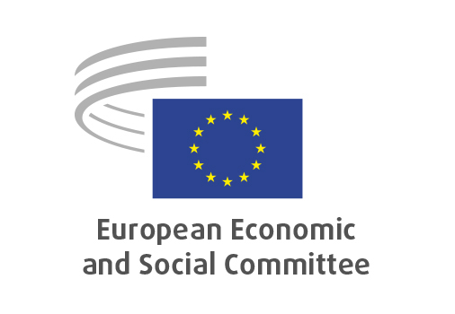
EN

NAT/977
Organic production amendment

Brussels, 18 Mach 2026

RECORD OF THE PROCEEDINGS
European Economic and Social Committee
Proposal for a regulation of the European Parliament and of the Council amending Regulation (EU) 2018/848 as regards certain production, labelling and certification rules and certain rules on trade with third countries
[COM(2025) 780 final – 2025/0417(COD)]
_____________

604 plenary session
Brussels
18-19
_____________

Meeting of 18th of March
_____________

Agenda item 5
_____________

The president moved that the Committee turn to agenda item 5 - adoption of an opinion on the

Proposal for a regulation of the European Parliament and of the Council amending Regulation (EU) 2018/848 as regards certain production, labelling and certification rules and certain rules on trade with third countries
COM(2025) 780 final – 2025/0417(COD).

The preliminary work had been carried out by the Section for Agriculture, Rural Development and the Environment (president: Mr Stoyan TCHOUKANOV). The rapporteur was Andreas THURNER.

As the section had adopted its opinion with less than five votes against on 26 February 2026 and no amendments had been tabled, the Committee decided unanimously not to hold a general discussion and to put the opinion straight to the vote (Rules 64(4) and 76(3)).

Vote on the opinion as a whole
The opinion was adopted by 204 votes in favour, 2 votes against and 1 abstention.

_____________

