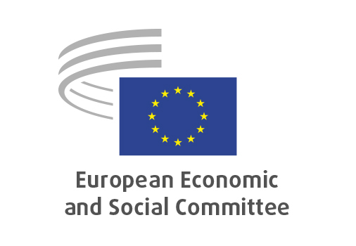
EN

INT/1118
Motor vehicles/Simplifying
technical requirements and testing

Brussels, 18 March 2026

RECORD OF THE PROCEEDINGS
European Economic and Social Committee
Proposal for a Regulation of the European Parliament and of the Council amending Regulations (EC) No 561/2006, (EU) 2018/858, (EU) 2019/2144 and (EU) 2024/1257 of the European Parliament and of the Council as regards the simplification of technical requirements and testing procedures for motor vehicles and repealing Council Directive 70/157/EEC and Regulation No 540/2014 of the European Parliament and of the Council
[COM(2025) 993 final - 2025/0422(COD)]
_____________

604th plenary session
Brussels
18-19 March 2026
_____________

Meeting of 18 March 2026
_____________

Agenda item 20
_____________

The president moved that the Committee turn to agenda item 20 - adoption of an opinion on the

Proposal for a Regulation of the European Parliament and of the Council amending Regulations (EC) No 561/2006, (EU) 2018/858, (EU) 2019/2144 and (EU) 2024/1257 of the European Parliament and of the Council as regards the simplification of technical requirements and testing procedures for motor vehicles and repealing Council Directive 70/157/EEC and Regulation No 540/2014 of the European Parliament and of the Council
COM(2025) 993 final - 2025/0422(COD)

The preliminary work had been carried out by the Section for the Single Market, Production and Consumption (president: Ms Emilie Prouzet).

In view of the urgency of the work, the European Economic and Social Committee had decided, under Rule 79 of the Rules of Procedure, to appoint Mr Hafner as rapporteur-general.

The rapporteur-general presented the opinion.

The opinion was adopted by 176 votes to three with three abstentions.

_____________

