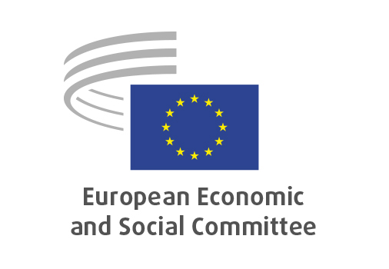
EN

INT/1110
European business wallets

Brussels, 18 March 2026

RECORD OF THE PROCEEDINGS
European Economic and Social Committee
Proposal for a Regulation of the European Parliament and of the Council on the establishment of European Business Wallets
[COM(2025) 838 final – 2025/0358 (COD)]
_____________

604th plenary session
Brussels
18-19 March 2026
_____________

Meeting of 18 March 2026
_____________

Agenda item 13
_____________

The president moved that the Committee turn to agenda item 13 - adoption of an opinion on the

Proposal for a Regulation of the European Parliament and of the Council on the establishment of European Business Wallets
COM(2025) 838 final – 2025/0358 (COD).

The preliminary work had been carried out by the Section for the Single Market, Production and Consumption (president: Ms Emilie Prouzet). The rapporteur was Mr Philip von Brockdorff.

The rapporteur presented the opinion.

In the ensuing debate Mr Athanasios Ioannidis and Ms Jurga Subačiūtė-Žemaitienė raised the following points:

- acknowledgement of the quality of the opinion which covered elements critical for the uptake of the European Business Wallets, including the need for operability at global level and incentives for small and medium-sized enterprises;
- appreciation for the inclusion of the need to ensure adequate protection for workers tasked with their management among the recommendations.

The Assembly then examined the opinion on the basis of the amendments tabled by Mr Bogdan, Mr Ioannidis, Ms Jelić, Mr Lefèvre, Ms Panayotova, Ms Sagramola, Ms Subačiūtė-Žemaitienė, Mr von Brockdorff and Mr Yiapanis (eesc-2025-03899-01-01-amp-tra-en).

Point 1.3 (amendment 1)

Delete point:

Section opinion | Amendment
recommends that the European Business Wallet facilitate innovation and make best use of the potential 28th Regime^{[1]};
^{[1]} The 28th regime is a proposed optional legal framework within the EU aimed at simplifying company formation and operation across Member States, fostering innovation and cross-border business activities.

The amendment was accepted by the rapporteur and the Assembly.

Point 2.12 (amendment 2)

Delete point:

Section opinion | Amendment
The 28th Regime can further reinforce the European Business Wallet by offering a harmonised EU-wide legal framework that enables companies, especially SMEs, start-ups and scale-ups to test, adopt and develop innovative digital solutions more easily and to grow, thereby strengthening the overall EU’s global competitiveness. The European Business Wallet, together with the potential adoption of the 28th Regime, should facilitate innovation, cross-border transactions and interoperability.

The amendment was accepted by the rapporteur and the Assembly.

The opinion was adopted by 190 votes to two with three abstentions.

_____________

