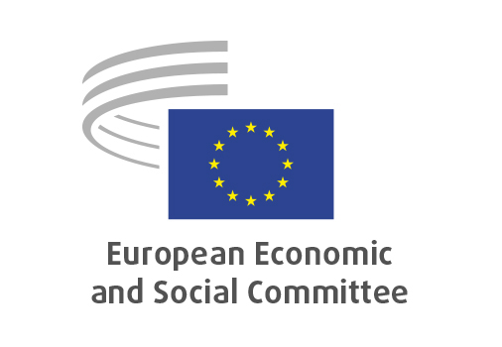
EN

ECO/694
EU market integration and efficient supervision

Brussels, 18 March 2026

RECORD OF THE PROCEEDINGS
European Economic and Social Committee
Proposal for a Regulation of the European Parliament and of the Council on settlement finality and repealing Directive 98/26/EC and amending Directive 2002/47/EC on financial collateral arrangements
(COM(2025) 941 final – 2025/0381 (COD))

Proposal for a Directive of the European Parliament and of the Council amending Directives 2009/65/EC, 2011/61/EU and 2014/65/EU as regards the further development of capital market integration and supervision within the Union
(COM(2025) 942 final – 2025/0382 (COD))

Proposal for a Regulation of the European Parliament and of the Council amending Regulations (EU) No 1095/2010, No 648/2012, No 600/2014, No 909/2014, 2015/2365, 2019/1156, 2021/23, 2022/858, 2023/1114, No 1060/2009, 2016/1011, 2017/2402, 2023/2631 and 2024/3005 as regards the further development of capital market integration and supervision within the Union
(COM(2025) 943 final – 2025/0383 (COD))
_____________

604th plenary session
Brussels
18-19 March 2026
_____________

Meeting of 18 March 2026
_____________

Agenda item 21
_____________

The president moved that the Committee turn to agenda item 21 - adoption of an opinion on the

Proposal for a Regulation of the European Parliament and of the Council on settlement finality and repealing Directive 98/26/EC and amending Directive 2002/47/EC on financial collateral arrangements
COM(2025) 941 final – 2025/0381 (COD),
on the
Proposal for a Directive of the European Parliament and of the Council amending Directives 2009/65/EC, 2011/61/EU and 2014/65/EU as regards the further development of capital market integration and supervision within the Union
COM(2025) 942 final – 2025/0382 (COD)
and on the
Proposal for a Regulation of the European Parliament and of the Council amending Regulations (EU) No 1095/2010, No 648/2012, No 600/2014, No 909/2014, 2015/2365, 2019/1156, 2021/23, 2022/858, 2023/1114, No 1060/2009, 2016/1011, 2017/2402, 2023/2631 and 2024/3005 as regards the further development of capital market integration and supervision within the Union
COM(2025) 943 final – 2025/0383 (COD).

The preliminary work had been carried out by the Section for Economic and Monetary Union and Economic and Social Cohesion (president: Elena Calistru). The rapporteur was Antonio García del Riego.

Mr García del Riego noted the strategic nature of further integrating capital markets, as it would impact the ability of the EU to fund its future. He explained that the opinion agreed with the objectives of the European Commission, among them, removing barriers to integration, supervisory convergence, and promoting an efficient allocation of capital. However, the opinion also asked for more ambition, in order to solve persistent fragmentation, heterogeneous regulatory frameworks, overlapping administrative requirements, and others. He explained that this reality led to higher costs, and less investment, innovation and economic growth. He informed that the opinion set a number of recommendations to solve these issues. He concluded that supporting integration meant supporting EU's confidence in its own future.

In the ensuing debate, Mr Alemany and Ms Calistru took the floor. Support for the opinion was expressed. It was pointed out that many innovative companies looked for funding in other jurisdictions, what better functioning capital markets could avoid. Also, it was noted that a more comprehensive discussion was necessary.

The opinion was adopted unanimously by 177 votes.

_____________

