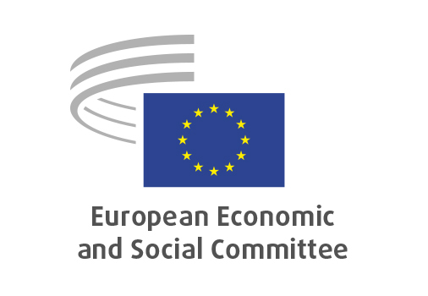
EN

ECO/693
Sustainable Finance Disclosure Regulation review

Brussels, 18 March 2026

RECORD OF THE PROCEEDINGS
European Economic and Social Committee
Proposal for a Regulation of the European Parliament and of the Council amending Regulation (EU) 2019/2088 on sustainability-related disclosures in the financial services sector (SFDR), Regulation (EU) No 1286/2014 on key information documents for packaged retail and insurance-based investment products (PRIIPs) and repealing Commission Delegated Regulation (EU) 2022/1288
(COM(2025) 841 final – 2025/0361 (COD))

_____________

604th plenary session
Brussels
18-19 March 2026
_____________

Meeting of 18 March 2026
_____________

Agenda item 18
_____________

The president moved that the Committee turn to agenda item 18 - adoption of an opinion on the

Proposal for a Regulation of the European Parliament and of the Council amending Regulation (EU) 2019/2088 on sustainability-related disclosures in the financial services sector (SFDR), Regulation (EU) No 1286/2014 on key information documents for packaged retail and insurance-based investment products (PRIIPs) and repealing Commission Delegated Regulation (EU) 2022/1288
COM(2025) 841 final – 2025/0361 (COD).

The preliminary work had been carried out by the Section for Economic and Monetary Union and Economic and Social Cohesion (president: Elena Calistru). The rapporteur was Javier Doz Orrit.

Mr Doz Orrit presented the opinion, highlighting that the financial sector needs clear and honest information regarding sustainability. This would enable actors (enterprises, banks, individuals, and investment funds) to understand investment options and decide freely whether to invest. The three product categories (sustainable, in transition, and basic) shall be aligned with EU climate objectives. Building on this, he noted the importance of simplifying sustainable finance rules, strengthening stewardship and reinforcing credibility.

In the ensuing debate, Ms Calistru took the floor and highlighted that the opinion comes up with proposals that reflect findings of public consultation of stakeholders.

The Assembly then examined the following amendment.

AMENDMENT 1  ECO/693  Sustainable Finance Disclosure Regulation review  Point 2.2  Amend as follows: | Tabled by:  BIEGON Dominika  DEL RIO Cinzia  DOZ ORRIT Javier

Section opinion | Amendment
Uphold the credibility and integrity of the SFDR by maintaining the exclusions set forth within the proposal and relying on credible ecological as well as social standards. | Uphold the credibility and integrity of the SFDR by maintaining the exclusions set forth within the proposal and relying on recognised ecological as well as social standards.

The amendment was accepted by the rapporteur and by the Assembly.

The opinion thus amended was adopted unanimously by 193 votes.

_____________

