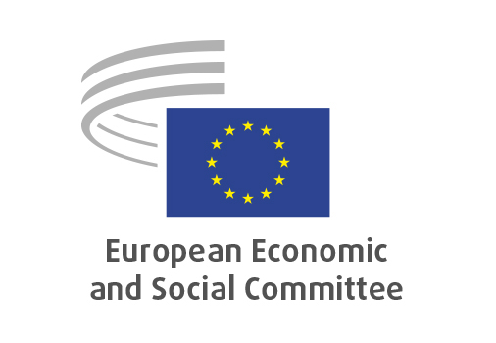
EN

CCMI/252
Battery Booster Strategy

Brussels, 18 March 2026

RECORD OF THE PROCEEDINGS
European Economic and Social Committee
Communication from the Commission Battery Booster Strategy
C(2025) 8950 final
_____________

604st plenary session
Brussels
18-19 March 2026
_____________

Meeting of 18 March 2026
_____________

Agenda item 5
_____________

The president moved that the Committee turn to agenda item 13 - adoption of an opinion on

Communication from the Commission Battery Booster Strategy
C(2025) 8950 final

The preliminary work had been carried out by the Consultative Commission on Industrial Change (President: Alain COHEUR). The rapporteur was Jason DEGUARA. The Co-rapporteur was Marco MENSINK

The section adopted its opinion by 38 votes in favour, no votes against and no abstentions by CCMI Members, and by 48 votes in favour, no vote against and 2 abstentions by CCMI Delegates on 10 March 2026.

Mr DEGUARA presented the opinion.

The opinion was adopted by 196 votes in favour, 0 against and 0 abstention.

_____________

