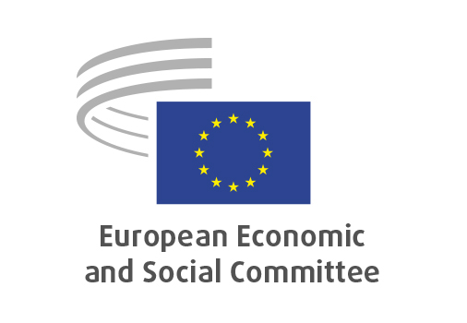
EN

TEN/867
EU Life Science Strategy and Research and Tech Infrastructures
Rare Diseases Focus

Brussels, 18 February 2026

RECORD OF THE PROCEEDINGS
European Economic and Social Committee
The European Life Science Strategy along with the Strategy on Research and Technology infrastructures with focus on the treatment of rare diseases
(exploratory opinion requested by the Cyprus Presidency of the Council of the EU)
_____________

603rd plenary session
Brussels
18-19 February 2026
_____________

Meeting of 18 January 2026
_____________

Agenda item 9
_____________

The president moved that the Committee turn to agenda item 9 - adoption of an opinion on

The European Life Science Strategy along with the Strategy on Research and Technology infrastructures with focus on the treatment of rare diseases
(exploratory opinion requested by the Cyprus Presidency of the Council of the EU)

The preliminary work had been carried out by the Section for Transport, Energy, Infrastructure and the Information Society (president: Mr NOWACKI). The rapporteur was Ms ANGELOVA (Group I, BG). The section adopted its opinion on 3 February 2026 by 92 votes.

Mr BOLAND gave the floor to the rapporteur Ms ANGELOVA who introduced the opinion.

Ms Angelova emphasised the critical importance of rare diseases as a policy priority. A holistic approach and nourishing the environment could position Europe a global leader in life science and especially for rare disease and genomics. Swift adoption of a European Action Plan for Rare Diseases, including the revival and further development of Advanced Therapy Medicinal Products, support for healthy lifestyles, and the need for One Health approach w highlighted. Definitions and research infrastructure had to be clarified and aligned to advance life sciences and the longevity economy, covering prevention, health, nutrition, biomedical treatment, and recreation.
Support should include promoting young entrepreneurs, data integration, and innovation funding in future EU financial frameworks. The opinion proposed establishing specialized translational centres for rare diseases in each Member State, coordinated at the European level, to foster collaboration among medical professionals, patients, social workers, and biobanks.
European partnerships were essential for engaging stakeholders; a formalized mechanism for their involvement is needed. Patients, social partners, and civil society organizations had to be represented in government bodies to ensure effective consultation and transparency in decision-making and data use.
The opinion would be presented in Nicosia in March during the Cyprus Presidency of the Council.

During the debate, the following members took the floor: Mr Meelis Joost, Mr Elo Gabor, and Mr Roger Alemany. The following points were raised:

Mr Joost agreed on the need for a holistic approach, highlighting the high costs of treatments (often unavailable or unaffordable), the need for coordinated financing solutions and cross-border cooperation.
Mr Gabor stated that 7% of the EU population is affected by rare diseases with more than 7000 disorders identified. Due to small, scattered patient populations and complex diagnostics, coordinated efforts were needed to improve advance diagnosis, research, care, and access. He stressed the importance of cooperation at the European level and the value of life sciences.
Mr Alemany focused on paediatric rare diseases, particularly cancer-related illnesses, indicating the need for personalised treatments, often not covered by public health systems, and mentioned donations possibilities for access to therapies.

In her answer Ms Angelova highlighted the gaps in care for patients transitioning from paediatric to adult healthcare systems. With Cyprus being an island in which same genes are shared, treatment should be the country's drive for further action for the increasing number of rare diseases patients in Europe.

The opinion was adopted by 219 votes and 4 abstentions.
_____________

