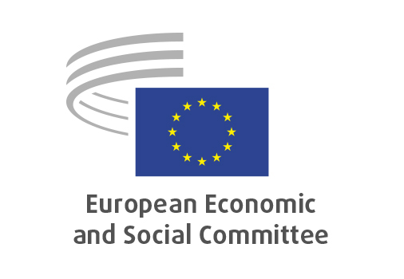
EN

TEN/865
Energy connectivity, electricity grids

Brussels, 18 February 2026

RECORD OF THE PROCEEDINGS
European Economic and Social Committee
Energy connectivity, electricity grids
(exploratory opinion requested by the Cyprus Presidency of the Council of the EU)
_____________

603rd plenary session
Brussels
18-19 February 2026
_____________

Meeting of 18 February 2026
_____________

Agenda item 11
_____________

The President asked that the Committee turn to agenda item 11 – adoption of an opinion on the

Energy connectivity, electricity grids
(exploratory opinion requested by the Cyprus Presidency of the Council of the EU)

The preliminary work had been carried out by the Section for Transport, Energy, Infrastructure and the Information Society (president: Marcin NOWACKI). The rapporteur was Christophe BÉGUINET (Group II, FR). The section adopted its opinion on 03 February 2026 by 81 votes and 1 abstention.

Mr BOLAND gives the floor to the rapporteur Christophe BÉGUINET who introduces the opinion. Mr Beguinet stresses that strengthening energy connectivity and electricity grids requires three key elements. First, he highlights the need for a clear forward‑looking vision, enabling comprehensive energy system management to anticipate future developments and to support timely investment and effective system operation. Second, he underlines the importance of a genuinely systemic approach, encompassing infrastructure across production, transport and distribution. Such an integrated perspective provides a much clearer understanding of how the system is evolving, whereas current arrangements remain insufficiently effective. Finally, he emphasises that affordability and access to energy are crucial issues: all citizens must be able to access decarbonised, affordable and high‑quality energy if the energy transition is to be both fair and sustainable.

Mr. Boland then opens the debate. Ms. Sanz Martín (ES-I), Mr. Arvidsson (SE-I), Mr. Kattnig (AT-II), Mr. Ulgiati (IT-NA), Mr. Tracevičius (LT-III) and Mr. Hidesten (SE-I) speak on the following issues:

- the role of energy interconnections as the foundation of affordable, secure and sustainable energy, including the need to maximise the use of existing networks, enhance demand‑side flexibility and strengthen electricity grids;
- the importance of careful planning and implementation of interconnections in order to avoid negative impacts on competitiveness, particularly in regions currently benefiting from lower energy prices;
- the need for long‑term planning and coherent strategies, supported by the EU budget, including a strategic vision for an EU‑wide interconnection system and adequate baseload capacity;
- the promotion of energy democracy, with a stronger role for prosumers;
- the importance of taking public opinion into account when developing major energy infrastructure projects and long‑term energy strategies;
- concerns regarding proposals to transfer additional decision‑making powers from Member States to Brussels, which could affect national choices on energy mix and undermine competitiveness where cost‑effective investments have already been made.

The opinion is adopted by 235 votes for, 4 against and 4 abstentions.

_____________

